Generating Electricity from Biomass
in Centre County, Pennsylvania

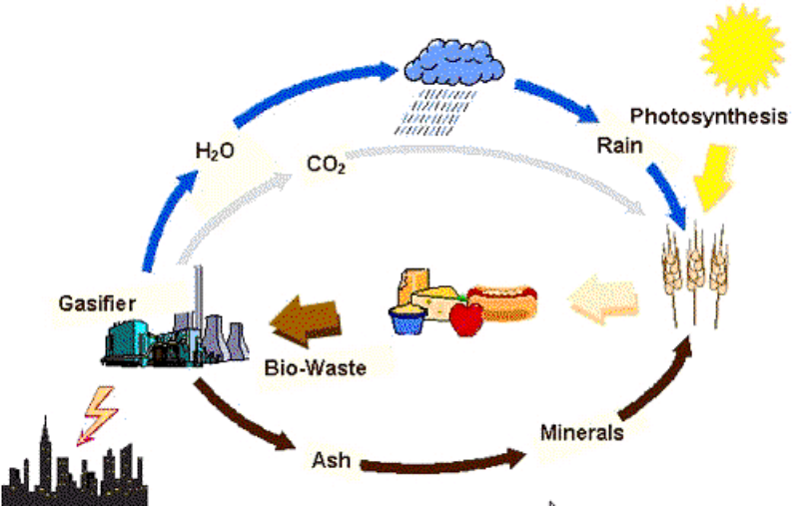

Prepared By

The Biomass Group

LaTosha Gibson
Junichiro Kugai
Charles Winslow
Chao Xie

4 May 2007

Introduction 1
Approach 2
Local Energy Demand and Biomass Availability 3
Objective, Scope, and Process 3
Biomass Defined 3
Centre County Energy Usage 4
Centre County Biomass Availability 5
Energy Content of Biomass 6
Project Feasibility 6
Supply and Logistics 7
Key Issues in Logistics 7
Simulation Method 8
Results and Discussion 10
Other Issues 11
Utilization of 100% Biomass 13
Biomass Gasification 13
Gasifiers 13
Gas Conditioning and Cleanup 14
Combined Cycle System 15
Summary for 100% Biomass Utilization 16
Utilization of Coal and Biomass 18
Objective 18
Design Concept 18
Approach 18
Chemical Reactions in the Co-Gasification of Coal and Biomass 19
Steam Gasification 19
Boudouard Reaction (CO₂ Gasification Reaction) 19
Water Gas Shift Reaction 19
Partial Combustion 19
Gas Cleaning Requirements 20
The Gas Power Cycle 21
The Steam Cycle 21
Conclusion 21
Cost Analysis of the Co-Gasification and Biomass Plant Configuration 23
Energy Flow Diagrams and Carbon Life Cycle Analysis 24
Energy Flow Diagrams 24
Carbon Life Cycle Analysis 24
APPENDIX A—Local Energy Demand and Biomass Availability 25
Table A1: Centre County Energy Usage in 2004 by Sector and Energy Resource (million BTU/year) 25
Table A2: Centre County Biomass Availability 26
Table A3: Centre County Woody Biomass Availability 26
Table A4: Energy Content of Various Biomass Types 27
Table A5: Difference in Composition between Hardwoods and Softwoods 27
Figure A1: Centre County Energy Consumption in 2004 by Sector 28
APPENDIX B—Supply and Logistics 29
Figure B1: Energy Consumption in Transportation 29
Figure B2: Proportion of Energy Consumption in Each Logistic Operation 29
(Comparison between forest residues and low-use wood) 29
Figure B3: Proportion of Energy Consumption in Each Logistic Operation 30
(Comparison between forest residues and low-use wood) 30
Figure B4: Total Energy Consumption in Logistics (Unit : BTU/dry-lb) 30
Figure B5: Total CO₂ emission in logistics (Unit : lbCO₂/dry-lb) 31
Figure B6: Sum of the Logistic Cost and Field Purchase Price (Unit : USD/MWh_{e}, Field Price: $2.2/MWh_{e} for forest residues, $4.5/MWh_{e} for low-use wood, $22.4/MWh_{e} for growing-stock,$11.5/MWh_{e} for coal) 31
APPENDIX C—Utilization of 100% Biomass 32
Table C1: Parameters of IGCC based on an atmospheric, directly-heated, steam-blown, circulating, fluidized gasifier 32
Figure C1: Relationship between various gasifiers: scale and efficiency for electricity production 32
Figure C2: Schematic of a gas turbine 33
Figure C3: Schematic of a steam turbine consisting of three parts (high-pressure turbine, medium-pressure turbine, low-pressure turbine) 33
Figure C4: Scheme of IGCC for biomass utilization based on an atmospheric, indirectly-heated, steam-blown, circulating, fluidized-bed gasifier 34
Figure C5: Energy and mass flow diagram for IGCC 34
Figure C6: Energy distribution diagram of IGCC 35
APPENDIX D—Utilization of Coal and Biomass 36
Table D1: Chemical Input and Balance for Gasifier and Gas Turbine 36
Figure D2: Gas Turbine Parameters 37
APPENDIX E: Group Work 47
Figure E1: Biomass Team Concept Map 47
Figure E2: Energy Flow Diagram for 100% Biomass Power Plant 48
Figure E3: Energy Flow Diagram for Coal and Biomass Power Plant 48
Figure E3: Energy Flow Diagram for Coal and Biomass Power Plant 49
Figure E4: CO₂ Flow Diagram for All Power Plant Scenarios 50
References 51

Introduction

The chemical potential energy stored in fossil fuel resources such as coal, natural gas and petroleum provides the largest source of energy production (i.e. heat and electricity), transportation fuels, and petroleum-based chemicals in the United States and the rest of the world [Balat, 2005]. However, fossil fuels are non-renewable, and their combustion produces emissions such as nitrogen oxides (NO_{x}), sulfur dioxides (SO_{x}), and carbon dioxide (CO₂)—all of which are greenhouse gases that contribute to global warming [Widiyanto, 2003]. Recently, biomass energy resources have gained increased favor as a renewable alternative to fossil fuels for a variety of reasons. For instance, the utilization of biomass reduces our dependency on foreign energy sources, produces less harmful emissions (and is carbon-neutral), and supports the U.S. forestry and agricultural industry [U.S. DOE, 2005].

In light of these benefits, this project specifically focuses on biomass energy utilization as an alternative to conventional fossil fuel resources (Appendix E, Figure E1). However, in an effort to make this broad problem more manageable and focused, the team decided to explore its associated issues in the context of Centre County, Pennsylvania. The inspiration for constraining the problem in this way resulted from reading about a similar undertaking in Minnesota, by the Centre for Energy and Environment, which investigated the feasibility of utilizing locally-grown biomass to meet the state’s electricity demand [Goldstein, 2006]. Therefore, the objective of this report consists of proposing the preliminary analysis and design of two power plants—one utilizing 100% biomass and a second utilizing both coal and biomass (up to 30% biomass)—for meeting Centre County’s electricity needs, as opposed to its heating and transportation energy demand. This project will hopefully stimulate further research and interest in this area, and get Centre County on the right track to delivering 100% clean, renewable, and secure biomass energy.

As with most technological advances, the best approach is often a stepwise one, so the design and construction of a power plant that utilizes both coal and biomass to meet Centre County’s electricity demand would constitute a step in the right direction toward 100% biomass utilization without being too economically or technically restrictive. The remainder of this paper shall attempt to further elucidate the details of this progressive proposal. Specifically, the design team shall discuss the key issues concerning the implementation of biomass energy utilization in the Centre region, including but not limited to (1) local biomass availability and energy consumption, (2) biomass supply logistics and transport, and (3) utilization of coal and/or biomass for power (i.e. electricity) generation.

Approach

Given the goal of meeting Centre County’s energy demand with biomass energy resources, our first priority was to determine the actual energy demand of the resident and transient population. Once we determined this figure, we estimated the necessary peak capacity of the power plants by using a base trend line from the monthly average of residential energy consumption in Centre County. The peak load was estimated to be between 75 and 100MW in order to meet the energy demand of Centre County. Therefore, the power plant utilizing 100% biomass was scaled to provide 125 MW while the power plant utilizing thirty percent biomass and seventy percent coal will be scaled to provide 375 MW. These numbers have been selected to meet both current and future energy demand. The biomass of choice is forest residue and growing stock hardwoods, which are available on a ten-year harvesting cycle. Based on the efficiencies of the plant configurations of interest (40% for the IGCC and 50% for the PGCC), the amount of power that could be attained from the woody biomass was determined.

As far as the selection of plant components and the configuration, maximum efficiency is a main concern in both the utilization of 100% biomass and co-gasification in order to make utilizing biomass a viable option for power generation. Due to the lower heating value of biomass compared to coal, a high carbon conversion is required in addition to a high efficiency of the gasifying unit. Although selection of the gasifier will determine the carbon conversion given the composition, only a energy/exergy analysis will provide a close approximate estimate on the efficiency of the plant. In addition to efficiency, issues such as agglomeration, tar formation, ash deposition, and fouling would have to be addressed. Because a full analysis in terms of such issues within gasification is beyond the scope of this project, gasifiers that would keep such issues at a minimum were selected. Emissions will be determined based on the mechanisms of thermal, fuel, and prompt NOx in addition to SOx in the case of the coal. Information has already been collected in terms of the standard capital cost of plant components. Based on the operation cost of each plant configuration, the cost per MWh of power has been determined.

Central to this project was performing a life cycle assessment and determining the feasibility of introducing biomass as an energy source for power generation for residential and commercial use. For the life cycle assessment, the approximate percentage of biomass that has been utilized for the end use of power generation versus the percentage of biomass loss through collection, transportation, and auxiliary power consumption. The pounds of carbon dioxide that has been generated per BTU of energy produced or used has also been determined in terms of logistics and power generation. Finally, the feasibility has also been assessed based on the cost of electricity per MWh in addition to logistics. In order for the introduction of biomass (through co-gasification and/or utilizing 100% biomass) to be feasible, the cost could not overly exceed the cost of existing power generation infrastructure and the utilization of fossil fuels. For a fair comparison, co-gasification with 10% biomass has been used as a reference scenario in terms of cost and logistics requirements.

By taking this approach, we have not only attained a comprehensive assessment of cost and emissions but a framework in which to balance energy efficiency, cost, and emissions. As more advanced and efficient technology becomes available, such a baseline will provide a gauge for the effectiveness of such components.

Local Energy Demand and Biomass Availability

Objective, Scope, and Process

The goal of this project is to promote interest in biomass energy by designing a combination of power plants utilizing defined amount of biomass feedstock (i.e. 100%, 30%, and 10%) to meet Centre County’s energy needs, while also making use of the local biomass supply. The power plants will be designed to meet Centre County’s present and future electricity needs. Energy demand associated with heating and transportation is not addressed in this report. Accordingly, this initial section on biomass availability first investigates the energy (i.e. electricity) demand of Centre County. After identifying the energy demand of the local community, next it is determined how much biomass the area can support. After taking into account inefficiencies, it will be shown that the local biomass supply surpasses the local energy demand, even after accounting for future population growth. Therefore, this project is technically feasible on a local scale.

Strictly speaking, we did not have to limit ourselves to using local biomass resources, but in an effort to make the system as self-contained as possible, as well as to reduce unnecessary costs associated with the transportation of biomass from more distant areas, the use of local biomass is the focus of this project. Should the design calculations have show that the local area did not produce enough biomass to support the energy demand of its population, we would have needed to expand this particular section of the report beyond the scope of local biomass availability in order to make the design technically feasible.

Biomass Defined

One can broadly define biomass as biological matter derived from plants and other plant-derived materials [U.S. DOE, 2007]. Essentially, the energy stored in biomass originated from the sun, so utilizing biomass energy constitutes an indirect use of solar energy [Ragauskas, 2006]. Therefore, biomass represents a renewable natural resource, and, in fact, biomass resources constitute the only renewable source of fixed carbon [Bridgewater, 2006]. In an energy context, biomass has the potential to supply the world with a significant amount of “green” power because utilization of biomass energy in and of itself does not inflict an additional carbon dioxide load on the atmosphere [Ragauskas, 2006]. Although burning biomass does in fact release carbon dioxide, this emission is balanced so long as new biomass is grown in its place. Thus, in its purest sense (i.e. 100% biomass energy economy), biomass energy utilization is entirely carbon neutral [Ragauskas, 2006].

In general, the three main types of biomass consist of woody biomass, non-woody biomass, and organic waste biomass. Woody biomass refers primarily to biomass originating from forest resources. Some examples of woody biomass include forest residues (e.g. what is left after logging), fuelwood (e.g. trees grown specifically for use in wood stoves), wood waste (e.g. remnants from the wood processing industry), short rotation forestry (e.g. fast-growing trees such as willow and eucalyptus that are not grown to maturity), and urban wood waste (e.g. trimmings and garden waste). Non-woody biomass, on the other hand, refers mainly to biomass originating from agricultural resources. Some important examples of non-woody biomass include agricultural crops (i.e. perennial and annual crops such as corn, soybean, alfalfa, and switchgrass), crop residues (i.e. husks and other material left after the harvest), and processing residues (i.e. waste materials produced from sugar cane processing and olive oil extraction). Finally, the third type of biomass consists of all the organic material not included in the woody or non-woody categories. The principal components of this organic biomass consist of animal waste (i.e. manure) and sewage of domestic and industrial origin (i.e. mostly human waste). [IEA, 2007]

Centre County Energy Usage

Based on the statistics reported in the 1990 and 2000 U.S. Census [U.S. Census Bureau, 2007], Centre County, PA, maintains a current resident population of over 140,000 in 2005, not including the approximately 40,000 strong student population. These Centre County residents and visiting students require a large quantity of energy to go about their daily lives, and this section aims to quantify this energy demand.

In 2005, faculty in the Penn State Department of Geography founded the Centre County Community Energy Project (CCCEP), and the first task of this organization consisted of assessing Centre County’s energy usage. Using a combination of direct and proxy methods, the CCCEP determined the baseline energy consumption for Centre County for the year 2004 [Knuth, 2005]. Direct methods entailed calling local utility and non-utility energy providers. Proxy methods utilized a variety of estimation methods for determining transportation energy usage and for filling any voids left from the direct method.

According to the data reported by the CCCEP, Centre County used approximately 30 x 10¹² BTUs (30 tera BTUs or TBTUs) during the year 2004 (Table A1). The different types of fuels included those used for producing electricity (i.e. electricity derived from mostly coal-fired powered power plants), providing heat (i.e. natural gas, heating fuel, coal, biomass, LPG/propane, and solar), and powering transportation (i.e. gasoline and diesel). The six energy sectors considered included residential, commercial/small industrial, large users (excluding Penn State), Penn State, public (i.e. lighting, traffic signals, etc.), and transportation. One can see that transportation accounts for a large portion of the 30 TBTU consumed annually (Figure A1). Specifically, about 34% of the energy demand resulted from that associated with powering Centre County’s cars, buses, and other vehicles (i.e. transportation). Large users and residents consumed almost equal amounts of energy, registering in at 20% and 19% of the total demand, respectively. Commercial and small industrial used about 15% of the total, while Penn State rounded out the major users accounting for about 12% of the total demand.

In the context of the current project, the design team will only consider that portion of the energy demand associated with electricity production, as opposed to that linked with heat and transportation. From the data reported in Table A1, one can see that electricity accounts for nearly 7 TBTUs of the 30 TBTUs consumed annually. However, this value does not take into account future population growth of the county, which must be accounted for when designing a single power plant or multiple plants.

It is reasonable to assume a 30-year useful life expectancy when designing a power plant for a community. Accordingly, the power plant designed for today must be able to accommodate the energy demand of the population at least 30 years in the future. Based on recent statistics, the population growth of State College, PA, is about 3.9% per year [Sperling’s, 2007]. This growth constitutes the highest in the county, with other notable cities such as Bellefonte, Phillipsburg, and Port Matilda growing at a dismal -1.1, -2.3, and -8.8%, respectively. Therefore, to be realistic with the future population projection, we used an estimated population growth of 3%. This value is conservative from an engineering perspective because the actual population growth is likely less than this value given that most of the cities surrounding State College are experiencing dwindling populations.

Assuming per capita energy usage remains the same 30 years from now, while also assuming a fixed population growth of 3%, the energy demand of Centre County will be about 18.6 TBTU or 622 MW in the year 2037. This value was estimated based on the 2004 energy demand of 7 TBTU projected 33 years into the future (current year is 2007). Therefore, in order for the project to be technically feasible, at least this amount of biomass energy must be available per year. Determining biomass availability is the focus of the next section of the report.

Centre County Biomass Availability

Like the rest of the state, Centre County, PA, has an abundant supply of woody, non-woody, and organic biomass resources (Table A2). Although not addressed specifically in the context of this design project, the non-woody and organic biomass resources are both diverse and plentiful. For instance, total farmland, including that which is regularly farmed as well that which currently lies fallow as part of the Conservation Reserve Program (CRP), totals nearly 165,000 acres. Corn and soybean crops total nearly 1.2 million and 0.25 million bushels, respectively. Organic biomass in the form of livestock manure totals about 325,000 tons, consisting of contributions mainly from beef cattle, milk cows, cattle-calves, broiler chickens, layer chickens, turkeys, and swine. [Morrison, in press]

The quantity and diversity of woody biomass is the focus of the current project (Table A3). Centre County sprawls across a land area of roughly 710,000 acres, of which about 520,000 acres consists of timberland. The distribution of privately- and state-owned timberland is almost equally divided at 272,000 and 248,000 acres, respectively. On this land thrives a healthy diversity of hardwoods and softwoods. The hardwood growing stock makes up nearly 90% of the total growing stock, totaling over 765 million cubic feet, while that of the softwood growing stock amounts to about 90 million cubic feet. The fact that about 90% of Centre County forestland consists of hardwoods has significant energy implications because hardwoods yield more energy per equal volume of softwoods because of their higher density. In addition to the woody biomass in forestland, process residues from logging and mill operations contribute an additional 4.26 million cubic feet. Of this figure, about 3.13 million cubic feet comprises logging residue (93% hardwoods by volume) and 1.13 million cubic feet consists of mill residue (90% hardwoods by volume).

Initially, the design team will focus on logging residue and growing stock timberland because these woody biomass supplies represent a significant amount of unutilized biomass that is currently available without necessitating further infrastructure improvements (i.e. access roadways). Should these biomass resources not provide sufficient energy to meet Centre County’s energy demand, tapping into the large supply of non-growing stock woody biomass in Centre Pennsylvania’s forestland will likely be considered. For the time being, woody biomass in the form of mill residue and organic biomass resources will not be considered because their composition differs substantially from that of logging residue and harvested timberland.

Limitations on biomass availability can arise from a number of factors, but, in general, the biggest problems consist of accessibility, climate, and environmental concerns [U.S. DOE, 2005]. For instance, one must take into account that not all forestland is accessible by roads, therefore reducing the region’s theoretical yield. Furthermore, biomass availability is intimately related to seasonal climate change, which is more pronounced in the Central PA region. Therefore, when considering biomass growth cycles, one must take into consideration seasonal weather variations. For instance, an energy-rich crop such as sugar cane, which might grow readily in a hotter climate, would not do well in Central PA. Finally, one must not forgot to take into account environmentally sensitive areas when determining the theoretical biomass yield of the Centre region, which has its share of protected land.

However, the decision of the design team to first focus on the utilization of woody biomass—in particular, logging residues and growing stock timberland—as the primary biomass resources minimizes the impact of accessibility, climate, and environmental concerns. For instance, whereas Centre County’s seasonality limits the time of year one could harvest energy crops (i.e agricultural biomass), in our estimation, one could theoretically harvest woody biomass year-round. Granted, doing so during the winter might be more difficult and less comfortable for the field workers, but it could, nonetheless, be accomplished. Furthermore, using logging residues and growing stock timberland eliminates the restrictions associated with non-growing stock forestland accessibility. Established logging operations already have the infrastructure and equipment to access Central PA’s dense forestland, so accessibility of the resource should not be an issue. Finally, restrictions associated with disturbing protected environmental areas should not constitute a major concern when utilizing logging residues and growing stock timberland as the primary biomass resources.

Energy Content of Biomass

The energy content of biomass varies over a relatively small range encompassing about one order of magnitude (Table A4). Landfill gas falls at the lower end of the spectrum, containing about 250 BTU/lb, while dry hardwoods can contain upwards of 9600 BTU/lb [U.S. EIA, 2007]. These values are of limited usefulness out of context. Therefore, for comparison’s sake consider that one gallon of gasoline contains approximately 125,000 BTU and cooking a small meal uses about 10,000 BTU [U.S. EIA, 2007].

As has been previously stated, this design project shall focus solely on utilization of woody biomass. However, the different varieties of woody biomass differ in chemical composition. For instance, hardwoods and softwoods differ in their relative percentage of cellulose, hemicellulose, lignin, and ash content [U.S. DOE, 2007]. In general terms, hardwoods contain anywhere from 39-50% (by weight) cellulose, 18-28% hemicellulose, 15-28% lignin, and 0.3-1.0% ash, while softwoods contain 41-57% cellulose, 8-12% hemicellulose, 24-27% lignin, and 0.1-0.4% ash (Table A5). Since over 90% of Centre County timberland and logging residue consists of hardwoods, all design calculations in subsequent sections shall assume the energy content of hardwoods. Specifically, the design team shall consider all biomass to have an energy content of approximately 6400 BTU/lb, which is a conservative value for hardwoods that have been properly air dried and contain no more than 20% moisture (Table A4). Furthermore, a conservative woody biomass density of 10 lb/ft³ shall be assumed for both growing stock timberland and logging residue.

Project Feasibility

Preliminary results suggest there is more than enough logging residue and growing stock timberland in Centre County to provide for a 100% biomass power plant, which is obviously the most demanding on the local biomass supply as opposed to the co-firing plants utilizing 90% and 70% coal. Assuming a 2037 energy demand of 18.6 TBTU’s, an extremely conservative plant efficiency of 40%, woody biomass energy content of 6400 BTU/lb (20% moisture content), and a wood density of 10 lb/ft³, the amount of woody biomass necessary is projected at 727 million cubic feet. Comparing this with the available woody biomass of 859 million cubic feet from logging residue and growing stock timberland (Table A3), one can see that there is about 18% or 132 million cubic feet of excess biomass available.

One assumption that has yet to be addressed is whether future biomass availability will be equal to current biomass availability. In the above calculation we assumed future biomass availability is indeed equal to the biomass currently available, but this is not necessarily true. Depending on the decisions of future local and county planners, some of the 859 million cubic feet currently available might be developed for housing or some other use as a result of the increasing population. However, fortunately (or maybe unfortunately, depending on how one looks at it), whether or not this holds true depends on the decisions of the local community. If Centre County residents make sustainable energy a priority and conserve enough natural biomass resources as deemed necessary, the assumption that future biomass availability equals current biomass availability is a fair and valid one.

Supply and Logistics

Logistics of biomass delivery from harvesting site to the power plant is one of the important aspects that affect on feasibility of biomass utilization for power generation. The logistical complexity of biomass stems from a wide distribution of sources, time and weather sensitive growth, limited term of harvesting, competition with other utilization of the biomass, and different properties of biomass from that of fossil fuels. In this study, logistics in biomass delivery was analyzed by literature survey, key issues were extracted, and knowledge and data were applied to power generation system built in Centre county, Pennsylvania. The objectives of logistic part is to collect reliable data of energy consumption (energy input), CO₂ emission, and cost for each operation section, to combine them together to serve for the calculation of life cycle of the biomass or coal-biomass power generation system. Three types of biomass, i.e. forest residues, low-use wood, and growing-stock, were considered for logistic analysis. Three power plants, i.e. 124MW 100%biomass-fed, 375MW 30%biomass/70%coal-fed, 375MW 10%biomass/90%coal-fed power plants, were considered for each biomass type. From literature survey, five main operations are found to comprise logistics. They are field operation (collecting and forwarding), transportation (loading , transport, and unloading), storage, comminuting, drying. Several literature estimates the ratio of energy input in whole logistics over electricity output to be around 0.1. It is expected biomass power plants can be also applied in Centre county to save energy from fossil sources. In the following paragraphs, method and assumption for simulation of logistics, results and discussion, other issues to be considered are described.

Key Issues in Logistics

Among several logistic operations, the field operation needs high energy consumption. This is because even the state-of-art equipment use much energy for collection and forwarding of biomass in various regional condition. Especially thinning accompanies cutting branches of standing tress, which costs more energy than collecting forest residues[DeMol, 1997]. It would be economically better to combine thinning and chipping into one operation. This also help to densify forest residues. Wood chips are reported to have a little higher density (about 10 dry-lb/ft³) compared to forest residue. They are easily collected by air-blowing collector. However, there is high risk of biochemical degradation of biomass [Wihersaari,2005]. Once wood is comminuted, abundant water content and large surface exposed to atmosphere promote propagation of fungi, causing severe degradation of biomass. Therefore, it is not recommended to comminute at the field unless wood chips is carefully maintained in a dry condition after the sizing process. Baling is another compacting method to increase the density of biomass, especially for forest residues. Since the density of forest residues is very small (about 8 dry-lb/ft³), amount of loading on a trailer is sometimes limited by the volume resulting in less efficient transportation. In that case, forest residue is baled before transportation. Baling also realizes easy handing and lower transportation cost, but baling process is energy consuming and costly [Forsberg, 2000].

The biomass is stacked on the roadside after forwarding to load on a vehicle. Loading and unloading biomass consumes relatively small amount of energy. Biomass can be comminuted simultaneously when it is loaded on the trailer using a special equipment with lower energy cost, however, it is not recommendable due to the risk of biochemical degradation of biomass as mentioned above. The vehicle type varies with amount and type of biomass. Dump trucks and semi-trailer vans are used [Badger, 2002].

Certain amount of biomass is stored beside the power plant to sustain stable supply of the fuel. Therefore the power plant needs certain storage space. Major storage facilities are open piles, piles partially covered by open shed such as bunkers, enclosed storage bins, hoppers, or silos. The design of storage facility depends on demand for fuel properties, whether condition, availability of storage area. Biochemical decay of biomass is always the issue in storage. Enclosed storage with dry atmosphere is suitable for storing comminuted biomass while open storage is acceptable for uncomminuted biomass.

Comminuting is done by a stationery equipment like hammermills (grinder), chippers, or chunkers which use electricity for the power source. Typical hammermills produce particle sizes in the range of 25-125 mm with grinding rate of 20-55 tonnes/hr and electricity consumption of 75-220kW. Generally, comminuting of biomass is more difficult than coal due to its non-friable character [Badger, 2002].

Drying biomass increase the flame temperature and increase the overall thermal efficiency in conversion process. Nonetheless, it cannot pay to install a dryer. It is usually the most economical way to integrate drying with the conversion process. Stack gas may be a source of waste heat. It contains low oxygen, which is good for preventing accidental fires, but it also contains high moisture and corrosive gas. Rotary drum dryer is one of most popular drying device in industry [Brammer, 1999]. Biomass is dried by heated air in the rotating, slightly inclined drum so that biomass is continuously exposed to hot air and forwarded to the end of the drum. The moisture content in biomass is easily controlled by residence time and temperature, but it is necessary to prevent a fire or explosion. The power source for this dryer is natural gas, fuel oil, propane, or wood fuels. The suspension dryer is suitable for small scale, whose system makes use of pneumatic conveyance. Therefore, drying efficiency depends on the size of biomass. Other possible dryers are belt dryer, tube bundle dryer, and fluidized bed dryer.

Simulation Method

According to the literature survey, biomass delivery route to be simulated in this work was set as follows: 1) collection and forwarding in the field, 2) transportation, 3) storage near the facility, 4) chipping at the facility, 5) drying at the facility. The power plant is assumed to built somewhere in Centre county, Pennsylvania, with a large space for storage. The supplied biomass sources considered in logistics are forest residues, low-use wood [Ray, 2007; Judd, 2006], Growing-stock. The biomass distribution density, annual yield in a unit area of land, are about 9,000 dry-lb/km²/year for forest residues, 101,000 dry-lb/km²/year for low-use wood, 3,000,000 dry-lb/km²/year for growing-stock. Biomass distribution density of mixed hardwood and spruce in western Canada is reported to be about 53,000 dry-lb/km²/year for forest residue and 1.85 x 10⁷dry-lb/km²/year for whole timber [Kumar, 2003]. This clearly shows extremely low yield of forest residue per unit area in Pennsylvania. Meanwhile, low-use wood, which is economically infeasible source for lumber industry, has about 10 times of distribution density of forest residue. Growing stock, utilization of which would compete with lumber industry, has about 30 times of distribution density of low-use wood. Growing-stock in Pennsylvania is actually of high quality and significant amount is exported to other countries. Three power plants were considered in this report, i.e. 124MW 100% biomass, 375MW 70% coal-30% biomass, 375MW 90% coal-10% biomass power plants. If power generation efficiency of 40% for 100%biomass power plant, 45% for coal-biomass power plants are assumed, annual demand for wood fuel are 12.1 x10⁸ dry-lb/year, 6.75 x10⁸ dry-lb/year, 2.21 x10⁸ dry-lb/year, respectively. By comparing wood fuel availability and demands for each power plant, one can find that forest residue in Pennsylvania cannot afford to cover the fuel demand of 100% biomass-fed power plant. On the other hand, low-use wood in Pennsylvania can provide about 10 times of fuel needed for this power plant.

The beginning of logistics was set at collection/forwarding since forest residue and low-use wood are byproducts in harvesting of logs. In fact, brush, deadfall, limb, and tops are left in the field or on roadsides in current practice. “Cut to fit” in the field is getting more common in lumber operations. The data of energy consumption and CO₂ emission in collection/forwarding were obtained from the two reports, which are well consistent each other [Forsberg, 2000; Wihersaari, 2005]. The cost for collection and forwarding is $11.4/dry-tonne according to Kumar et al. [Kumar, 2003]. As mentioned above, increasing the density of forest residues by baling increases the transportation efficiency. The data for baling of forest residue were also available, but it doubles the energy consumption and CO₂ emission, for which the advantage of efficient transportation could not compensate. Therefore baling is not considered in this study.

A simulation of transportation was based on the method reported in literature [Caputo, 2005; Dornburg, 2001]. Energy consumption and CO₂ emission in transportation is variables of biomass distribution density, biomass mass flow into the power plant, vehicle capacity, and specific energy consumption of the vehicle. Using these parameters, annual traveling distance of vehicles for transportation of biomass from collection sites to the power plant was calculated, then it was multiplied by specific energy consumption or specific CO₂ emission of the vehicle to obtain energy consumption or CO₂ emission respectively. The method assumes the distribution of biomass over the region is constant and biomass is transported over a marginal transport distance that is the radius of a circle in which biomass is spread with the given distribution density. The traveling distance of transport (km/year), d_{T} , is expressed as follows:

d_{T} = (4/3) m^{1.5} (D_{b} π)^{-0.5} (VC)⁻¹

where m is the biomass delivered to the power plant (lb/year), D_{b} is the biomass distribution density (lb/km²/year), VC is the vehicle capacity (lb/vehicle). It is also assumed that biomass is concentrated at 2/3 of the radius of the catchment circular area necessary to produce the amount m of biomass feeding the plant. The vehicle is assumed to be fully loaded on the way to the power plant and empty in the return trip. The parameter “m” in above equation is obtained by the power plant scale and its efficiency. The type of vehicle was set to a trailer with capacity of 20 tonnes, which corresponds to 4.405 x 10⁴ green-lbs (2.937 x 10⁴ dry-lbs) when the moisture content of biomass is 50%(db). Kumar et al. used specific energy consumption of 1.3MJ/tonne/km, that is 25,000BTU/km(26MJ/km) in the case of 20 tonne trailer. Dornburg et al. used 0.8MJ/ton/km, that is 15,000BTU/km(16MJ/km). In this study, the former was employed for calculation. CO₂ emission is reported to be 3g-carbon/GJ-biomass/km in the same literature. Since energy content of biomass is 7680BTU/dry-lb(17.84MJ/dry-kg) and carbon content in dry matter is 50%, 5.76 lbCO₂/km(2.62 kg-CO₂/km) is emitted from this 20 tonne trailer. Since CO₂ emission from combustion of diesel fuel is around 71kg-CO₂/GJ-diesel , CO₂ emission from this trailer is estimated to be 4.05 lb-CO₂/km (1.84 kg-CO₂/km), which is comparable order with the assumption of Kumar et al.. 20 tonnes of biomass loading was assumed for all the trailer trips. Cost for transportation is also based on the report of Kumar et. al. To check the validity, relation between cost and travel-distance were plotted in a figure using the data from several reports.

As mentioned above, energy consumption and CO₂ emission during storage of biomass are mainly caused by biochemical degradation of biomass. In this study, biomass is comminuted at the power plant before drying, therefore dry matter loss by biochemical degradation is ignored. Although it is not taken into calculation, approximately 1x10⁷ ft³ of forest residue, volume of a baseball ground with 12m height, would be needed for storage of fuel for 1 month in the case of 100% biomass plant.

Energy consumption in comminuting operation depends on capacity of chippers, size of wood chips, the location of chipping (chipper types). Very few data were obtained for large scale chipping at the power plant. The data of energy consumption and CO₂ emission used in this study are those from Wihersaari’s report and cost data from those of Junginger’s report [Wihersaari, 2005; Junginger, 2001]. Comminuting cost is reported to range from $0.37/dry-lb to $0.65/dry-lb, but this study considered a large scale stationery chipper, which costs much less. The diskscreen of wood chips follows after comminuting to remove oversized pieces, but energy and costs for this process are negligible.

The moisture content of biomass depends on the wood species, but generally around 50wt%. It is reduced to 20wt% at drying process. Energy required for drying using a conventional dryer is as follows:

1)Heating 0.5kg of water contained in 1dry-kg of biomass from 20ºC to 100ºC needs 0.5(kg) x 4.184(kJ/kg/ºC) x 80ºC = 168(kJ/dry-kg)
2)Vaporizing 0.3kg of water contained in 1dry-kg of biomass at 100ºC needs 0.3(kg) x 2256(kJ/kg) = 678(kJ/dry-kg)
3)Heating 1 dry-kg of biomass from 20ºC to 120ºC needs 1(kg) x 1(kJ/kg/ºC) x 100ºC = 100(kJ/dry-kg)

Theoretically needed energy is 946 kJ/dry-kg. Typical efficiency of a dryer is 70%, therefore, the energy consumption is estimated to be around 1352 kJ/dry-kg. In fact, Cocco et. al. provided parameters in rotary dryer where 283.8ºC of flue gas was utilized for drying fluid, and 1660 kJ/dry-kg of energy consumption was obtained [Cocco, 2006]. Since a rotary dryer is widely used in drying powder, wood chips, grains, and considered more practical, the latter was chosen as the parameter in this study. CO₂ emission from this process corresponds to amount of CO₂ in flue gas utilized for drying. When 1660 kJ of consumed energy corresponds to 0.093 dry-kg of dry biomass, that is, 0.047 dry-kg of carbon since carbon content in dry matter is 50%. Therefore, 0.171kg of CO₂ emission is estimated. Cost for drying process was obtained from a report [Maciejewska, 2006].

The logistics of coal delivery was investigated for biomass/coal power plant. Only transportation and comminuting were taken into account. It was assumed that coal is transported from Pittsburg #8 coal seam. Pittsburg #8 coal is bituminous coal, which has 12540 BTU/lb (29.13MJ/kg) of heating value[McClintock, 2005]. (7680 Btu/dry-lb for biomass) The composition of the coal is 74%C, 5%H, 2.5%S, 1.5%N, ash around 10%. (composition of wood is 49%C, 6%H, 42%O, 0.5%N, 0.05%, Ash 0.5% for clean wood, 3 to 4% for bark.) The distance between the coal minemouth and Centre county is about 300km. In many cases of transportation from Appalachian coal seam to the northeast area, coal is transported by railroad or combination of railroad and trucks . Rail transportation is much efficient than truck transportation, the energy consumption and CO₂ emission were assumed to be 0.6 times of those of truck transportation [Borjesson, 1996]. Cost was set to $0.0068/lb ($15/tonne) referring to data from IEA [IEA, 2007].

Price analysis is somewhat difficult since the field of lumber industry mainly uses price based on volume of wood. Density and heating value of wood largely depend on the type of wood, grade of wood, even sale season. Typical density of hardwood sawtimber is 28 dry-lb/ft³ (450dry-kg/m³) according to literature. The price is $200 to 400/MBF (MBF is the unit volume conventionally used for lumber industry, corresponds to 384ft³) , that is $0.52 to 1.04/ft³. The price is converted to $0.0172 to 0.0343/dry-lb with 50% moisture content, $0.0229 to 0.0458/dry-lb with 100% moisture content [Canada, 2003; USDA, 2001;Timber South-Mart, 2000]. Therefore $0.0227 ($50/dry-tonne) was assumed for the price of growing-stock. Density and heating value of low-use wood is basically considered same as growing stock. The diameter of wood corresponds to that of pulpwood, the price of pulpwood was applied to low-use wood ($0.00454/dry-lb, $10/dry-tonne). Density of forest residue is much lower than growing-stock or low-use wood. Density of 8 dry-lb/ft³ (128dry-kg/m³) and unit price of $0.00227/dry-lb ($5/dry-tonne) was applied. The price of coal is reported to be $1.2 to 1.8/MBTU. Since heating value is 12540BTU/lb, the price of $0.019/lb ($42/dry-tonne) is obtained.

Results and Discussion

As mentioned before, the biomass distribution density and biomass flow to the power plant determine average transportation distance in one round trip. It was 275km for 100% biomass power plant with fuel of forest residue, less than half distance of coal from Pittsburgh coal seam to Centre county. The average distance for growing-stock was only 15km. Fig 1 shows energy consumption of transportation for each power plant and each wood source. The figure indicates distribution density of biomass has large effect on energy consumption in transportation rather than plant scale. Transportation distance of coal is 600km, however energy consumption was slightly less than the case of 100% biomass power plant because of rail transport. The trend of CO₂ emission was similar to that of energy consumption. Transportation cost was estimated from data from literature which are shown in Fig B2 [Kumar, 2003; Caputo, 2005; Dornburg, 2001; Borjesson, 1996; Hall, 2001; Korpilahti,1998]. It shows good agreement in each literature in the distance range of 20 to 100km.

Comparison of all 5 logistical operations are shown in Fig B3. Drying process consumes energy most. In the case of 100% biomass plant fed by forest residue, almost it occupies 70% of total logistic energy consumption. Transportation occupies 22%. In the case of low-use wood or growing-stock, energy for transportation becomes much lower, therefore drying process occupies most of the energy consumption. Coal, on the other hand, does not need drying process. Instead, it consumes more energy in transportation due to longer transportation distance. The percentage of available energy in fuel for power generation was 86% for forest residue power plant, 89% for low-use wood power plant, 89% for growing-stock. Comparison between 100% biomass plant and 70% coal-30% biomass plant in Fig B4 shows significant decrease of energy for drying. Increase of transportation energy can be compensated by decrease of drying energy. The percentage of available energy in fuel for power generation was 96% for the coal-biomass power plant compared to 88% for 100%biomass power plant.

Fig B5 shows the summary of percentage of energy consumed in logistics to energy contained in fuel. In the all 100%biomass plant, energy consumption in logistics exceeded 10% of energy contained in fuel. 70%coal-30%biomass plant has significantly lower energy consumption compared to 100% biomass plant. It is about twice of energy consumption for 100% coal power plant. The influence of biomass type does not have much effect on coal-biomass power plant, but it has large effect in the case of 100% biomass plant. Fig B6 shows percentage of CO₂ emited in logistics to CO₂ emitted by burning fuel. CO₂ emission showed the same trend as energy consumption in logistics. CO₂ emission by burning is 1.83 lbCO₂ for biomass and 2.71 lbCO₂ for coal based on dry-lb of fuel, which corresponds to 1807 lbCO₂/MWhe for biomass and 1639 lbCO₂/MWhe for coal if efficiency of the power plant is assumed to be 45%. Fig B7 shows delivered price of fuel. The delivered cost for biomass is affected by field purchase cost. As mentioned above, utilization of growing-stock for energy competes with lumber industry, therefore field price is much higher than other wood sources. The highest delivered cost was obtained for 100% growing-stock biomass plant due to its high field price. Low-use wood is economically competitive even for 100%low-use wood plant. Forest residue and growing-stock are acceptable only for biomass-coal plants. Fig B8 shows relation between energy consumption and biomass distribution density. The energy consumption increases exponentially with decrease of biomass distribution density. The energy, CO₂ emission, cost are very sensitive to distribution density in the case of forest residues.

Other Issues

Some of issues has to be considered in addition to 5 operations in logistics. Storing forest residues without comminuting is not recommended due to its low density. Storing without compressing requires large storage space. Handling is not easy too. To densify forest residue, baling process could be added to logistics. If baling is involved, 110 BTU/dry-lb of energy is needed, 0.019 lbCO₂/dry-lb of CO₂ is released. Dry matter loss is ignored in this study because comminuting at the power plant followed by drying was assumed in this study. However, small loss of dry matter in forwarding or transportation could occur. Short-term storage of comminuted wood chips could be needed for stable operation of the power plant. Biochemical decay of the wood chips would proceeds during the short-term storage. Dry matter loss is reported to be 3.6wt%/week during peak week, 0.4 to 0.7wt%/week after the peak. If a-week-storage at peak decay rate is assumed, 276 BTU/dry-lb of energy is lost, approximately 0.157 lbCO₂eq/dry-lb of CO₂ is released. The unit of lbCO₂eq/dry-lb includes contribution of CH₄ and N₂O released during biochemical decay. Green house effects of CH₄ and N₂O are 23 and 296 times of CO₂ respectively. That is why the amount of emission of CO₂ equivalents is extremely high. Nitrogen circulation could be necessary to recover the nitrogen in soil. Especially forest residues contain relatively large portion of nutrients. Mineral matter can be compensated by ash recirculation from the power plant, however nitrogen cannot be recovered because it is released into atmosphere as NOx. Nitrogen fertilization costs 108 BTU/dry-lb and releases 0.035 lbCO₂eq/dry-lb. These three additional operations are relatively high energy-consuming and high CO₂-releasing operations. The sum of these three operations counts 6.4% of heating value loss of biomass and 11.6% of CO₂ emission. The worst case consumes about 20% of energy and releases 25% of CO₂. Still 80% of energy is saved and 75% of CO₂ is reduced by utilizing biomass.

By harvesting biomass, the balance of carbon in soil changes. Soil acts as a carbon pool. The utilization of forest residue for burning reduces more carbon in soil in a long time periods compared to decomposition of residues at the site. The difference in carbon stocks was reported to be 11% of total carbon amount in the residues, which means 0.2 lbCO₂/dry-lb of emission is from carbon in soil because 1.83 lbCO₂/dry-lb is emitted when biomass is burned. This amount of carbon is not considered to be “renewable”. However, the carbon stock in Finnish forest soil has been growing from zero to the recent level since the glacial period about 7000 years ago. This carbon stock level is also affected by improved forest cultivation method and wild fire. The effect of utilizing forest residues on soil carbon is expected to be negligible since the portion of forest residues is very small in the total forest resources.

Utilization of 100% Biomass

Biomass Gasification

Biomass can be converted to heat, electricity, and chemicals, transport fuels via thermal, biological, and mechanical conversion processes [Bridgwater, 2006]. As opposited to biological and mechanical conversion processes that are mainly applied to produce chemicals and transport fuels, thermal conversion processes have been widely employed to produce electricity. At present, many power plants based on biomass thermal conversion have been built up worldwide [Bridgwater, 2003]. Biomass thermal conversion processes contain three sub-methods: pyrolysis, gasification, and combustion. Of these three methods, gasification is receiving growing interests because it is the cleanest and most efficient for biomass conversion. Gasification is a partial oxidation process using less than the stoichiometric amount of oxidants necessary for complete combustion. By this approach biomass can be broken down to H₂, CH₄, CO, CO₂ in the presence of gasification reagents (air, oxygen, or steam). In principle, biomass gasification can be divided into two stages [Dasappa, 2004]. The first stage is pyrolysis to release volatile components of biomass leaving carbon residues behind, followed by the second stage that is reactions of the carbon residues with the gasification reagents. If air is used as the gasification reagent, the product gas called producer gas is N₂ rich so that it has a low heating value (~5 MJ/m³). Gasification using oxygen or steam as the gasification reagent will yield syngas with a relatively high heating value (~10-20 MJ/m³) [Gil, 1999]. The advantages of biomass gasification could be summarized as followings [Bridgwater, 1995]: (1) gasification is capable of readily converting all major biomass components including refractory lignin to usable product gases. The carbon conversion efficiency could be as high as ~98%. The overall efficiency of converting biomass to electricity based on biomass gasification could reach around 40%, being much higher than traditional biomass combustion (25-30%); (2) high reactivity of biomass leads biomass gasification to be undertaken at relatively low temperatures, thus decreasing the potential of alkali volatilization, fouling, slagging, and bed agglomeration; (3) biomass gasification is easy to be integrated with highly efficient biomass utilization processes such as Integrated Gasification Combined Cycles (IGCC).

Due to the endothermic characteristic of biomass gasification, external heat is required for driving gasification. There exist two distinct manners (direct or indirect) by which heat can be introduced into gasifiers. Direct gasification occurs when gasification reagents containing oxidants (air or pure oxygen) are used to partially combust biomass to provide thermal energy for driving gasification. In indirect gasification additional processes that take place outside gasifiers are employed to provide the thermal energy, followed by transferring the heat into gasifiers [Hauserman, 1997]. Steam is the most commonly used in indirect gasification because it is easy and cheap to produce and is able to increase the hydrogen content [Belgiorno, 2003].

Gasifiers

Gasifiers play a crucial role in successfully implementing biomass gasification. As illustrated in Figure C1, fixed bed gasifiers have relatively lower overall efficiency and inferior scale-up potential as compared to fluidized bed gasifiers and entrained flow gasifiers. As to entrained bed gasifiers, although they were proven to be quite successful in coal industry, their market attractiveness in biomass gasification is fairly low because of a number of technology barriers so that their applications in biomass gasification are dramatically limited [Valero, 2006]. Owing to the advantages including high scalability, low feed restriction on biomass pretreatment, and good controllability fluidized bed gasifiers are considered to be the best choice for 100% biomass utilization in a large scale (~100 MW). Furthermore, the operation temperatures of fluidized bed gasifiers are generally lower than the melting point of ash, thus effectively avoiding the formation of sticky ash that can glue together with bed materials to cause agglomeration in gasifiers.

There are two types of fluidized bed gasifiers: circulating fluidized bed gasifiers (CFBs) and bubbling fluidized bed gasifiers (BFBs) [Bingyan, 1992]. CFBs possess obvious advantages over BFBs such as much improved heat transfer and carbon conversion efficiency. As a result, CFBs show much higher market attractiveness than BFBs in biomass utilization. For fluidized bed gasifiers, they are able to run under either atmospheric or pressurized conditions. For a pressurized gasification system, feeding is more complex and very costly as compared with that of an atmospheric system, resulting in the capital costs of a pressurized system to be very high [Corella, 2006]. Despite pressurized gasifiers have higher overall efficiency, greater technical and financial resources are required to successfully implement them, and problems with gas cleanup may occur. Consequently, CFBs under atmospheric pressure appear to be the most promising technology for 100% biomass conversion at present technical and economic status.

Presently several commercial processes under atmospheric pressure including directly heated air-blown gasification, directly heated oxygen-blown gasification, indirectly heated steam-blown gasification, are available for biomass conversion [Bridgwater, 2006]. Biomass gasification with air as the gasification reagent results in producer gas with a low heating value due to the presence of considerable N₂. The product gases produced by this approach are not suitable for direct combustion in gas turbines. Additionally, due to the presence of a large amount of N₂, the flue gas from gas turbines will contain considerable NO_{x} compounds that are regarded as the most deleterious species responsible for environmental pollution. Directly heated oxygen-blown gasification is such a process that pure oxygen obtained via air separation unit is used as the gasification reagent. Unlike directly heated air-blown gasification, this process yields product gases with a much higher heating value and essentially free of NO_{x}. However, the cost for separating oxygen from air is extremely high, especially for large-scale power plants (>50 MW) [Bridgwater, 2006]. This makes directly heated oxygen-blown gasification is not economically feasible for large-scale biomass gasification. By contrast, indirectly heated steam-blown gasification may effectively circumvent the aforementioned limitations associated with directly heated air- or oxygen-blown gasification to achieve a satisfying overall efficiency. The utilization of steam as the gasification reagent can not only produce product gases with a medium heating value, but also efficiently recover the thermal energy in hot product gases. Given the apparent advantages of indirectly heated steam-blown gasification, this technique combined with a circulating fluidized bed gasifier under atmospheric pressure was chosen to convert 100% woody biomass in this project. The detailed parameters of this process are demonstrated in Table C1. This process consists of two reactors: (a) a gasification reactor where biomass is converted to product gases and residual chars at temperatures of ~850ºC; (b) a char combustion reactor that burns the residual chars at ~1000ºC to provide heat for gasification by means of circulating hot bed materials between the gasifier and the combustor. A small amount of MgO is added into the gasifier to prohibit the formation of glass-like bed agglomerations that result from interactions of biomass potassium with bed materials. A typical product gas composition from this process is 21.2% H₂, 43.1% CO, 13.4% CO₂, 15.8% CH₄, and 6.5% C₂+.

Gas Conditioning and Cleanup

The product gases from biomass gasification contain a number of impurities such as particulates, tars, alkali metals, and nitrogen/sulfur compounds. The gases must be treated to match the end applications. The critical for the success of IGCC is the appropriate maintenance of the gas turbine, the lifetime of which strongly depends on the quality of product gases. The erosion and high temperature corrosion to the turbine blades caused by the impurities are severe threats to the turbine. Additionally, ash deposition (slagging and fouling), sintering and agglomeration inside the gasifier also dramatically decline the overall efficiency of biomass utilization. Considering that the primary concern of contaminants includes particulates, alkali metals, tars, and sulfur compounds, the system for gas conditioning and cleanup consists of a char combustor that is used to burn chars and two cyclone separators that are used to remove particulates, followed by a tar cracker, sulfur removal ZnO bed, and water scrubber. Particles larger than 10 μm can be easily removed using conventional cyclones. However, cyclone alone is not effective in removing fine particles smaller than 10 μm. Consequently, some other processes such as a water scrubber is added to ensure that these fine particles are further removed to a very low level. Alkali metals in the product gases can cause high-temperature corrosion to gas turbines [Davidsson, 2002]. Additionally, they can induce serious slagging inside gasifiers. Due to these reasons the concentrations of alkali metals in the product gases must be reduced to a very low level (less than 1 ppm). It is not feasible to remove alkali metals at high temperatures (>500ºC). With cooling the product gases to temperatures below 450°C through a gas cooler volatile alkali metals could be condensed on the remaining particulates after the cyclone units, thus allowing these alkali metals to be removed from the system by the water scrubber with an overall removal efficiency approaching as high as 99.9%. Besides particulates and alkali metals, sulfur compounds are also a big concern for downstream utilization of the product gases As mentioned later, dolomite inside the gasifier as a tar cracker catalyst is capable of absorbing significant proportions of sulfur, but possibly not to the low levels required. Further sulfur removal may therefore be necessary and can often be achieved with a conventional sulfur removal ZnO bed.

In biomass gasification, one of the major problems is the formation of tars that are defined as any materials condensable in gasifiers or in downstream processing equipments. If hot gas cleanup is applied, most of the tars are not problematic because they only begin to condense at temperatures <450ºC. However, with a gradual decrease of product gas temperature, tar could cause serious troubles to downsteam utilization [Klass, 2006]. Tar removal has been regarded as one of the greatest technical challenges for the successful development of commercial gasification technology [Ma, 2005]. So far, chemical tar treatment processes involving thermal and catalytic cracking are the most widely practiced in biomass gasification [Le, 1996]. Thermal destruction has been shown to be able to efficiently break down tars at tempeartures higher than 1000ºC, which however is notably higher than the operation temperatures of CFBs. That means additional energy is needed to meet the energy demand for thermal tar cracking. As a consequence, the overall efficiency of biomass utilization will be declined. In view of this, catalytic cracking is therefore preferred. In general, tar production in biomass gasification is much greater than that in coal gasification, and the tars tend to be heavier and more stable aromatics. This means these tars could easily give rise to soot that can render severe problems of gasification downstream treatments. For the sake of effectively reducing tars to an acceptable level, catalytic tar cracking is applied in biomass utilization because this technique not only actually destroys the tars, but also improves the quality of gas product. Nowadays, there exist two distinct approaches of catalytic tar cracking depending on the location where tar cracking takes place (inside gasifiers or outside gasifiers) [Klass, 2006]. In the case of catalytic tar cracking inside gasifiers, calcined dolomites are the most widely practiced with tar removal efficiency approaching ~95%. Nevertheless, it is very difficult to reduce the tar level below 1.0 g/Nm³ [Davidsson, 2007]. As a result, catalytic tar removal outside gasifiers using Rh or Ni-based catalysts is necessary to further reduce the tar level with overall tar conversion of > 99%.

Combined Cycle System

Direct combustion of product gases from biomass gasification in heat engines is a traditional approach for electricity generation, which is associated with a huge amount of energy waste that might be two or more times as much as the electricity generated. To avoid such a substantial energy waste, much effort has been dedicated to developing IGCC that has been widely regarded as the most efficient and environmetally friendly technology to utilize biomass for power generation. It is a concept of burning product gases obtained from biomass gasification in a gas turbine, followed by recoverying the thermal energy in exhaust gases derived from the gas turbine to produce steam to power steam turbines. The importance of this technology relies on the fact that it can take advantage of advanced turbine designs and heat-recovery steam generators to achieve high overall efficiency exceeding 40% [De Jong, 1999]. Moreover, with advanced technologies for gasification, turbines, gas separation and cleaning becoming available, each of these can be readily integrated into IGCC to improve the efficiency.

After gas conditioning and cleanup the product gases can be burned in a gas turbine to generate electricity. Prior to this process, the product gases must be compressed to meet the preliminary combustion requirements in the gas turbine [Bridgwater, 1995]. The gas turbine typically comprises a compressor, a combustion chamber and a turbine (Figure C2). The compression is able to increase the pressure up to 10 MPa. The principle of power generation based on a gas turbine has been well established: air and the product gases at ambient temperature and pressure are compressed into the gas turbine, where the product gases are burned to drive the gas turbine to produce electricity. The temperature inside the gas turbine is fairly high (~1200°C), and the output temperature of flue gases is relatively high (~600°C) as well. It can be seen that the flue gases exhausted from the gas turbine contain abundant thermal energy. If this thermal energy is not efficiently utilized, the energy waste will substantially decrease the overall efficiency of biomass utilization. In a combined cycle, a heat recovery steam generator (HRSG) recovers this thermal energy to produce steam that can be used to generate electricity via a steam turbine. HRSG normally has a superheater, through which the temperature of the steam can be raised up to 540ºC to provide the steam necessary for driving steam turbines. The steam turbine comprises three parts including high-pressure (HP), intermediate-pressure (IP) and low-pressure (LP) steam turbines, as shown in Figure C3. The superheated steam derived from HRSG is partially introduced into the HP turbine. Exhaust from the HP turbine passes though IP and LP turbines. Such a configuration leads to a superior efficiency (over 40%) of converting the energy contained in steam to electricity. The whole schematic of IGCC, the energy and mass flows, and energy distribution in IGCC are shown in Figures C4, C5 and C6, respectively.

The efficient utilization of biomass via the combined cycle leads IGCC to have many environmental benefits such as extremely low SO_{x}, NO_{x} and particulate emissions. Therefore, IGCC can meet any of present stringent emission regulations for industry. From the power plant alone, NOx and SOx are released at rates 1/5 and 1/12 of those required by the New Source Performance Standard (NSPS) for fossil-fueled plants [Bridgwater, 1995].
Furthermore, biomass energy has a strong potential to reduce CO₂ emissions per unit of energy produced because CO₂ released during IGCC will be removed from the atmosphere during the growing cycle of biomass materials. This likely suggests that IGCC is a zero-net CO₂ process, which however is not the case if considering CO₂ emissions in biomass production and transportation. It is no doubt that the net amount of CO₂ emitted from a biomass-based system is much less than that from a fossil-fueled system in that IGCC can reach as high as 95% CO₂ recycle based on a lifecycle analysis for 100% biomass utilization.

Summary for 100% Biomass Utilization

For 100% biomass utilization, gasification is considered to be the best approach to convert biomass to the usable product gases. Through comparing the various gasification options including gasifier type, gasification reagent, and operation pressure, as well as the addition manner of heat that is necessary for driving gasification into the gasifier, a indirectly heated steam-blown circulating fluidized gasifier operated under atmospheric conditions is believed to a ideal choice for 100% biomass conversion because of the unique features of this gasifier. The product gases from the gasifier contain a variety of pollutants (particulates, alkali metals, tars, and SO_{x}) that are able to cause serious troubles to downstream utilization. Consequently, gas conditioning and cleanup units involving tar cracker, gas cooler, desulfurization ZnO bed, and water scrubber follow the gasifier to ensure the product gases are clean. In order to efficiently utilize the product gases, a combined cycle of gas turbine, HRSG, and steam turbine is used to convert the product gases to electricity with an overall efficiency as high as 42.9%. The output of the proposed power plant based on 100% biomass utilization is 124 MW, among which 71.6 MW comes from the gas turbine and 52.4 MW from the steam turbine. The emissions from the IGCC power plant are CO₂ (46 g/KWh), NO_{x} (0.7 g/KWh), and SO_{x} (0.2 g/KWh), which are released at rates 1/5 and 1/12 of those required by the New Source Performance Standard (NSPS) for fossil-fueled plants. Therefore, the proposed IGCC power plant based on 100% biomass utilization can meet any of present stringent emission regulations for industry.

Utilization of Coal and Biomass

Objective

The objective of this section of the project is to develop a plant configuration to meet energy demand utilizing 30% of biomass through co-gasification of coal and biomass. The efficiency of the plant must be high enough to accommodate for the loss of throughput as a result of replacing a percentage of biomass for coal. However, the capital cost of components of the plant must be kept to a minimum to make the co-gasification of coal and biomass comparable in terms of cost compared to using pulverized coal. Although agglomeration, ash deposition, fouling, and slagging have been identified as issues that are likely to increase as a result of using biomass as opposed to coal, focus will be primarily placed on the energy and exergy performance of components in the plant.

Design Concept

The official plant configuration consists of a pressurized circulating fluidized bed gasifier, a fixed bed reactor for hot gas clean-up, two General Electric 7B gas turbines coupled with two heat recovery steam generators, a split cycle steam turbine, and a reheater that recovers heat from the syngas of the circulating fluidized bed gasifier to be used by the low pressure cycle of the steam turbine (see Figure D1). The process of the plant configuration has been divided into three blocks. These stages are gasification of coal and biomass, gas cleaning, and the gas and steam cycle. Therefore, the gasification will be run separately from the gas and steam cycle. However, calculations for the gas cleaning process has been done by hand, since there was no preset thermodynamic data for limestone or zinc oxide that are the chemical components to be used for gas cleaning.

Approach

In order to attain the maximum amount of hydrogen which was in interest in powering the gas turbines, the maximum flow rate for the KRB gasifier was used at the oxygen and fuel ratio of .6. The coal of interest was the Pennsylvania Coal Sample while the biomass of interest was forest residue and hardwood (see Table D1). Based on the original mass fractions of the original fuel samples and the ratio of biomass to coal, the mass fraction for carbon, nitrogen, sulfur, hydrogen, oxygen, and water (moisture) was determined in addition to the heating value. The heating value was determined by using an equation [Sami, 2000]. that was a function of the mass fraction of carbon, nitrogen, sulfur, oxygen, and hydrogen. In terms of the gas clean-up process, the amount of limestone needed to remove sulfur dioxide and was determined based on the overall chemical reaction and effectiveness (in the case of sulfur dioxide). Once the flue gas composition was determined through the gasification process, the mass fraction was adjusted and used for the simulations calculating the power generated for the Integrated Gasification Combined Cycle illustrated in Figure D3. The process of the flow diagram has been divided into three simulations demonstrating the power generated from one gas turbine coupled with the heat recovery steam generator and split rankine steam turbine: 1. ) the high pressure cycle (of the HRSG), the low pressure cycle (of the HRSG)

Once the power generated and power consumed from the simulation has been determined, the efficiency of the IGCC layout has been determined by dividing the power generated by the sum of the power loss, consumed, and generated. In addition to determining the efficiency the mass of carbon dioxide (in lbs) per Btu was determined for the gasification process and the gas turbine cycle for the carbon cycle analysis. A special case for the CO2 acceptor process has been developed for the drying process of biomass. As will be seen through the cost analysis, the efficiency carries as much weight as the ultimate cost of fuel through logistics.

Chemical Reactions in the Co-Gasification of Coal and Biomass

The following chemical equations represent the four processes that characterize gasification. These reactions are termed steam gasification, the Boudouard reaction (CO2 gasification reaction), the water gas shift reaction and partial combustion.

The resulting products of these reactions are hydrogen, carbon monoxide, sulfur (from the coal), and trace amounts of minerals

Steam Gasification

Both steam gasification reactions are endothermic in nature (as can be seen in the chemical equations below) and have thermodynamic constraints that influence the gasifier. Steam in excess of stoichiometric requirements is needed.

C +H₂O →CO + H₂ ΔH₂₉₈º = 131.3kJ/mol
C + 2H₂O → CO₂ + 2H₂ ΔH₂₉₈º = 90.1kJ/mol

Boudouard Reaction (CO₂ Gasification Reaction)

Boudouard reaction is a reaction in which the carbon dioxide formed reacts with carbon to form carbon monoxide.

C + CO₂ →2CO ΔH₂₉₈º = 172.5 kJ/mol

This reaction is endothermic and favored at high temperatures (T> 680ºC).

Water Gas Shift Reaction

The gaseous products from a gasifier usually contain a large amount of carbon monoxide and hydrogen plus some quantities of other gases [Lee, 1996].

CO + H₂O (g) → CO₂ + H₂ ΔH₂₉₈º = -41.2 kJ/mol

Partial Combustion

In partial combustion, Coal combusts with air or oxygen to form carbon monoxide. This leads to also a substantial amount of heat as can be seen in the following chemical reaction.

C + O₂ (g) → CO₂ ΔH₂₉₈º = -393.5kJ/mol

Based on a preliminary analysis involving the mass fractions of the Pennsylvania coal sample in the gasifier simulation, the maximum amount of hydrogen that is attained is toward the lower end of the oxygen and fuel ratio as can be seen from the results of the graph showing the mass fraction of hydrogen gas , carbon monoxide, and carbon dioxide versus the oxygen and fuel ratio. The data in the graph is consistent with information from [Zhao, 2006] which has stated that the maximum of hydrogen production decreases with an increase to the oxygen fuel ratio while the mass fraction of carbon dioxide increases.

Figure 1: Mass Fraction of Hydrogen, Carbon Dioxide, and
Carbon Monoxide as a Function of Oxygen/Fuel Ratio for Coal
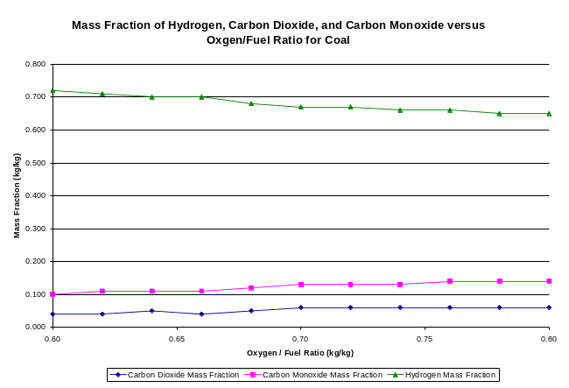

Gas Cleaning Requirements

To prevent corrosion of the gas turbine fins due to sulfur and alkaline metal salts, gas cleaning technologies are implemented. Current “wet” gas cleaning technologies not only increase investment and operation costs but place a demand of almost complete fuel to gas conversion due to the onset of reduction in the overall efficiency of the combined cycle [Cai, 2001]. Therefore, a hot gas technology termed the two-stage desulfurization process has been considered for the simulation of this project. This process consists of a fluidized bed reactor and a fixed bed reactor [Park, 2006]. For this project, limestone is used to remove sulfur dioxide as a bed material in the KRB circulating fluidized bed gasifier as the first step in the two gas cleaning process. In the second step zinc oxide is used to remove hydrogen sulfide in a fixed bed gasifier. All of the hydrogen sulfide was assumed to be removed based on the 1 to 1 molar ratio illustrated in the following reaction.

ZnO + H2S à ZnS + H2O
ZnO + COS à ZnS + CO2

Sulfur dioxide is removed by limestone in the second chemical reaction

CaO + ½ O2 + SO2 à CaSO4 + 486 kJ/g mol

Because the amount of sulfur dioxide removed is partially influenced by the reactivity of limestone, the reactivity based on “blank” was used to determine the actual amount of sulfur dioxide removed.

Table 1: Gas Cleaning Analysis
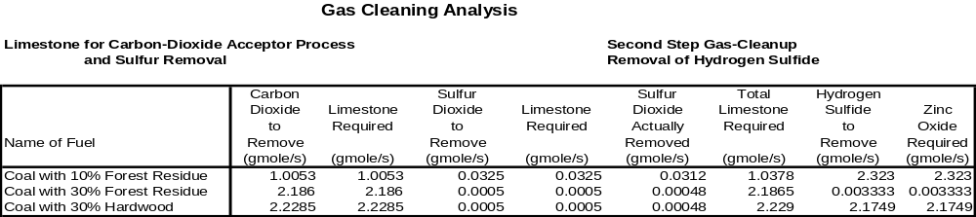

The above table show the values of sulfur dioxide remove. Based on the sulfur removed, the emissions in parts per million for the 10% Forest residue case is 22.4. The sulfur removed for both the 30% Forest residue and 30% hardwood case was 0.33 ppm.

The Gas Power Cycle

As stated previously, the gas turbine selected was a GE 7B gas turbine. The gas turbine operates with a firing temperature of 1533 K and has a pressure ratio of 13.5: 1. The compressor that is coupled with the gas turbine is an eight stage compressor. The gas turbine has been incorporated in each of the simulations to determine how much power can be generated by the steam turbine according to the thermodynamic conditions for each cycle. In GC Tool, the models that were used in the simulation for the gas power cycle was labeled “gas” (fuel input), “cp” (the compressor), “heater” (used as the combustor), and “gt” (the gas turbine). Each of these models had the c extension which was the function that accepted input from the gas stack and returned output onto the gas stack (see appendix D).

The Steam Cycle

The steam cycle comprised of the reheat cycle and the high and low pressure cycle for the heat recovery steam generator. Incorporating the reheat cycle has not only increased efficiency but it also allows the steam turbine to operate at peak load –nearly independent of the gas turbine. In the simulation the temperature of the cold side is set at 400.15 K for the reheat cycle. Because the reheat cycle is presumed to be connected to the heat exchanger of the gasifier and the fixed bed reactor (for gas clean-up), the enthalpy from the gasifier after 20 seconds (the time necessary to produce the minimum amount of hydrogen needed to power the gas turbines) was determined from the heat exchanger model in the gasifier simulation.

Since each heat recovery steam generator comprise of an economizer, evaporator, and super heater, three heat exchangers were set for both the low pressure and high pressure of the dual pressure heat recovery steam generator in the plant layout. In a heat recovery steam generator, water is heated until it reaches the saturated temperature at the pressure that is heated. The water is then circulated to a steam drum where water in the liquid state is separated from the water vapor. The evaporator evaporates the resulting steam at constant pressure and temperature. This steam is then superheated at a higher temperature at the given pressure and is directed towards the steam turbine. Because the exhaust gas from the gas turbine can only heat a limited amount of water to a desired temperature at a certain pressure, it is advantageous to recover heat from steam at multiple pressures. In addition to the heat exchanging sections that comprise an HRSG, are the pumps for the low pressure, the high pressure, and between the low pressure and high pressure sections. Because pressure is decreased by the low pressure and high pressure pumps, these pumps behave more like valves. However, the pump situated between the steam drum of the low pressure cycle and the economizer of the high pressure cycle, increases the pressure that dictates the high pressure cycle.

Conclusion

Given that the plant layout is partially configured based on the partial gasification combined cycle (50%), the efficiency of 51.6 seems approximately close to the actual efficiency. However, the scaling capacity of the gasifier would need to be examined more to determine the maximum amount of fuel that would be available for the gas turbine. The power output of the gas turbine was 92 MW although the GE 7FB gas turbine is capable of delivering 150 MW. However, the mass flow rate of the gas turbine was limited to 100 kg/s. The main loss in the plant configuration was the condenser which accounted for 33% of the energy. However, since hot gas clean-up was employed in place of amine scrubbers, the water was only cooled in the cycle once instead of twice as required by Integrated Gasification Combined Cycles using amine scrubbers and solvents such as Rectisol. Although other components and systems such as triple-pressure heat recovery steam generators and partial gasification could have been employed, capital and start-up cost was of concern given the required power output.

Cost Analysis of the Co-Gasification and Biomass Plant Configuration

The following equation was used to determine the cost of electricity:

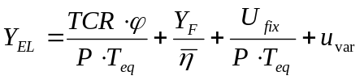

Where Y_{EL} is the cost of electricity in $/MWh , P is the power output in MW, T_{eq} is the equivalent time of plant operation in hours per year, 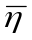 is the average efficiency of the plant, is the annuity factor, U_{fix} is the fixed operating cost of the plant, and u_{var} is the variable operating cost of the plant. The Total Capital Return (TCR) comprises of the purchase cost of all major equipment in the plant. For the 375 MW co-gasification plant this included the air separation unit (along with the O2 and N2 compression), the heat recover steam generator, coal handling, steam turbine and condenser, and particulate clean-up. Equipment for the 125 MW Biomass Plant, however, consisted of the tar cracker, char combustor, and quench system in addition to the gas and steam turbine and the heat recovery steam generator. Reference values for the 375 MW plant was taken from (Kruetz, 2005) while values for the 125 MW Biomass Plant was taken from the “Cost and Performance Analysis of Biomass-Based Integrated Gasification Combined-Cycle (BIGCC) Power Systems report. The annual operation time and the annuity factor was set at 7000 hours and 11.7 percent respectively for the 10% and 30% 375 MW plant and the 100% 125 MW plant with forest residue as the biomass fuel input. Based on the results both plants were comparatively low and were close to the cost of electricity per MWh for a typical IGCC plant. The 375 MW plant had a higher capital cost while the variable cost for the 125 MW plant was higher. Although the 100% biomass plant was lower in the cost of electricity for this case, it is not as feasible (in the long term) as the co-gasification plants since projections in population growth would demand more power output and thus more equipment to satisfy this demand. Raising the power output of the biomass to meet the power output of the co-gasification plant would make the make the option of 100% biomass three times higher than the cost of electricity for the co-gasification plants.

As for the total cost, the 125 MW biomass plant was lower than the co-gasification plants although the cost of logistics was significantly higher. However, as in the case of the cost per electricity, the total cost would be three times higher if the same power output of 375 MW was set in the 100% biomass case as in the co-gasification cases.

Energy Flow Diagrams and Carbon Life Cycle Analysis

Energy Flow Diagrams

After designing the power plants, the design team performed an energy balance on each of the individual processes (i.e. harvesting, transportation, processing, and utilization) in order to determine the flow of energy through the system (Figure E2 and Figure E3). The total amount of energy at the beginning of the energy flow diagram is the theoretical maximum amount of energy stored in Centre County’s woody biomass, which was determined previously to be 55 TBTU. This value was then input into the logistics and transportation process, and after taking into account all the losses and inefficiencies, it was determined that 49.6 TBTU of potential biomass energy was delivered to the power plants. In theory, the energy cost associated with logistics and transportation would depend on the power plant configuration. Because we only considered the logistics and transportation costs associated with biomass and not coal, the 100% biomass plant would be most expensive from this point of view, while the 10% biomass and 90% coal power plant would be least expensive. Therefore, the values indicated in our energy flow diagram are for the most conservative case (i.e 100% biomass plant)

Although it was determined that the energy associated with logistics and transportation would be the same for both power plants, the energy losses in the 100% biomass plant were different from those of the coal and biomass co-firing plant. Specifically, it was determined that of the 49.6 TBTU input into the plant, 26 TBTU of electricity would be delivered to consumers by the 100% biomass plant, while 28.6 TBTU would be delivered by the co-firing plant. Recall from before that it is expected that the energy demand of Centre County in 2037 will be approximately 18.6 TBTU. Therefore, for both plant scenarios, in particular the plant utilizing 100% biomass, sufficient electricity will be delivered to meet the areas demand 30 years in the future, while utilizing the local supply of biomass.

Carbon Life Cycle Analysis

Similarly, a CO₂ flow diagram was produced in much the same way as the energy flow diagram (Figure E4). In order for the diagram to make more sense, CO₂ production was normalized to energy production for the overall process. Only CO₂ production from non-neutral sources was expressly considered in the diagram. For instance, CO₂ production resulting from utilization of biomass was not considered, while that from combustion of coal and gasoline was. In light of this fact, one can understand why essentially zero CO₂ is output by the 100% biomass plant, while much more CO₂ is produced by the plant utilizing coal as well as from the transportation segment, which utilized gasoline and diesel. The small amount of CO₂ released by the 100% biomass plant is from small, unavoidable fossil fuel expenditures. Perhaps in the future a 100% carbon-neutral plant will be possible, but based on current research and technology, a small amount of non-neutral CO₂ production is practically inevitable.

APPENDIX A—Local Energy Demand and Biomass Availability

Table A1: Centre County Energy Usage in 2004 by Sector and Energy Resource (million BTU/year)
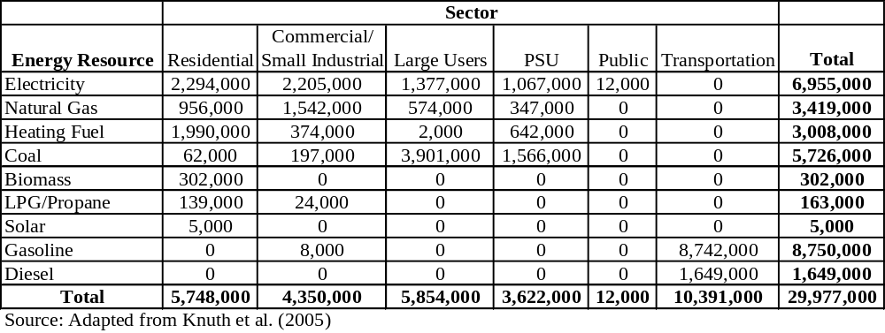

Table A2: Centre County Biomass Availability
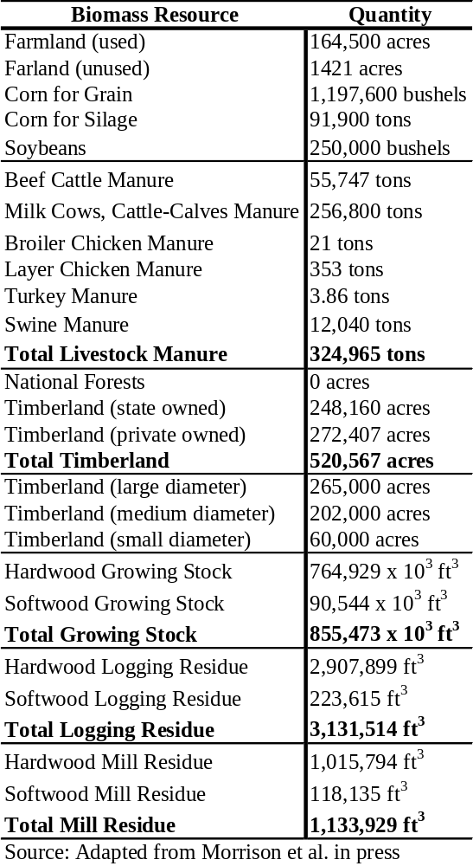

Table A3: Centre County Woody Biomass Availability
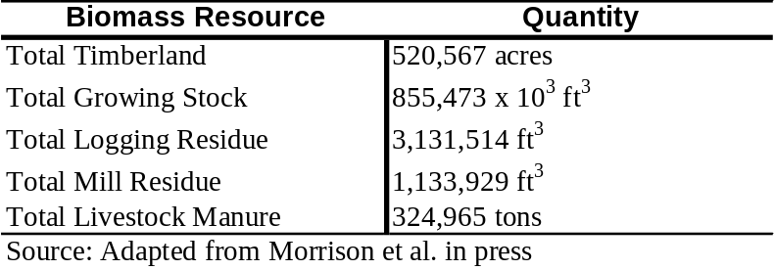

Table A4: Energy Content of Various Biomass Types
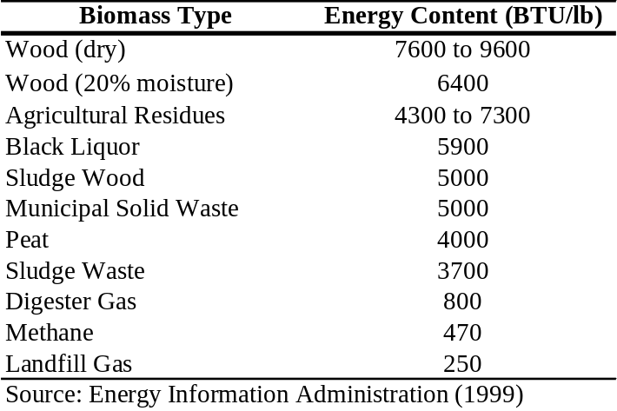

Table A5: Difference in Composition between Hardwoods and Softwoods
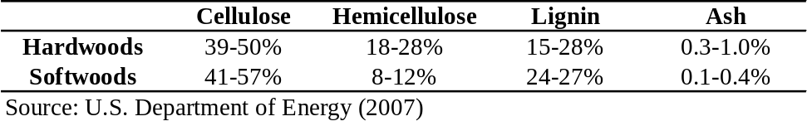

Figure A1: Centre County Energy Consumption in 2004 by Sector
Residential
19%
Commercial/
Small Industrial
15%
Large Users
20%
PSU
12%
Public
<1%
Transportation
34%

APPENDIX B—Supply and Logistics

Figure B1: Energy Consumption in Transportation
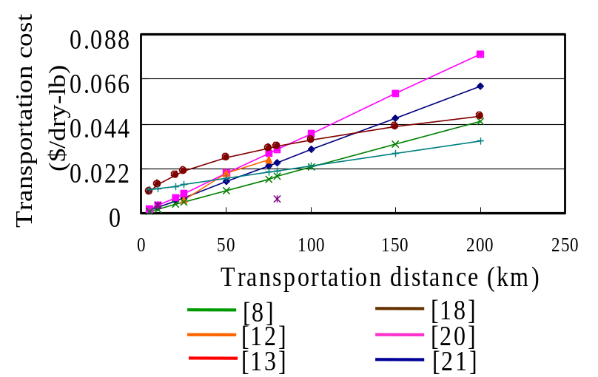

Figure B2: Proportion of Energy Consumption in Each Logistic Operation

(Comparison between forest residues and low-use wood)

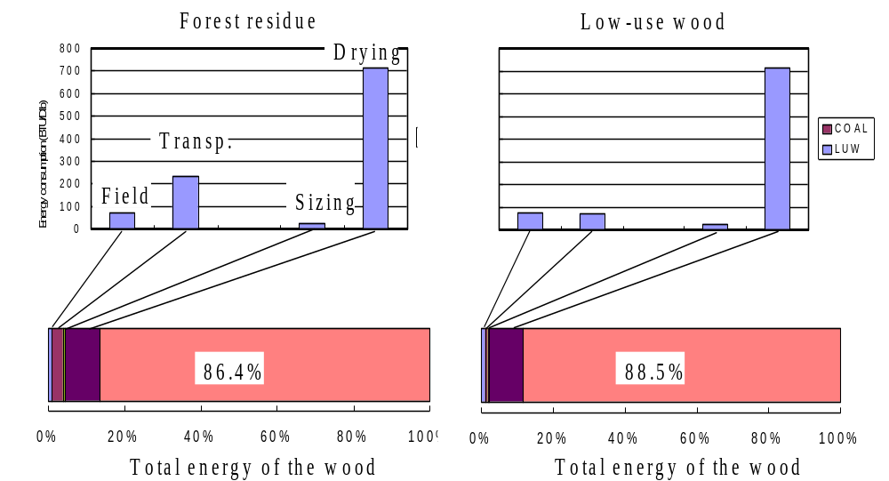

Figure B3: Proportion of Energy Consumption in Each Logistic Operation

(Comparison between forest residues and low-use wood)

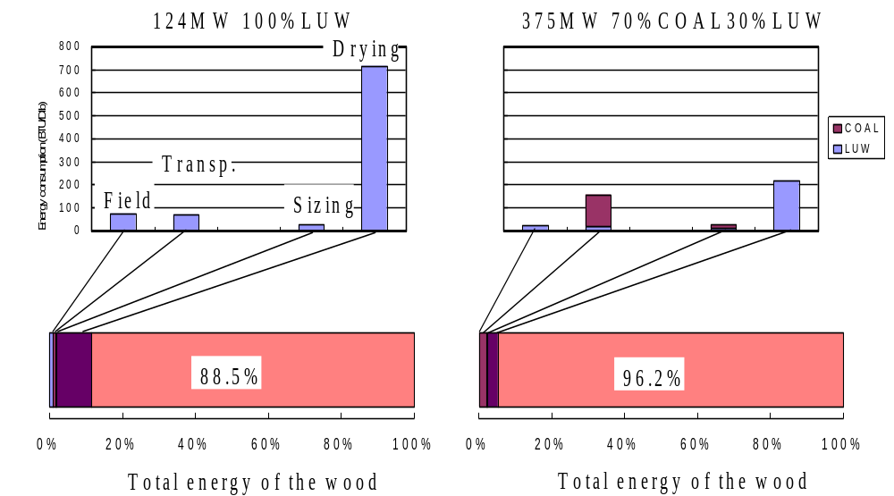

Figure B4: Total Energy Consumption in Logistics (Unit : BTU/dry-lb)
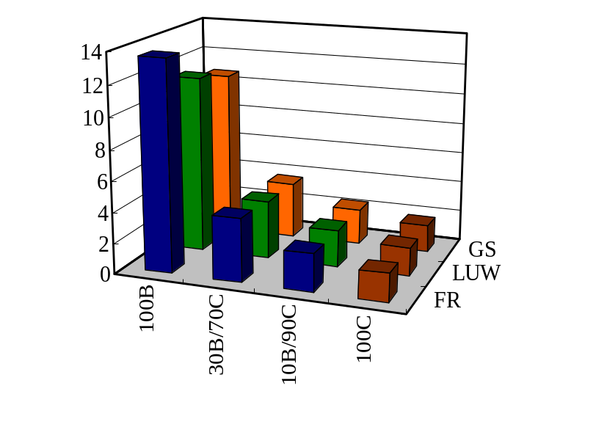

Figure B5: Total CO₂ emission in logistics (Unit : lbCO₂/dry-lb)
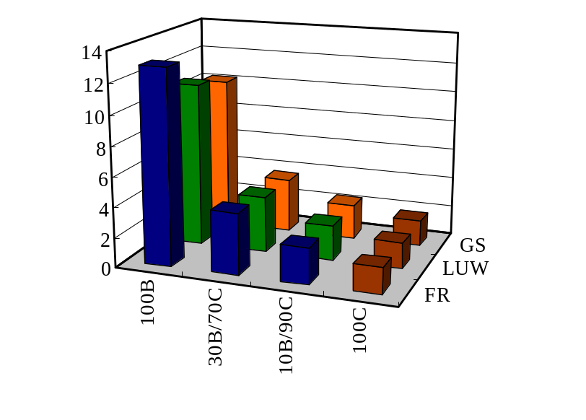

Figure B6: Sum of the Logistic Cost and Field Purchase Price (Unit : USD/MWh_{e}, Field Price: $2.2/MWh_{e} for forest residues, $4.5/MWh_{e} for low-use wood, $22.4/MWh_{e} for growing-stock,$11.5/MWh_{e} for coal)
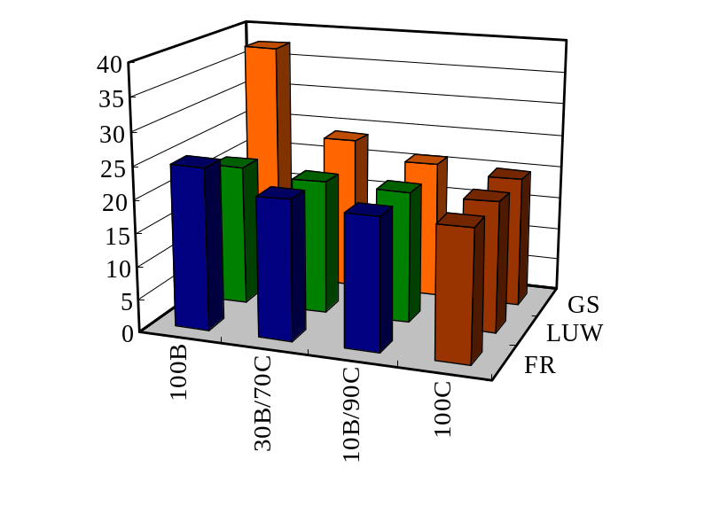

APPENDIX C—Utilization of 100% Biomass

Table C1: Parameters of IGCC based on an atmospheric, directly-heated, steam-blown, circulating, fluidized gasifier

Temperature | ~850ºC (gasifier)  ~1000ºC (char combustor)
Biomass feed to gasifier | 1669 T/day
Steam/wood (wt/wt) | 0.45
Sand/wood (wt/wt) | 21.2
Product gas composition  (dry basis, volume%) | 21.2% H₂, 43.1% CO, 13.4% CO₂, 15.8% CH₄, 5.4% C₂+, 0.4% Tar, and 0.08% H₂S
Output (MW) | 124
Gas turbine output (MW) | 71.6
Steam turbine output (MW) | 52.4
Efficiency (HHV) | 42.9%
Cost of electricity (¢/kWh) | 6.55
Emissions from IGCC
CO₂ (g/KWh) | 46
NO_{x} (g/KWh) | 0.7
SO_{x} (g/KWh) | 0.2

Figure C1: Relationship between various gasifiers: scale and efficiency for electricity production
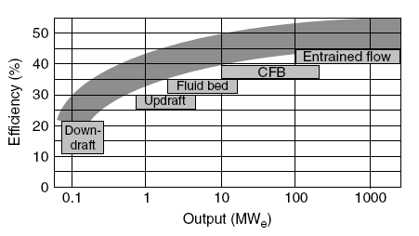

Figure C2: Schematic of a gas turbine

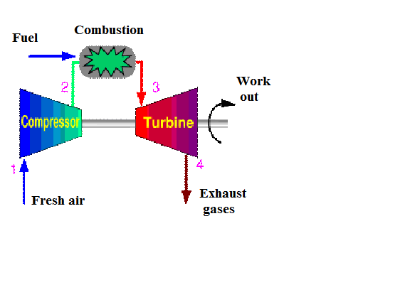
[http://en.wikipedia.org]

Figure C3: Schematic of a steam turbine consisting of three parts (high-pressure turbine, medium-pressure turbine, low-pressure turbine)

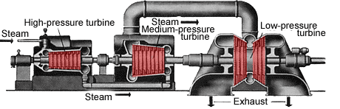
[http://library.thinkquest.org]

Figure C4: Scheme of IGCC for biomass utilization based on an atmospheric, indirectly-heated, steam-blown, circulating, fluidized-bed gasifier
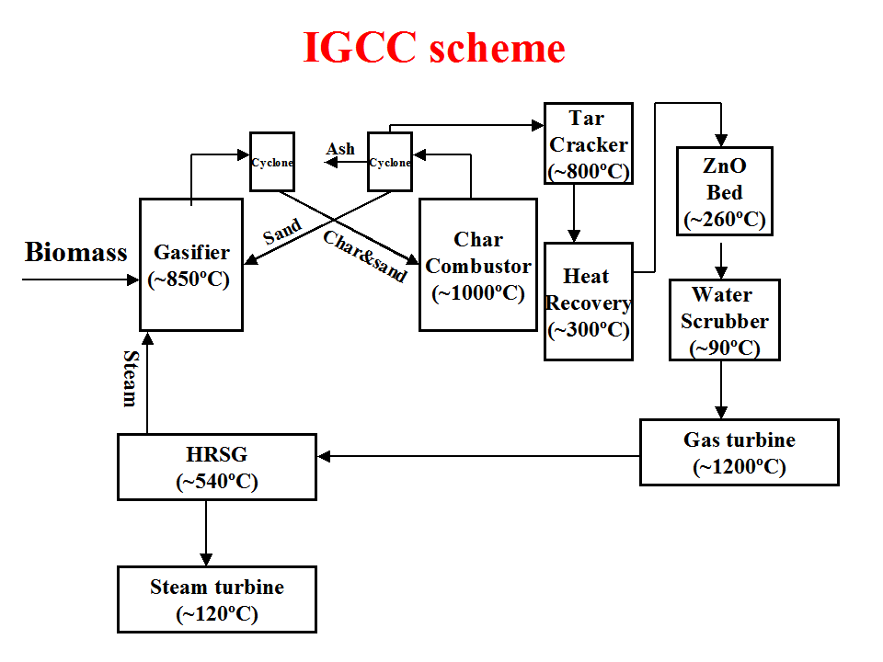

Figure C5: Energy and mass flow diagram for IGCC
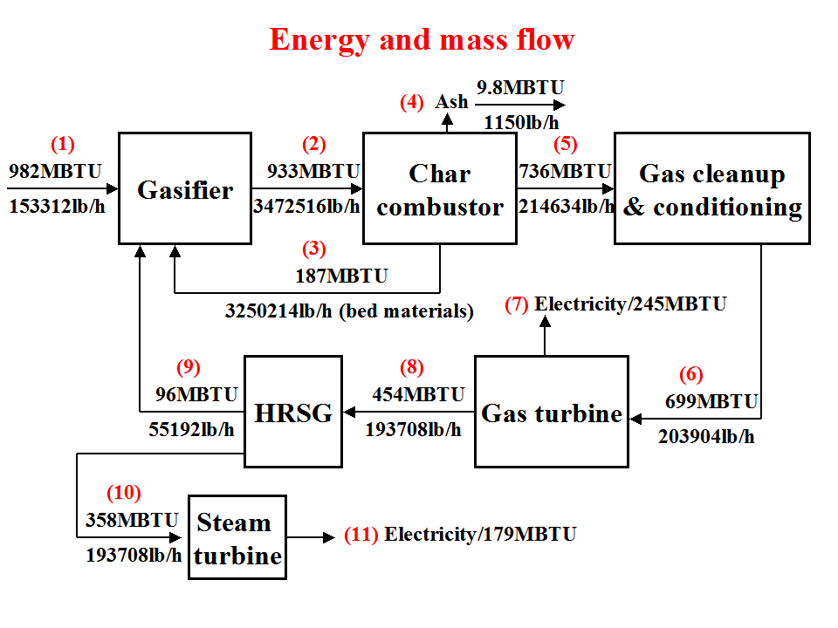

Figure C6: Energy distribution diagram of IGCC
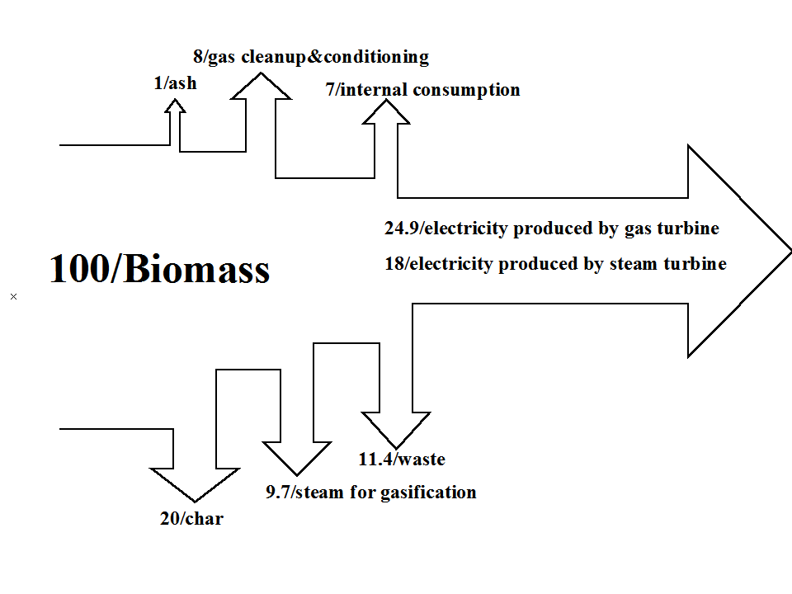

APPENDIX D—Utilization of Coal and Biomass

Table D1: Chemical Input and Balance for Gasifier and Gas Turbine

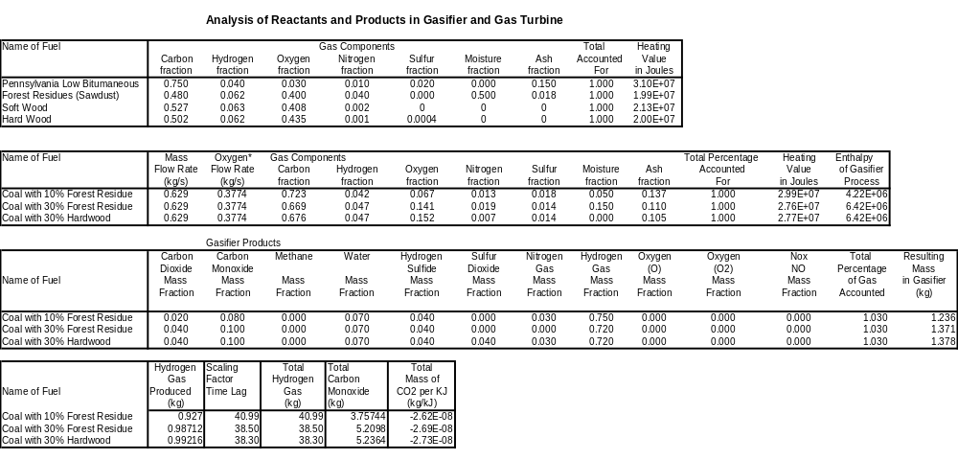
Figure D1: KBR Transport Reactor (Pressurized Circulating Fluidized Bed Gasifier)

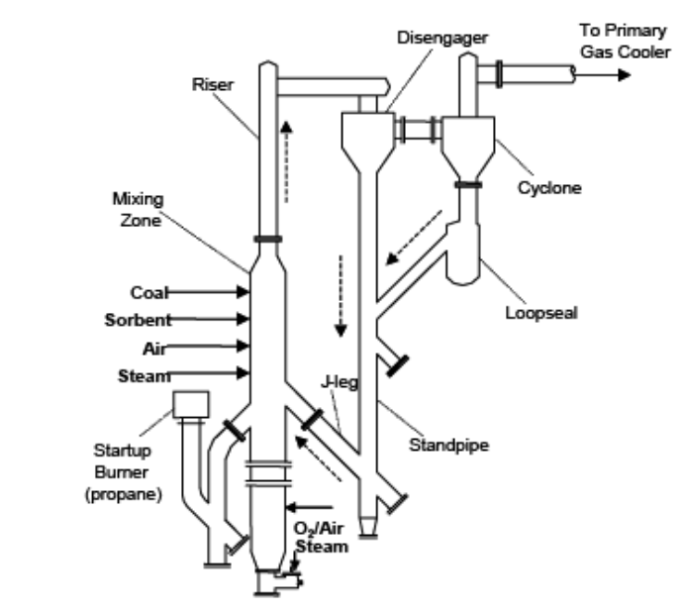
Specifications

Temperature Range of Operation:

1172.15- 1255.15 K

Maximum Pressure: 1.9 MPa

Mass Flow Rate Range:

1133kg/hr (.314kg/s) to
2594.75 kg/hr (.69 kg/s)

Carbon Conversion: 98%

[Nelson, 2003]

Figure D2: Gas Turbine Parameters

Gas Turbine of Choice: GE 7FB Series Gas Turbine

Pressure Ratio 13.5:1

Turbine Inlet Temperature: 2300 F 1533K

Power Output: 150 MW

Stack
HP Super heater

HP Evaporator
HP Economizer
LP Super heater
LP Evaporator
LP Economizer
Hot Gas
Cleaning
Fixed Bed
Gas Turbine and Generator
Compressor
HRSG 1
HRSG 2
Nitrogen as a NOx Diluents
Feed rate =1.371 kg/s (30% case)
Feed rate= 1.236 kg/s (10% case)
P=1.9MPa
T=850K for gasifier and fixed bed clean-up
Reheat Exchanger
T = 400K cold side
Firing Temperature 1533K
P=1atm
P = 1atm
T=871K
M = 100 kg/s
Mass flow water 51.2 kg/s
Mass flow rate of exhaust and flue gas : 100 kg/s
Pressure (atm) Temperature (K)
1. 46.80 768.1
2. 46.80 558.8
3. 48.68 558.8
4. 4.30 460.1
5. 4.30 420.1
6 . 4.30 420.1
1.
2.
3.
4.
5.
6.
7.
8.
9.
Pressure (atm) Temp. (K)
7. 4.30 419.9
48.68 300.3
46.80 553.4
P = 18.50 atm
T=402.8 K
M = 100 kg/s
P = .11 atm
T=311.1 K
Steam Turbine
G
G
G
Coal and Biomass
Limestone
Pressurized Circulating Fluidized Bed Gasifier
A.S.U
Deaerator
Condenser
Oxygen
Air
Steam
Reheater
Steam Drum
P = . 01 atm
T=280.5K
H Pressure P (end)= . 10 atm
T=319.2
L Pressure P (end)=.011
T = 311.1
Stack
Steam Turbine
G
G
G
HP Super heater

HP Evaporator
HP Economizer
LP Super heater
LP Evaporator
LP Economizer
Coal and Biomass
Limestone
Pressurized Circulating Fluidized Bed Gasifier
Hot Gas
Cleaning
Fixed Bed
A.S.U
Deaerator
Condenser
Gas Turbine and Generator
Compressor
HRSG 1
HRSG 2
Nitrogen as a NOx Diluent
Oxygen
Air
Steam
Reheater
Auxiliary Power Consumption of 6.749MW
Consume 29.746 MW
Produce 29.746 MW
Produce 161.9 MW
Consume 29.746 MW
Produce 196.80 MW
Loss 8.7 MW
Consume .030747MW
Steam Turbine:
HP 54.56 2MW
LP: 15.1 MW Reheat
26.057 LP Cycle
Input : 728.900 MW
Consumed: 60.7 MW
Loss: 291.5 MW
Power Produced: 376. 5 MW
Efficiency with Gasifier and Clean-up
51.4%
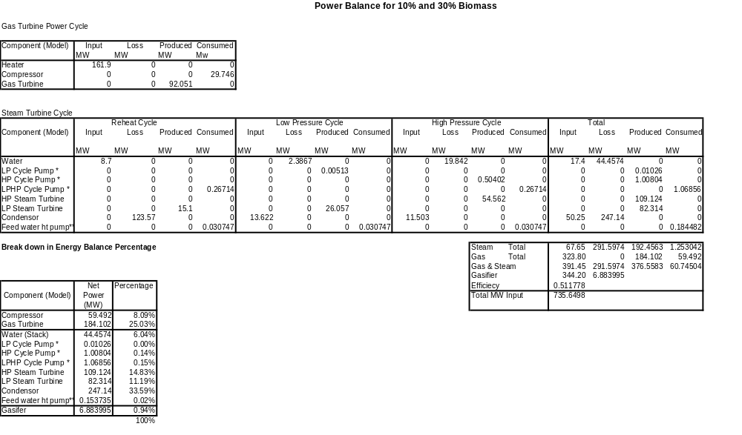

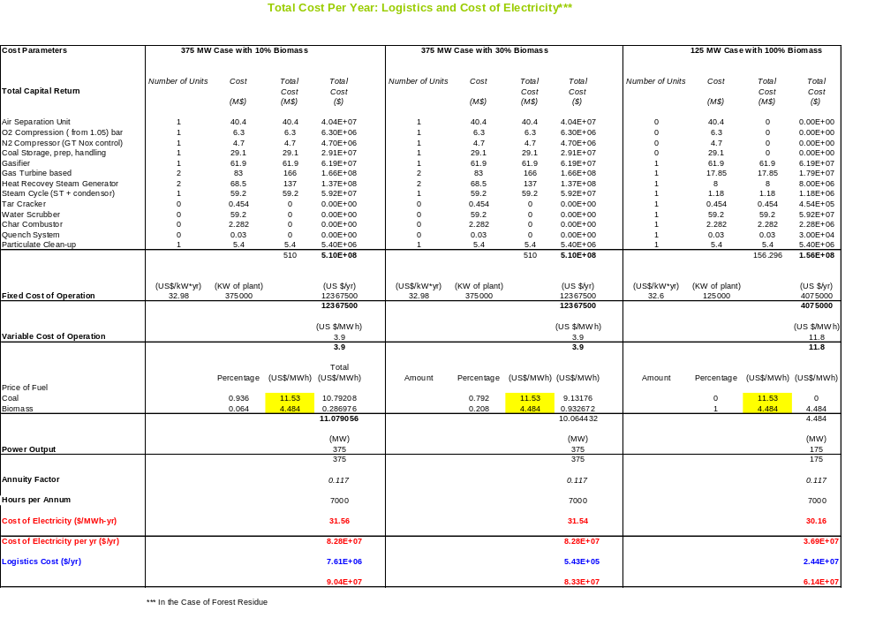

Simulation For Reheat Cycle and Output

modstack mods;
gas gas1={id="GAS"; t=300; p=1; m=100; comp[H2]=.19; comp[N2]=.64; comp[O2]=.12; comp[CO]=.06;};
cp cp1={pres=18.5; eff=0.90;};
ht ht1={temp=1533;};
gt gt1={pres=1; eff=0.90;};

gas gas_wat1={id="STM"; t=322.15; p=5.1; m=51.2;};

hx gt_hx={t_cold=400.15;},
gas1_hx={t_cold=400.15;},
rh_hx={t_cold= 400;},
hpsh_hx={t_cold=400;};

pump pump_hp={pres=46.50;};

ht ht_cond={temp=0.0; qual=0.0;};

gt hpst_gt={pres=.1; eff=0.88;},
lpst_gt={pres=.01; eff=0.88;};

sd sd_1;

gas1.c;cp1.c; ht1.c; gt1.c; gt_hx.h; hpsh_hx.h; rh_hx.h;gas1_hx.h;
gas_wat1.c; hpsh_hx.c; hpst_gt.c; rh_hx.c; lpst_gt.c; ht_cond.c; pump_hp.c; gas_wat1.cycl;

gass.print; mods.print;gass.mprint;pows.print;

output of model gastype flows

model temp pres mass enth entr dens vol qual
(K) (atm) (kg/s) (J/kg) (J/kg-K) (kg/m^3) (m^3/s)

gas1 300.0 1.00 1.000e+002 -3.127e+006 6.47e+003 1.33e+000 7.49e+001 1.00
cp1 402.8 18.50 1.000e+002 -2.828e+006 6.54e+003 1.63e+001 6.13e+000 1.00
ht1 1533.0 18.50 1.000e+002 -1.199e+006 8.57e+003 3.94e+000 2.54e+001 1.00
gt1 871.1 1.00 1.000e+002 -2.120e+006 8.70e+003 3.75e-001 2.67e+002 1.00
gt_hx.h 871.1 1.00 1.000e+002 -2.120e+006 8.70e+003 3.75e-001 2.67e+002 1.00
hpsh_hx.h 871.1 1.00 1.000e+002 -2.120e+006 8.70e+003 3.75e-001 2.67e+002 1.00
rh_hx.h 871.1 1.00 1.000e+002 -2.120e+006 8.70e+003 3.75e-001 2.67e+002 1.00
gas1_hx.h 871.1 1.00 1.000e+002 -2.120e+006 8.70e+003 3.75e-001 2.67e+002 1.00
gas_wat1 322.1 5.10 5.120e+001 -1.577e+007 4.21e+003 9.89e+002 5.18e-002 -0.21
hpsh_hx 400.0 5.10 5.120e+001 -1.544e+007 5.12e+003 9.38e+002 5.46e-002 -0.05
hpst_gt 319.2 0.10 5.120e+001 -1.547e+007 5.13e+003 5.37e-001 9.53e+001 0.13
rh_hx 400.0 0.10 5.120e+001 -1.323e+007 1.21e+004 5.49e-002 9.32e+002 1.06
lpst_gt 280.3 0.01 5.120e+001 -1.353e+007 1.22e+004 8.07e-003 6.35e+003 0.97
ht_cond 280.3 0.01 5.120e+001 -1.594e+007 3.62e+003 1.00e+003 5.12e-002 0.00
pump_hp 280.5 46.50 5.120e+001 -1.594e+007 3.63e+003 1.00e+003 5.11e-002 -0.66
gas_wat1.cycl 280.5 46.50 5.120e+001 -1.594e+007 3.63e+003 1.00e+003 5.11e-002 -0.66

output of species molar flow rates(gmol/s) and mole fractions(%)

gas1 CO2=241.27 6 CH4=10.487 0 H2=0.0109 0 H2O=106.13 3 N2=2685.5 72 H2Oc=670.13 18
total=3713.49
cp1 CO2=241.32 6 CH4=10.444 0 H2=0.1841 0 H2O=489.15 13 N2=2685.5 72 H2Oc=287.02 8
total=3713.57
ht1 CO=18.813 1 CO2=232.95 6 H=0.0021 0 H2=23.147 1 H2O=774.09 21 OH=0.0022 0
N2=2685.5 72 NO=0.0003 0 total=3734.4623
gt1 CO=4.4909 0 CO2=247.27 7 H2=37.469 1 H2O=759.78 20 N2=2685.5 72 t

Simulation for High Pressure Cycle and Output

modstack mods;
gas gas1={id="GAS"; t=300; p=1; m=100; comp[H2]=.19; comp[N2]=.64; comp[O2]=.12; comp[CO]=.05;};
cp cp1={pres=18.5; eff=0.90;};
ht ht1={temp=1533;};
gt gt1={pres=1; eff=0.90;};

gas gas_wat1={id="STM"; t=300; p=5.1; m=51.26;};

hx gt_hx={t_cold=753.15;},
hpecon_hx={t_cold=558.75;},
hpevap_hx={t_cold=558.75;},
hpsh_hx={t_cold=768.15;};

sd sd_2;

pump pump_lp={pres=4.3;},
pump_hp={pres=46.80;},
pump_fwh={pres=5.1;},
pump_lphp={pres=48.68;};

ht ht_cond={temp=0.0; qual=1.0;};

fh fh_1;

gt hpst_gt={pres=.1; eff=0.88;};

gas1.c; cp1.c; ht1.c; gt1.c; gt_hx.h; hpsh_hx.h;
gas_wat1.c; pump_lphp.c; hpecon_hx.c; pump_hp.c; hpevap_hx.c; hpsh_hx.c; hpst_gt.c;ht_cond.c; fh_1.h; pump_fwh.c; gas_wat1.cycl;
gass.print; mods.print; gass.mprint; pows.print;

output of model gastype flows

model temp pres mass enth entr dens vol qual
(K) (atm) (kg/s) (J/kg) (J/kg-K) (kg/m^3) (m^3/s)

gas1 300.0 1.00 1.000e+002 -3.092e+006 6.46e+003 1.34e+000 7.47e+001 1.00
cp1 402.5 18.50 1.000e+002 -2.795e+006 6.53e+003 1.64e+001 6.10e+000 1.00
ht1 1533.0 18.50 1.000e+002 -1.176e+006 8.56e+003 3.94e+000 2.54e+001 1.00
gt1 868.2 1.00 1.000e+002 -2.096e+006 8.68e+003 3.76e-001 2.66e+002 1.00
gt_hx.h 868.2 1.00 1.000e+002 -2.096e+006 8.68e+003 3.76e-001 2.66e+002 1.00
hpsh_hx.h 868.2 1.00 1.000e+002 -2.096e+006 8.68e+003 3.76e-001 2.66e+002 1.00
gas_wat1 300.0 5.10 5.126e+001 -1.586e+007 3.91e+003 9.97e+002 5.14e-002 -0.25
pump_lphp 300.3 48.68 5.126e+001 -1.585e+007 3.91e+003 9.99e+002 5.13e-002 -0.63
hpecon_hx 558.8 48.68 5.126e+001 -1.309e+007 9.65e+003 2.28e+001 2.25e+000 1.05
pump_hp 553.4 46.80 5.126e+001 -1.310e+007 9.65e+003 2.21e+001 2.32e+000 1.04
hpevap_hx 558.8 46.80 5.126e+001 -1.308e+007 9.68e+003 2.17e+001 2.36e+000 1.06
hpsh_hx 768.1 46.80 5.126e+001 -1.255e+007 1.05e+004 1.39e+001 3.69e+000 1.38
hpst_gt 319.2 0.10 5.126e+001 -1.361e+007 1.10e+004 7.61e-002 6.73e+002 0.91
ht_cond 319.2 0.10 5.126e+001 -1.339e+007 1.17e+004 6.90e-002 7.43e+002 1.00
fh_1.h 309.2 0.10 5.126e+001 -1.582e+007 4.03e+003 9.94e+002 5.16e-002 0.00
pump_fwh 309.3 5.10 5.126e+001 -1.582e+007 4.04e+003 9.94e+002 5.16e-002 -0.23
gas_wat1.cycl 309.3 5.10 5.126e+001 -1.582e+007 4.04e+003 9.94e+002 5.16e-002 -0.23

Simulation for Low Pressure Cycle and Output

modstack mods;
gas gas1={id="GAS"; t=300; p=1; m=100; comp[H2]=.19; comp[N2]=.64; comp[O2]=.12; comp[CO]=.05;};
cp cp1={pres=18.5; eff=0.90;};
ht ht1={temp=1533;};
gt gt1={pres=1; eff=0.90;};

gas gas_wat1={id="STM"; t=300; p=5.1; m=51.26;};

hx gt_hx={t_cold=753.15;},
lpecon_hx={t_cold=420.15;},
lpevap_hx={t_cold=420.15;},
lpsh_hx={t_cold=460.15;};

sd sd_1, sd_2;

pump pump_lp={pres=4.3;},
pump_hp={pres=46.80;},
pump_fwh={pres=5.1;};

ht ht_cond={temp=0.0; qual=1.0;};

fh fh_1;

gt lpst_gt={pres=.11; eff=0.88;},
hpst_gt={pres=1; eff=0.88;};

gas1.c;cp1.c; ht1.c; gt1.c; gt_hx.h; lpsh_hx.h;
gas_wat1.c; lpecon_hx.c; sd_1.c; pump_lp.c; lpevap_hx.c; lpsh_hx.c; lpst_gt.c; ht_cond.c; fh_1.h; pump_fwh.c; gas_wat1.cycl;
gass.print; mods.print; gass.mprint; pows.print;

output of model gastype flows

model temp pres mass enth entr dens vol qual
(K) (atm) (kg/s) (J/kg) (J/kg-K) (kg/m^3) (m^3/s)

gas1 300.0 1.00 1.000e+002 -3.092e+006 6.46e+003 1.34e+000 7.47e+001 1.00
cp1 402.5 18.50 1.000e+002 -2.795e+006 6.53e+003 1.64e+001 6.10e+000 1.00
ht1 1533.0 18.50 1.000e+002 -1.176e+006 8.56e+003 3.94e+000 2.54e+001 1.00
gt1 868.2 1.00 1.000e+002 -2.096e+006 8.68e+003 3.76e-001 2.66e+002 1.00
gt_hx.h 868.2 1.00 1.000e+002 -2.096e+006 8.68e+003 3.76e-001 2.66e+002 1.00
lpsh_hx.h 868.2 1.00 1.000e+002 -2.096e+006 8.68e+003 3.76e-001 2.66e+002 1.00
gas_wat1 300.0 5.10 5.126e+001 -1.586e+007 3.91e+003 9.97e+002 5.14e-002 -0.25
lpecon_hx 420.1 5.10 5.126e+001 -1.535e+007 5.33e+003 9.20e+002 5.57e-002 -0.01
sd_1 420.1 5.10 5.126e+001 -1.535e+007 5.33e+003 9.20e+002 5.57e-002 -0.01
pump_lp 419.9 4.30 5.126e+001 -1.535e+007 5.33e+003 7.67e+002 6.69e-002 0.00
lpevap_hx 420.1 4.30 5.126e+001 -1.323e+007 1.04e+004 2.34e+000 2.19e+001 1.00
lpsh_hx 460.1 4.30 5.126e+001 -1.314e+007 1.06e+004 2.11e+000 2.43e+001 1.04
lpst_gt 321.1 0.11 5.126e+001 -1.365e+007 1.08e+004 8.49e-002 6.04e+002 0.89
ht_cond 321.1 0.11 5.126e+001 -1.338e+007 1.16e+004 7.55e-002 6.79e+002 1.00
fh_1.h 311.1 0.11 5.126e+001 -1.581e+007 4.06e+003 9.93e+002 5.16e-002 0.00
pump_fwh 311.1 5.10 5.126e+001 -1.581e+007 4.06e+003 9.93e+002 5.16e-002 -0.23
gas_wat1.cycl 311.1 5.10 5.126e+001 -1.581e+007 4.06e+003 9.93e+002 5.16e-002 -0.23

APPENDIX E: Group Work

Figure E1: Biomass Team Concept Map

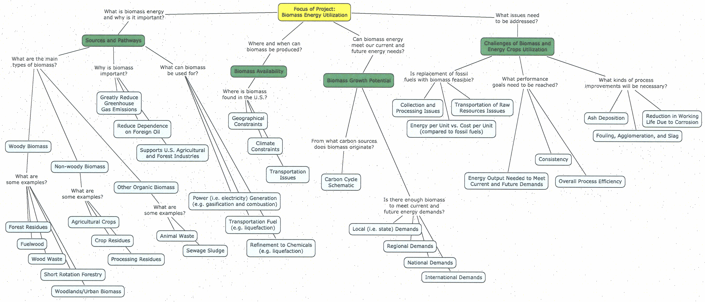

Figure E2: Energy Flow Diagram for 100% Biomass Power Plant
Logging Residue
(0.2 TBTU)
Hardwood Growing Stock
(54.8 TBTU)
Local Biomass
Available (
55 TBTU
)
Losses between
Harvesting and the
Plant (
13.6 TBTU
)
Field Operations (0.5 TBTU)
Baling (0.5 TBTU)
Transportation (0.2 TBTU)
Chipping (0.2 TBTU)
Drying (4.0 TBTU)
55 TBTU
49.6 TBTU

Losses in the Plant
(
23.6 TBTU
)
Ash (0.4 TBTU)
Char (8.3 TBTU)
Steam (4.0 TBTU)
Waste (4.7 TBTU)
Internal Consumption (2.9 TBTU)
Electricity Delivered
(
26 TBTU
)
Gas Cleanup & Conditioning (3.3 TBTU)

Figure E3: Energy Flow Diagram for Coal and Biomass Power Plant
Losses in the Plant
(
21 TBTU
)
Gasifier
(0.8 TBTU)
Gas Turbine (0.2 TBTU)
Steam Turbine (0.1 TBTU)
Condenser (16.5 TBTU)
Stack (3.3 TBTU)
Electricity Delivered
(
28.6 TBTU
)
HRSG (0.1 TBTU)
Logging Residue
(0.2 TBTU)
Hardwood Growing Stock
(54.8 TBTU)
Local Biomass
Available (
55 TBTU
)
Losses between
Harvesting and the
Plant (
13.6 TBTU
)
Field Operations (0.5 TBTU)
Baling (0.5 TBTU)
Transportation (0.2 TBTU)
Chipping (0.2 TBTU)
Drying (4.0 TBTU)
55 TBTU
49.6 TBTU

Figure E4: CO₂ Flow Diagram for All Power Plant Scenarios

Logistics &
Transportation
100% Biomass Plant
55 TBTU
30% Biomass Plant
10% Biomass Plant
2.9
lb CO
2
/BTU
49.6 TBTU
0.13
lb CO
2
/BTU
0.34 x 10
-
8
lb CO
2
/BTU
0.13
lb CO
2
/BTU

References

Badger, P. C., (2002) "Processing cost analysis for biomass feedstocks" ORNL/TM-2002/199 report.

Balat, M., G. Ayar, (2005). "Biomass Energy in the World, Use of Biomass and Potential Trends." Energy Sources 27: 931-940.

Belgiorno, V., G. De Feo, et al. (2003). "Energy from gasification of solid wastes." Waste Management 23(1): 1-15.

Bingyan, X., W. Chuangzhi, et al. (1992). "Kinetic-Study on Biomass Gasification (a 1991 Ises Solar World Congress Honors Paper)." Solar Energy 49(3): 199-204.

Borjesson, P., Gustavsson, L., (1996). "Biomass transportation," Renewable Energy 9: 1033-1036.

Brammer J. G., Bridgwater, A. V., (1999). "Drying technologies for an integrated gasification bio-energy plant" Renewable & Sustainable Energy Reviews 3: 243-289.

Bridgwater, A. V. (1995). "The Technical and Economic-Feasibility of Biomass Gasification for Power-Generation." Fuel 74(5): 631-653.

Bridgwater, A. V. (2003). "Renewable fuels and chemicals by thermal processing of biomass." Chemical Engineering Journal 91(2-3): 87-102.

Bridgwater, T. (2006). "Biomass for energy." Journal of the Science of Food and Agriculture 86(12): 1755-1768.

Cai, N., T. Yu, et al. (2001). "Thermal performance study for the coal-fired combined cycle with partial gasification and fluidized bed combustion." Proceedings of the Institution of Mechanical Engineers Part a-Journal of Power and Energy 215(A4): 421-427.

Caputo, A. C., Palumbo, M.et al. (2005). "Economics of biomass energy utilization in combustion and gasification plants: effects of logistic variables" Biomass & Bioenergy 28: 35-51.

Cocco, D., Deiana, P. et al. (2006). "Performance evaluation of small size externally fired gas turbine (EFGT) power plants integrated with direct biomass dryers" Energy 31: 1459-1471.

Corella, J., J. M. Toledo, et al. (2006). "Steam gasification of coal at low-medium (600-800ºC) temperature with simultaneous CO₂ capture in fluidized bed at atmospheric pressure: The effect of inorganic species. 1. Literature review and comments." Industrial & Engineering Chemistry Research 45(18): 6137-6146.

Craig, K., M. Mann. Ciferno, (1996). “Cost and Performance Analysis of Biomass-Based Integrated Gasification Combined-Cycle (BIGCC) Power Systems” D. O. E. National Energy Technology Laboratory.

Dasappa, S., P. J. Paul, et al. (2004). "Biomass gasification technology - a route to meet energy needs." Current Science 87(7): 908-916.

Davidsson, K. O., L. E. Amand, et al. (2007). "Potassium, chlorine, and sulfur in ash, particles, deposits, and corrosion during wood combustion in a circulating fluidized-bed boiler." Energy & Fuels 21(1): 71-81.

De Jong, W. B., J. Andries, et al. (1999). "Coal/biomass co-gasification in a pressurised fluidised bed reactor." Renewable Energy 16(1-4): 1110-1113.

DeMol, R. M., Jogems, M. A. H. et al. (1997). "Simulation and optimization of the logistics of biomass fuel collection" Netherlands Journal of Agricultural Science 45: 217-226.

Dornburg, V., Faaij, A., (2001). "Efficiency and economy of wood-fired biomass energy systems in relation to scale regarding heat and power generation using combustion and gasification technologies" Biomass & Bioenergy 21: 91-108.

Energy Information Administration. (2007). "Annual Energy Outlook"
<http://www.eia.doe.gov/oiaf/aeo/pdf/trend_5.pdf>

Forsberg, G.., (2000) "Biomass energy transport - Analysis of bioenergy transport chains using life cycle inventory method" Biomass & Bioenergy 19: 17-30.

Gil, J., J. Corella, et al. (1999). "Biomass gasification in atmospheric and bubbling fluidized bed: Effect of the type of gasifying agent on the product distribution." Biomass & Bioenergy 17(5): 389-403.

Goldstein, N. (2006). "Woody biomass as renewable energy source." BioCycle 47(11): 29-31.

Hall, P., Gigler, J. et al. (2001). "Delivery systems of forest arisings for energy production in New Zealand" Biomass & Bioenergy 21: 391-399.

Hauserman, W. B. (1997). "Relating catalytic coal or biomass gasification mechanisms to plant capital cost components." International Journal of Hydrogen Energy 22(4): 409-414.

IEA Bioenergy Task 29. (2007). Educational Web Site on Biomass and Bioenergy. http://www.aboutbioenergy.info

Judd, F. (2006)., ""Wood to Energy": The Governors Task Force for Low-Use Hardwoods" 6th Goddard conference, http://woodpro.cas.psu.edu/Goddard%20Forum.htm

Junginger, M., Faaij, A. et al. (2001). "Fuel supply strategies for large-scale bio-energy projects in developing countries. Electricity generation from agricultural and forest residues in Northeastern Thailand" Biomass & Bioenergy 21: 259-275.

Klass, D. L. (1998). Biomass for Renewable Energy, Fuels, and Chemicals. San Diego, Academic Press.

Knuth, S., W. Jennifer, et al. (2005). “Centre County Community Energy Project. Phase I Report: Baseline Energy Consumption in Centre County.”

Korpilahti, A., (1998). "Finnish forest energy systems and CO₂ consequences" Biomass & Bioenergy 15: 293-297.

Kruetz, T., R. Williams, et al. (2005). “Co-production of hydrogen, electricity and CO₂ from coal with commercially ready technology. Part B: Economic analysis.”International Journal of Hydrogen Energy 30:769-784.

Kumar, A., Cameron, J. B. et al. (2003). "Biomass power cost and optimum plant size in western Canada" Biomass & Bioenergy 24: 445-464.

Lee, S. (1996). Alternative Fuels. New York, Taylor and Francis.

Maciejewska, H., Sanders, J. et al. (2006). "Co-firing of biomass with coal: Constraints and role of biomass pre-treatment" EUR 22461 EN - DG JRC - IE report.

McClintock, P., (2005). "Maryland CO₂ Emissions from Power Plants," Maryland Department of Natural Resources PPRP-136 report.

Nelson, J. Matthew, Roxann Leonard, Guohai Liu, W. Peng, D. Romans, P. Vimalchand , Peter V. Smith, James Longanbach, “Low-rank coal gasification studies at the PSDF”, Eighteenth Low-Rank Fuels Symposium, Session 2B - Gasification June 24-26, 2003, Billings, Montana.

Park, N. K., D. H. Lee, et al. (2006). "Two-stage desulfurization process for hot gas ultra cleanup in IGCC." Fuel 85(2): 227-234.

Ragauskas, A. J., K. Charlotte, et al. (2006). "The Path Forward for Biofuels and Biomaterials." Science 25(2): 484-489.

Ray, C., (2007). "Pennsylvania Low-Use Wood Potential" 7th Goddard conference, <http://www.outreach.psu.edu/C&I/goddard/downloads.html>

Sami, M., K. Annamalai, and M. Wooldridge. (2001). “Co-firing of coal and biomass fuel blends.” Progress in Energy and Combustion Science 27:171-214.

SNB Wood Co-op Ltd., Stumpage (2003). <http://www.snbwoodcoop.com/markets/Stumpage.html>

Sperling’s Best Places. (2007). Informational website providing statistical data on America’s cities and towns. <http://www.bestplaces.net/>

Timber Mart-South Inc., "Wood and Log Volume Conversion Factors" <http://members.aol.com/JOSTNIX/convert.htm>

United States. (2007). Census Bureau. <http://www.census.gov>

United States Department of Agriculture (2001). Report <http://www.fs.fed.us/ne/newtown_square/publications/technical_reports/pdfs/2001/gtrne286.pdf>

United States. Department of Agriculture (USDA). (2007). "Census of Agriculture Quick Stats: State and County Data. " <http://www.nass.usda.gov>

United States. Department of Energy (DOE). (2007). "Energy Efficiency and Renewable Energy." Biomass Program. <http://www1.eere.energy.gov/biomass>

United States. Department of Energy (DOE) and Department of Agriculture (USDA). (2005). "Biomass as Feedstock for a Bionergy and Biproducts Industry: The Technical Feasibility of a Billion-Ton Annual Supply."

Valero, A., S. Uson, (2006). "Oxy-co-gasification of coal and biomass in an integrated gasification combined cycle (IGCC) power plant." Energy 31(10-11): 1643-1655.

Widiyanto, A., K. Seizo, et al. (2003). "Environmental Impact of Fossil Fuel Fired Co-Generation Plants Using a Numerically Standardized LCA Scheme. " Journal of Energy Resources Technology 125: 9-16.

Wihersaari, M., (2005). "Evaluation of greenhouse gas emission risks from storage of wood residue" Biomass & Bioenergy 28: 444-453.

Wihersaari, M., (2005). "Greenhouse gas emissions from final harvest fuel chip production in Finland" Biomass & Bioenergy 28:. 435-443.

Zhao, Y. H., W. Hao, et al. (2006). "Conceptual design and simulation study of a co-gasification technology." Energy Conversion and Management 47(11-12): 1416-1428.

