Theme 2. Individual Research Investigation

Class : EGEE 520
Name : Hyun Jae Kim

Research Topic : Heat Exchanger with Cooling Fins

1. Introduction

Heat exchangers are commonly used in many fields of industry, which are composed of finned surfaces for dissipation of heat by convection and conduction. The calculation of heat transfer of a cooling fin in heat exchanger system is the good practical application of heat transfer. Such fins are used to increase the cooling area of system available for heat transfer between metal walls and conducting fluid such as gases and liquids.
Heat transfer is defined as the movement of energy due to a temperature difference. It is characterized by the following three mechanisms: conduction, convection and radiation. Conduction is heat transfer by diffusion in a stationary medium due to a temperature gradient. The medium can be a solid or a liquid. Convection is heat transfer between either a hot surface and a cold moving fluid or a cold surface and a hot moving fluid. It is heat transfer by mass motion of a fluid such as air or water when the heated fluid is caused to move away from the source of heat, carrying energy with it. Convection above a hot surface occurs because hot air expands, becomes less dense, and rises. Radiation is heat transfer between the surfaces of different temperature via electromagnetic waves. In a chemical process, the reactor at hot temperature is cooled using cooling fins. The coolant is the surrounding air. Heat transfer in heat exchanger is dominated by convection from the surfaces, although the conduction within the fin may also influence on the performance. A convenient method to treat convection cooling is to use heat transfer coefficients, h.

The object of this study is to analyze the heat exchanging fins and to show the effects of convection and radiation in heat transfer model on a catalytic reactor with 1-, 2- Dimensional model.

2.1~2.2. Governing Equation and formulation

A system is catalytic reactor with heat exchanging fins (Fig.1), which is a monolithic bed reactor for autothermal reaction (ATR). As the reactant gas is introduced into the monolythic ATR reactor, the reaction occurs along the monolith, but the temperature in the reactor is not uniform. The temperature of inlet end rises rapidly, and then gradually decreases. (in Fig. 1, Sheldon H.D. Lee et al, Hydrogen from natural gas, International Journal of Hydrogen Energy, 30, 2005, 829-842)
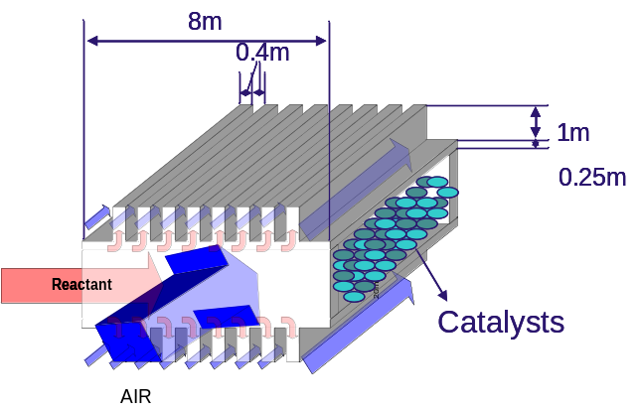
Fig. 1. 3-D Reactor Design

The temperature of reactor depends on the flow rate and composition of reactant like above diagram. In my model, the temperature at the inlet end of catalytic processor is 450℃, and it is increased rapidly to 680℃ and cooled down to 500℃. The temperature of reactor surface and the temperature profile of fin can be estimated by simulation using FEMLab.

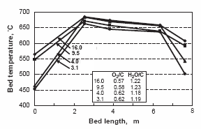
Fig. 2. Temperature profile in the reactor bed (From Sheldon H.D. Lee’s paper)

Model Background
A 2D profile of a heat exchanger will be modeled (Fig.3). This example models time independent (steady state) heat transfer. Reactant gas enters the catalytic reactor path and heat transfer in the stainless steel profile is studied. Due to symmetry, I only have to model one of the walls. The wall thickness and the length of the heat exchanger are 0.25m and 8m, respectively. The dimensions of fins are 0.4*0.4m. During operation, the temperature inside the wall is maintained. The heat is conducted within the fins and then transferred to the surrounding air. As the air is heated, buoyancy effects cause heat to transport upward by heated air which rises (natural convection heat transfer) or heat sweep to right by forced stream of air (forced convection heat transfer)

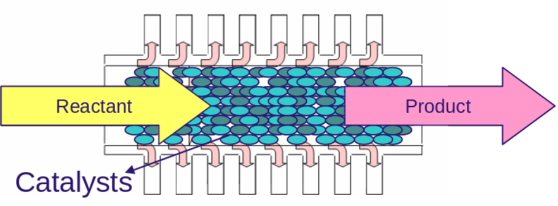
Fig. 3. 2-D schematic diagram of reactor

Subdomain and Boundary condition
The heat transfer in the profile is described according to the equation for steady-state heat conduction in a solid. (with no internal heat sources)
The heat transfer within the fin is governed by the stationary heat equation.
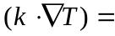0
Where k is thermal conductivity, and T is temperature.
On the external boundaries of the fin, which face the air, heat convection term is added.
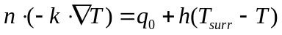 (z direction)
Where n is the normal vector of the boundary, h is the heat transfer coefficient and T_{surr} is the temperature of the surrounding. The term on the right side of the above equation is the Newton’s law of cooling. The value for the heat transfer coefficient at the side of reactor is approximated with a 10 Wm⁻²K⁻¹, since the fluid velocity is close to constant and the temperature of the fluid is assumed to decrease only slightly. The ranges of h on the surface of the wall are varied from 10 to 500 Wm⁻²K⁻¹ for forced convection in air. For forced convection, the fluid motion is caused by mechanical means such as pumps and fans. In this system, the heat transfer coefficient is defined as a constant for a convenience of calculation.

- Surrounding - T_{surr}=25℃
- Material Properties
Material | k[Wm⁻¹K⁻¹] | [kgm⁻³] | 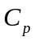[Jkg⁻¹K⁻¹]
Steel AISI 4340 | 44.5 | 7850 | 460

- Boundary Condition
On the external boundaries of the wall is also governed by below equation.
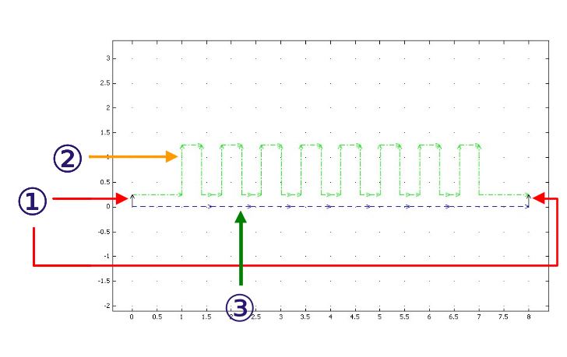
Fig. 4. 2-D Image of Reactor wall and boundary Condition
(Black-BC1, green-BC2 and blue-BC3)

Boundary condition | ①Heat Flux | ②Heat Flux | ③Temperature
q₀ (Inward Heat Flux) | 0 | 0
h (heat transfer coeff)  (Wm⁻²K⁻¹) | 10  (Natural convection) | 150  (Forced convection)
T_{inf}(K) (External Temperature) | 298.15 | 298.15
Const (Problem-dependent) | 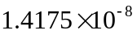  (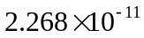) | ()
T_{amb}(K) (Ambient Temperature) | 298.15 | 298.15
T(K) |  |  | T0_ht(x)
*Constant
Stainless Steel:
Aluminum:
:Stefan-Boltzmann constant, :Emissivity

4) Function of Temperature (Boundary condition ③)
X | 0 | 2.5 | 3.5 | 6 | 7.5
T0_ht(x)(K) | 723.15 | 938.15 | 923.15 | 918.15 | 773.15

2.3. Solution

From the result of natural convection (Fig. 5.), I can confirm that the heat is dispersed well throughout the reactor wall and the temperature range is from 500 to 938K. All cross-section temperature profiles are converged into around 500K at the end of the fins. The comparison among the temperature profile of surface and insides shows the effect of convection. (Figure 6.) For the exact observation of heat convection, the convective heat flux h is set to 150 Wm⁻²K⁻¹. Two temperature profiles of insides are similar (the temperature difference between insides of the fin is around 10K), but on the other hand, the temperature at the surface is lower than those of inside (temperature difference between surface and inside is around 40K).
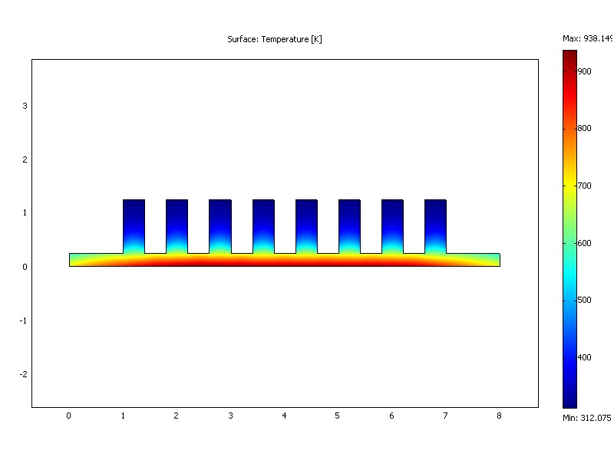
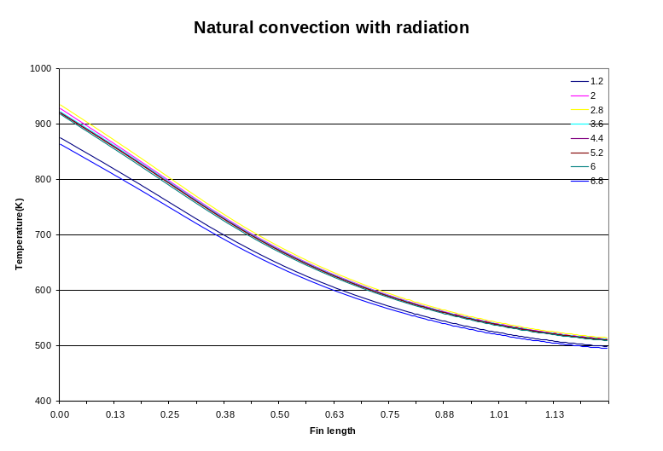
Fig. 5. Temperature profile in the wall


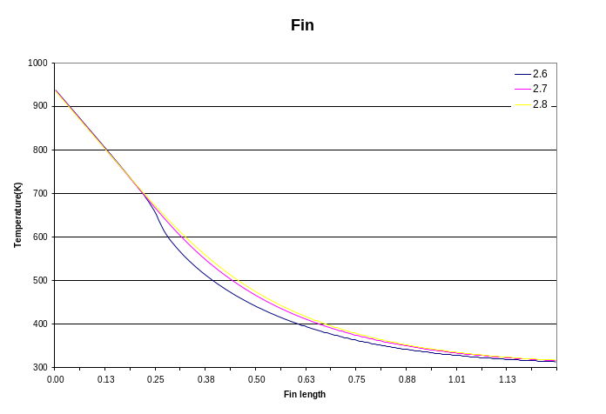
Fig. 6. Temperature profile in a fin

3. Validation
To validate the system, I solved it manually.
The equation is
where T is a function of both x and z, but the dependence on z is more important.
A small quantity of heat is lost from the fin at the end and the edges in real system.

Some assumptions is needed in validation of the system
1) T is a function of x alone
2) No heat lost from the end or from the edge
3) Heat flux at surface is 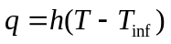, where h=constant, T=T(x)
4) Radiation is not concerned in validation.

This equation can be restated;
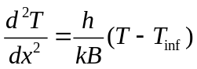
And the boundary conditions;
(1)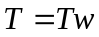 
(2)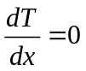 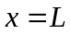

By introducing following dimensionless quantities
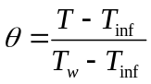=dimensionless temperature
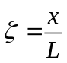=dimensionless distance
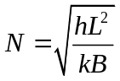=dimensionless heat transfer coefficient

The equation is changed to :
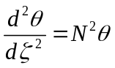 with boundary Condition (1)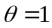 at 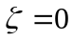 (2)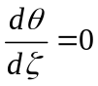 at 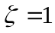

Above equation was integrated to give hyperbolic functions. When two integration constants have been determined, The solution is
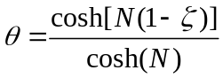

The system using for validation is the 3rd left fin (Temperature of Wall : 933.15K)
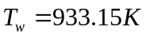, 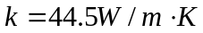, 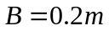, 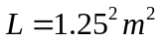
N=1.33(h=natural convection), 5.13(Forced convection)
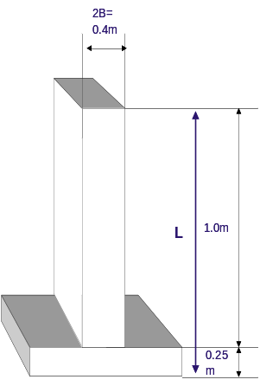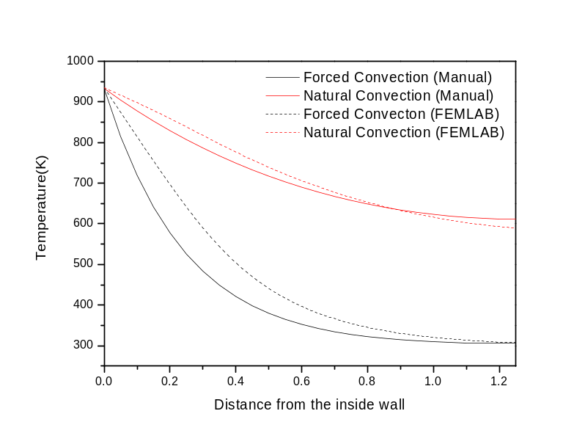
Fig. 7. Comparison between forced convection and natural convection

Figure 7 is the results from manual calculation and FEMLab. The calculation of natural convection by hand shows similar result to FEMLab result. However, in forced convection, the manual calculation is lower than that of FEMLab. The main reason is the wall of reactor is assumed to be same with fin and the second assumption “No heat lost from the end or from the edge”. Even though the temperature profile of forced convection has differences between REMLAB and Manual calculation, the temperatures at the end of the fin are same.

Result- Temperature at the end of the fin
Convection Type | Radiation | T (K)[FEMLAB] | T (K)[Calculation]
Natural (h:10W/(m²K) | Without Radiation | 589.5 | 612.1
Forced (h:150W/(m²K) | Without Radiation | 307.4 | 305.7

The Minimum Temperature in the system using FEMLAB
 | Tmin(K)
Forced convection without radiation | 307.37
Forced convection with radiation | 306.98
Natural convection without radiation | 551.075
Natural convection with radiation | 489.498

4. Parametric Study

By Changing the convective heat coefficient, radiation coefficient and material properties, parametric studies were performed.
Figure 8 shows the temperature profile according to change of the heat coefficient. Temperature at the end of fin is around 610K when the convection term is ignored, but as the heat coefficient is getting increased, the temperature profile is getting decreased.
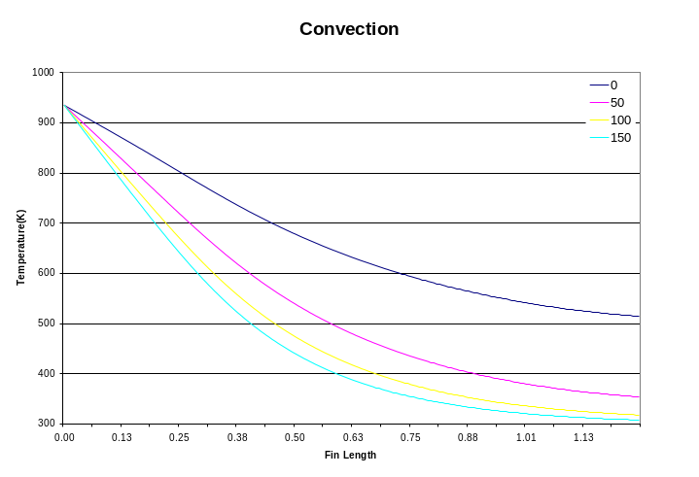
Fig. 8. The effect of convection

Figure 9 displays the temperature profile to confirm the radiation effect. From the graph, I can find that the radiation term is important in natural convection system. The temperature profile considering radiation is higher than that considering radiation. At the end of fin, the temperature difference is 75K.
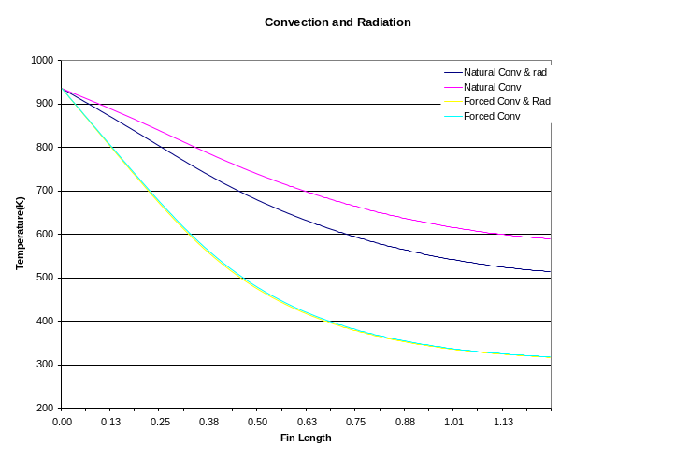
Fig. 9. The effect of radiation
However, the temperature profiles of radiation show different aspects. The temperature difference is just 1K, which tells the radiation term did not affect the temperature profile. It means radiation can be ignored in the forced convection system.

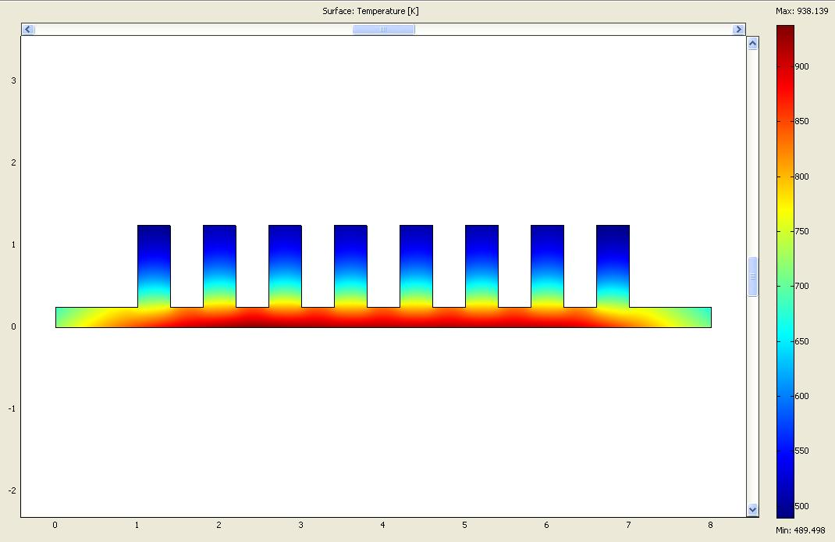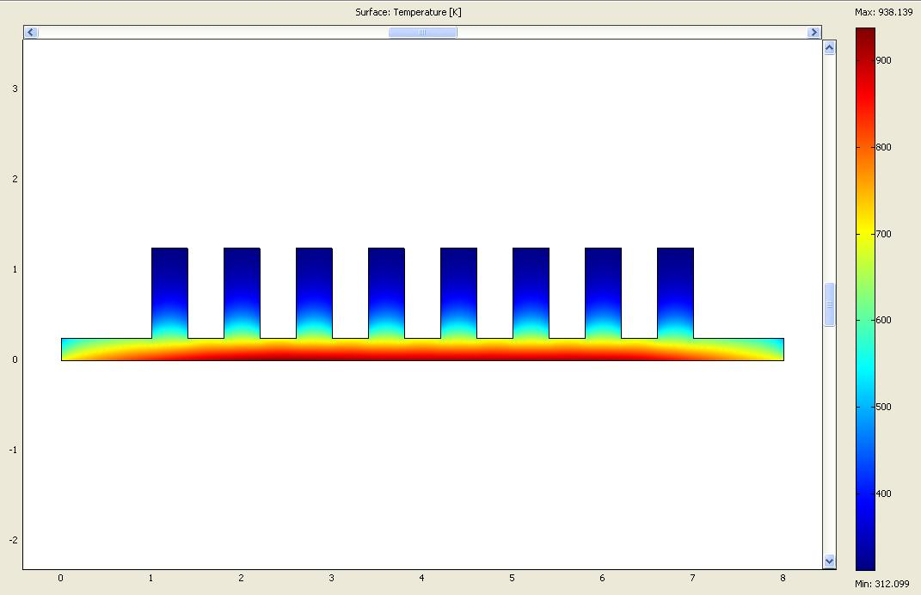
Natural convection with radiation Forced convection with radiation

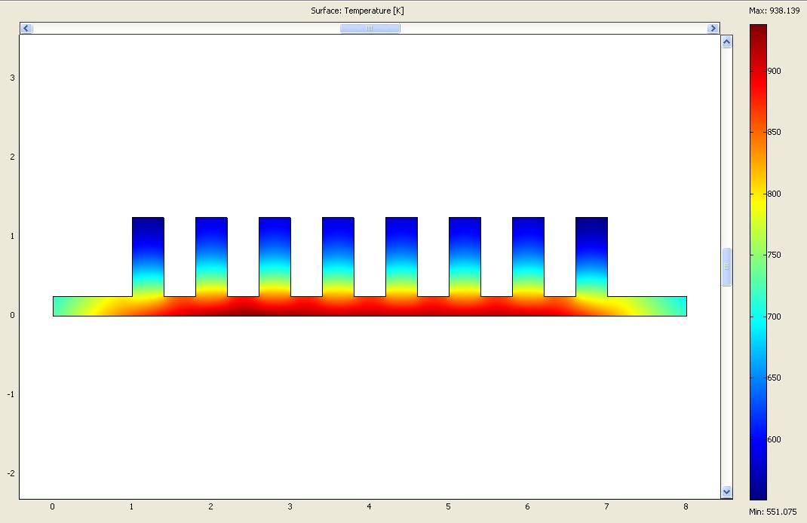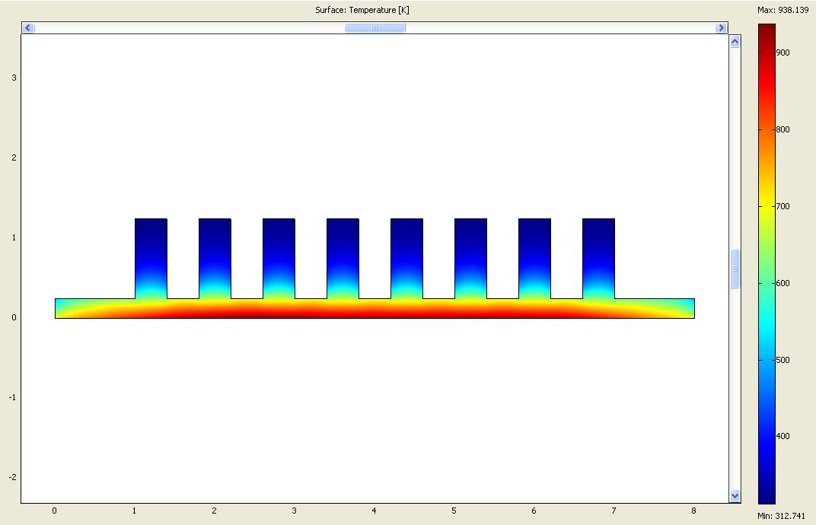
Natural convection without radiation Forced convection without radiation

Fig. 10. The effect of convection and radiation

For the effect of material properties, the material is changed from steel AISI 4340 to aluminum. The temperature at the surface of the aluminum wall is 150K higher than that of steel. This is the effect of thermal conductivities (k) of materials. Thermal conductivity of the aluminum is 200 W/m∙K, which is 4 times higher than that of steel (k of steel AISI 4340 is 44.5W/m∙K). The temperature of the surface in aluminum is reached to 650K.
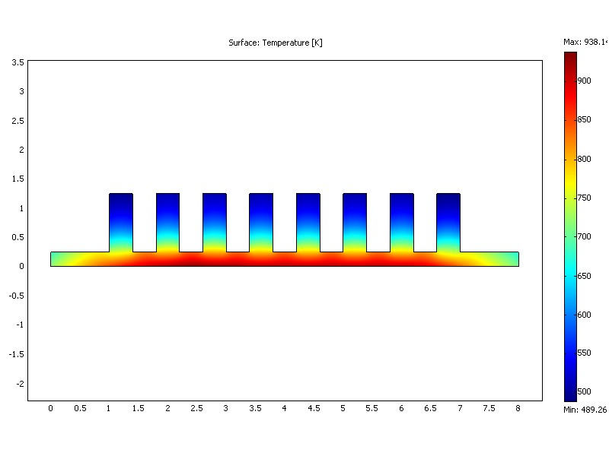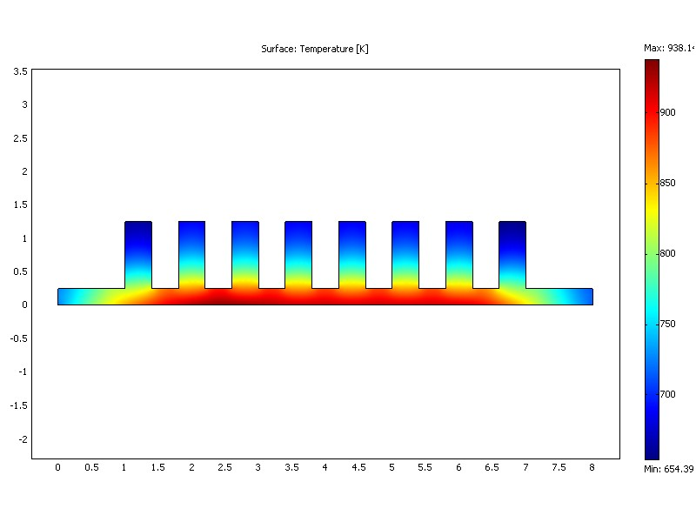
Fig. 11. Temperature distribution of Reactor Wall (L)Stainless Steel, (R)Aluminum

5. Conclusion

Heat exchange with fins was examined and we can find convection term is important factor in calculation of surface temperature.
Comparison between solution from FEMLAB and direct calculation of ODE indicates that the former might get the more exact estimated value than the latter which needs more assumptions.
Even though consideration of radiation is important in the natural convection system, it can be easily ignored when convection becomes significant term.

6. References
(1) Bird, Stewart, lightfoot, “Transport Phenomena”, John Wiley & Sons, p. 265-309
(2) Welty, Wicks, Wilson, “Fundamentals of Momentum, Heat, and Mass Transfer, 3rd edition”, John Wiley & Sons, p.252-295
(3) Lindon C. Thomas, “Heat Transfer”, Prentice-Hall International, Inc., p.34-256
(4) Erwin Kreyszig, “Advanced Engineering Mathematics, 8th edition”
(5) FemLab User’s Guide, Comsol
(6) FemLab Modeling Guide, Comsol
(7) FemLab ECRE, Comsol
(8) FemLab Introductory Course, Comsol
(9) John H Lienhard, “A Heat Transfer Textbook”, phlogiston press, p.139-266
(10) Paul Kurowkski, “Good Solid Modeling, Bad FEA” , www.Machinedesign.Com/BDE/ cadcam/ bdecad3/bdecad3_4.html
(11) Carnegie Melon University, “Ansys Tutorial”, www.me.cmu.edu/ academics/ courses/ NSF_Edu_Proj/ ThFlEngr_ANSYS/ Default.htm
(12) University of Waterloo, “Sample Input Form for Rectangular Heat Sink”, www.mhtl.uwaterloo.ca/old/ onlinetools/nat_hs/rect_hs/input.html
(13) University of Leicester, “An introduction to FEMLAB: Heat Conduction Problem”, http://www.le.ac.uk/engineering/computing/eg2090/femlab.pdf
(14) Saini, Manish, “Modeling and optimization of air cooled plane fin aluminum heat sinks used in computer cooling”, Thesis (M.S.)--Pennsylvania State University, 2002
(15) Elsworth, “Course Notes and Resources : Mathematical Modeling of Energy and Geo-Environmental Systems”

