Setting up Your Camera

Knowing how to set your camera will give you the ultimate control over the look and feel of your photos. Changing simple settings like your aperture and ISO will allow you to control things like the depth of field, exposure, and image size and quality—all essential to creating high-quality brand-style photography.

Camera Modes

Choosing your camera mode is the first step in setting your camera. By using a setting other than Auto, you are making creative decisions that will allow better control of the outcome of your photo. The four most commonly used modes (other than Auto) are Manual, Aperture Priority, Shutter Priority, and Program.

Putting this into practice:

Before you do anything, ensure your battery is charged and memory card is clear and inserted in camera.

1. Each camera has a different way to set a camera’s mode. It may be located in your camera's menu or on a dial on the exterior of your camera.
2. Selecting Manual (M) or Aperture Priority (A) will give you complete creative control over your camera’s exposure settings.
   1. Manual (M)—manually set ISO, aperture, and shutter speed to achieve proper exposure.

TIP: When you are in Manual (M) mode, the exposure meter signifies when exposure is properly balanced.

* 1. Aperture Priority (A or Av)—manually set ISO and aperture; the camera compensates for shutter speed to achieve proper exposure.

TIP: Nikon, Sony, etc. modes are abbreviated M, A, S, P whereas Canon’s are abbreviated M, Av, Tv, P.

CAMERA SETUP | PAGE 1

The proper white balance setting on your camera will ensure colors look natural and accurate. Once your whites are true whites, the rest of the colors in the photo will naturally be in the correct balance.

Putting this into practice:

1. Set white balance (WB) to Auto (AWB). Most DSLRs’ Auto WB is very accurate.
2. Many DSLRs have a WB button on the camera body:
   1. Press and hold the WB button and rotate the rear main command dial to scroll through WB icons until you reach AUTO or AWB.
   2. You can also select white balance in your camera’s menu.

TIP: You have several other WB options to choose from if you’d like to experiment.



CAMERA SETUP | PAGE 2

## Auto Focus

Selecting the correct auto focus settings will ensure your photos are sharp and in focus. Many cameras will allow the selection of several points in your focal range to pinpoint your subject.

Putting this into practice:

1. Set your camera body and lens to Auto Focus (AF).
   1. There are usually switches on the DSLR camera lens and body that are labeled (A/M or AF/M). You should select A or AF to ensure auto focus is on.
2. Ensure your auto focus (AF) is set to AF-S (Auto Focus Single Point). You may have to check your user manual to complete this task, as every model is different.
   1. With the AF-S setting selected, your camera should display only one red square focal point (press the shutter halfway down to engage the auto focus function), not multiple focal points.

## Quality Settings

Setting appropriate quality settings is important to ensuring your images are of sufficient resolution and can be used on a variety of platforms and channels as needed.

Putting this into practice:

1. Set quality (QUAL) to RAW or FINE. This will ensure your images will be captured at the highest quality setting available.
   1. Change the quality settings by either:
      1. Pressing and holding the QUAL button on your DSLR while scrolling the rear command dial until the main or top screen reads RAW or FINE.
      2. Going into your menu settings to find the quality settings and select RAW or FINE.

CAMERA SETUP | PAGE 3

## Setting Exposure

The ISO, aperture, and shutter speed should be balanced to achieve a properly exposed image.

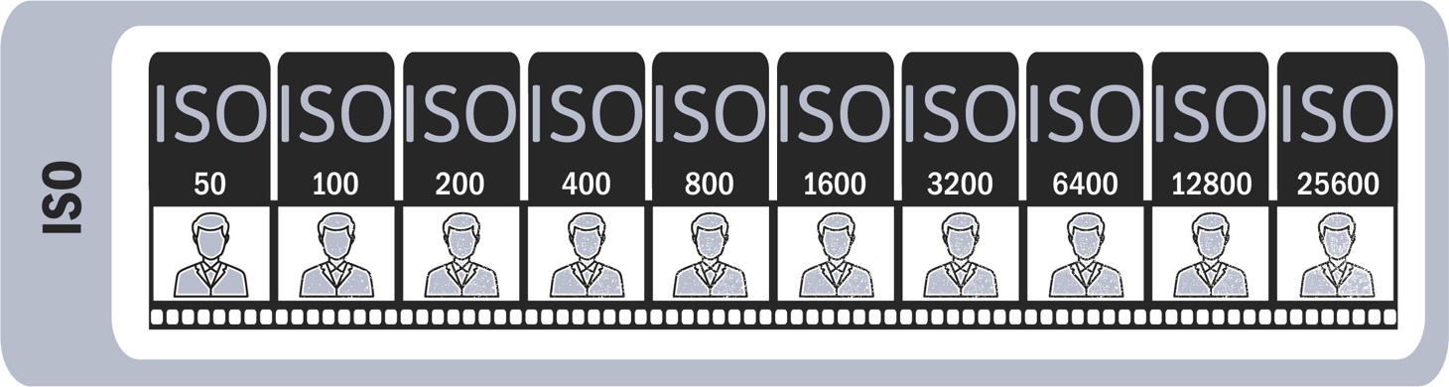

Putting this into practice:

1. Set the **ISO** first. The ISO will typically be set between 100–400 in very bright direct sunlight settings; 400–1600 in well-lit indoor settings or cloudy/dusk outdoor settings; and 1600+ in low light situations.
   1. Change the ISO settings by either:
      1. Holding down your ISO button while scrolling the rear command dial to scroll through your ISO settings
      2. Going into your camera’s menu settings and selecting ISO

TIP: ISO directly affects the quality of an image. Noise/grain can become an issue in low light situations when a high ISO setting is needed for proper exposure.

CAMERA SETUP | PAGE 4

1. Set **aperture** second. (**NOTE**: While aperture is not the same as f-stop, for the purposes of this guide, it's sufficient to use them interchangeably.)
   1. Aperture (f-stop) controls depth of field, which affects how clear or blurry a photo’s foreground and background appear compared to your subject (or focal point).
   2. 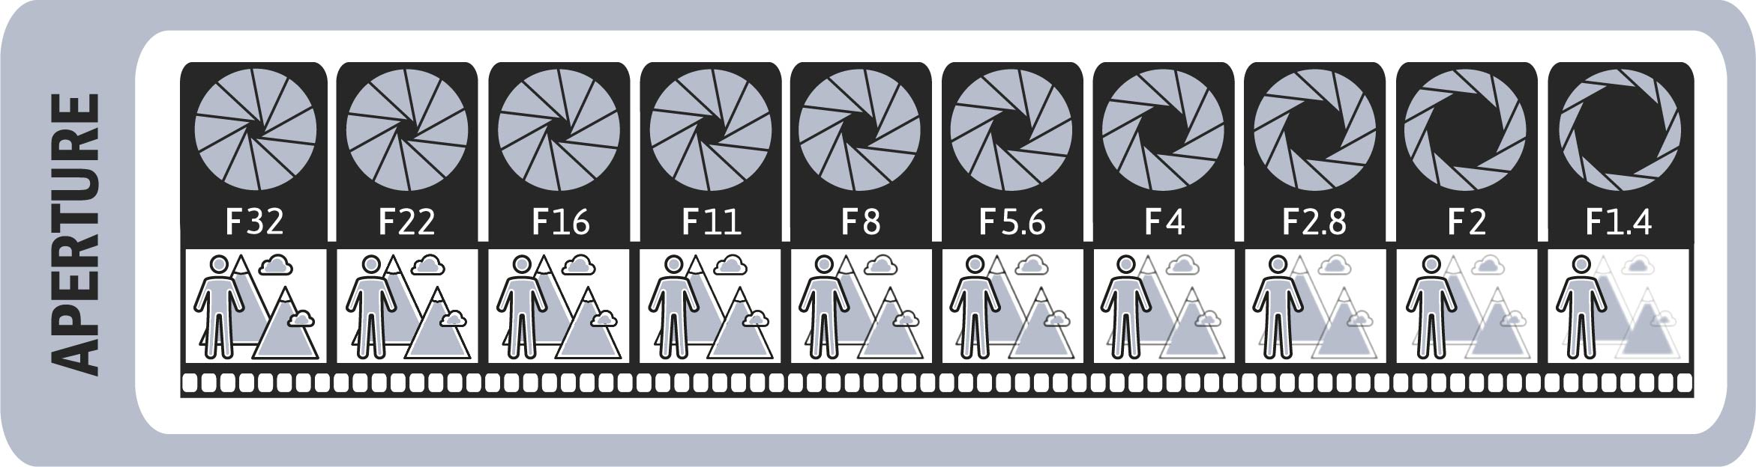A low aperture (f/1.4 or f/2.8) will make the foreground and background of your photo blurry, whereas a high aperture (f/22 or similar) will show most everything in the image clear and in focus. (See infographic below)
   3. Use the sub-command dial to adjust aperture (f-stop), or go into your camera’s menu settings, select "Aperture" or "F-stop," and select your preferred setting.

TIP: Using a low aperture (f-stop) means more light is entering the lens. This typically translates into a faster shutter speed. The reverse is also true: using a high f-stop means that less light is entering the lens. This typically translates into a slower shutter speed.

1. Set **shutter speed** third (only when using **manual mode**).
   1. Shutter speed helps control motion blur and the sharpness of an image. This can stop action in your scene or allow blur from movement. (See infographic below)
   2. Change the shutter speed settings by either:
      1. Using the main command dial (rear). View the top of the camera to see adjustments.
      2. Using your camera’s menu settings to access "Shutter Speed" controls and select your preferred setting.

CAMERA SETUP | PAGE 5

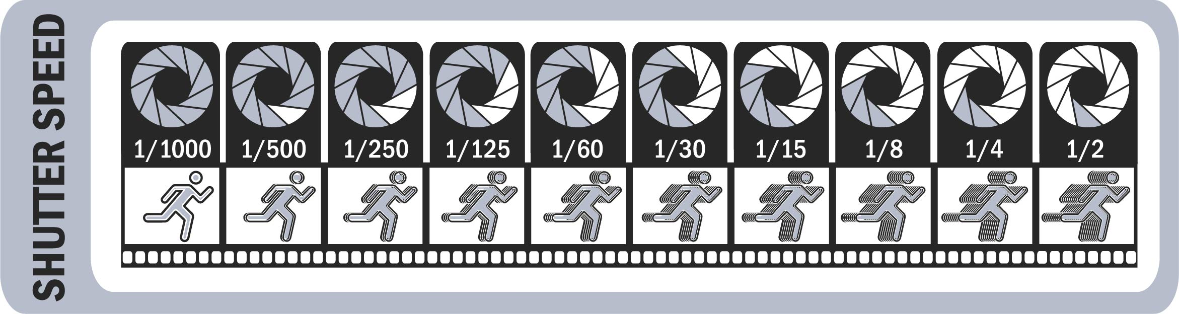TIP: Keep the shutter speed above 1/100 of a second to stop action. Slow shutter speeds = motion blur in photos.

TIP: In manual mode, every time the shutter speed is changed, you must also rebalance the exposure by adjusting ISO or aperture. The same applies if you change ISO or aperture.

brand.psu.edu

Penn State is an equal opportunity, affirmative action employer, and is committed to providing employment opportunities to all qualified applicants without regard to race, color, religion, age, sex, sexual orientation, gender identity, national origin, disability, or protected veteran status.

THIS PUBLICATION IS AVAILABLE IN ALTERNATIVE MEDIA ON REQUEST.   
Produced by the Penn State Department of University Marketing U.Ed. SCM 18-55

PHOTOGRAPHY FIELD GUIDE | PAGE 2

CAMERA SETUP | PAGE 6