|  |
| --- |
| The Pennsylvania State University |
| Renewable Sources of Electricity for Penn State University Park |
| EME 580: Integrative Design of Energy & Mineral Engineering Systems |
|  |
| **Olaide Oyetayo& Osahon abbe** |
|  |

*PROBLEM STATEMENT: A comparison of biomass and wind energy as potential alternative source of electricity for Penn State University Park, and the techno-economic feasibility analysis of the chosen option for implementation on the campus.*

|  |
| --- |
| *With special thanks to Susan Stewart, Bruce Miller, Rhett McLaren, Steve Weyandt (PSU employees), and Jack Rehorst (Energex).* |

**Executive Summary**

This report examines the feasibility of the development of a 10 MW alternative electric generation plant on Penn State campus or close-by; owned and operated by the university and is located in Centre county Pennsylvania. Two alternate sources (wind and biomass) were investigated to determine which option would provide the best benefit for Penn State. Due to the limited power in the wind in the surrounding area, it was decided that biomass would suit our purpose better. Additionally, the abundance of biomass resources in Centre County helps to justify the need to looking into the feasibility of using biomass as fuel.

Due to its environmental and efficiency benefits, Integrated Gasification Combined Cycle (IGCC) was chosen as the conversion technology that would be used to convert biomass into electricity. The initial goal of the project was to minimize the carbon emissions and maximize efficiency as much as possible. With these objectives in mind, a CO2 capture and Air Separation Unit were both considered for the system. However, it was realized that incorporating these technologies for such a small plants creates an economic burden and might make the project highly unfeasible. Therefore, it was decided that the environmental benefits that a standard IGCC plant offers is good enough for our purpose.

The economic considerations for this plant showed that the cost of electricity that is produced by the biomass plant is twice the current cost of electricity in Pennsylvania. This high cost can be attributed with the high cost of the biomass feedstock ($150/ton), and the fact that biomass plant capacity is relatively small. A reduction of the cost of feedstock will certainly also lower the cost of electricity in the long run. Also the emergence of more incentives might help to offset the electricity cost.

Other challenges that this plant face includes the current substation capacity and its ability to handle a 10MW plant. Transmission lines may be needed for a new plant design depending on the location and documentation on the distance should be taken. Retrofitting will require changing out the old transmission lines and replacing them with adequately sized ones for the rated transmission level. One key task that will be monitored closely is the availability of the fuel to be used to run the facility and connections are going to be established with potential suppliers.

Contents

**1.** **Introduction** 4

**2.** **Literature Review** 4

***2.1.*** ***Wind Energy*** 4

***2.2.*** ***Biomass*** 6

**3.** **Wind and Biomass Resources in Centre County** 10

***3.1.*** ***Wind*** 10

***3.2.*** ***Biomass*** 14

***3.2.1.*** ***Fuel Type*** 14

***3.2.2.*** ***Drying the Fuel*** 14

***3.2.3.*** ***Fuel Procurement*** 15

***3.2.4.*** ***Conversion Technology*** 15

**4.** **Biomass IGCC Plant Design** 20

***4.1.*** ***Plant Location*** 20

***4.2.*** ***Fuel Supply & Handling*** 20

**4.3.** ***Gasifier*** 21

***4.4.*** ***Air Separation Unit*** 23

***4.5.*** ***Gas Clean-Up*** 23

***4.6.*** ***CO2 Capture*** 23

***4.7.*** ***Gas Turbine*** 24

***4.8.*** ***Heat Recovery Steam Generator (HRSG)*** 24

***4.9.*** ***Water Supply*** 24

**5.** **PERMITTING, REGULATIONS AND CAPACITY ISSUES** 25

***5.1.*** ***NPDES – National Pollutant Discharge Elimination System*** 25

***5.2.*** ***PCSM – Post Construction Storm-water Management*** 25

***5.3.*** ***MACT- Maximum Achievable Control Technology*** 25

***5.4.*** ***Electrical capacity compatibility*** 26

**6.** **Environmental Considerations** 27

***6.1.*** ***Life Cycle*** 27

***6.2.*** ***Wastes*** 27

***6.3.*** ***Act 213*** 28

**6.4.** ***Anticipated Environmental Requirements*** 28

***6.4.1.*** ***Air Pollution*** 28

***6.4.2.*** ***Ambient Air Quality*** 28

***6.4.3.*** ***Environmental Control Definition*** 29

***6.5.*** ***Good Engineering Practice (GEP) Stack Height*** 29

***6.6.*** ***Water Pollution*** 29

***6.7.*** ***Noise*** 30

**7.** **INCENTIVES** 30

***7.1.*** ***Modified Accelerated Cost-Recovery System (MACRS) & Bonus Depreciation (2008-2012)*** 30

***7.2.*** ***Renewable Electricity Production Tax Credit (PTC)*** 32

**8.** **Economic Analysis** 32

**9.** **Sensitivity Analysis** 35

**10.** **Conclusion** 35

Appendix 36

1. **Introduction**

The Pennsylvania State University consumes approximately 320,000MWh of electricity per year, most of which is generated from coal[1]. With increased interest in finding alternative options to fossil fuels, and need for reducing environmental pollutants, Penn State can be one of the front runners in implementing a renewable source of energy on campus. In this study, two renewable sources of electricity are explored as possible electricity sources for the university: Biomass and Wind Energy. Based on the resources available in Centre County, one source was chosen, and investigated to determine viability of installing either a wind farm or biomass plant to power Penn State. The goal is to design a sustainable and environmentally friendly process and assess whether it is cost-effective.

1. **Literature Review** 
   1. ***Wind Energy***

Unequal solar heating produces wind, which creates a lift that spins the turbine blades and rotor. The kinetic energy in wind is converted to mechanical energy in the turbine, which is then converted into electrical energy in a generator[2]. As shown in figure 1, power in the wind is transferred to the rotor which then passes through the gearbox, generator, power electronics, and eventually to the grid.[3]

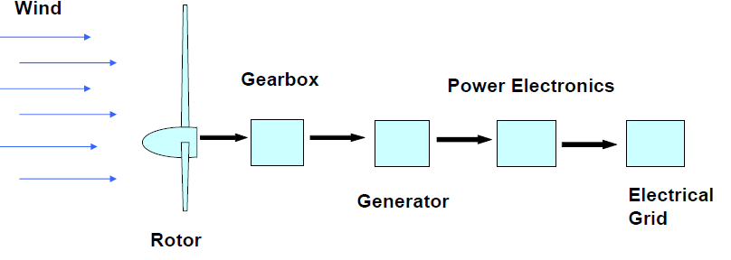

Figure 1: Transfer of Wind through turbine system

Wind turbines utilize some part of the wind’s kinetic energy, which slows down the wind; it is not possible to use all the wind’s capacity as this would require the wind to completely stop. The power in wind is represented by the equation:

P=1/2*ρAV3, where ρ : density of air (Kg/m3), A: swept rotor area (m2), V: wind speed (m/s), P: Power (watts).

It is impossible to capture all of the power in wind, so the maximum efficiency of a turbine is about 59.3 percent, which is governed by Betz’s law. Most turbine efficiencies however are between 25-45 percent[4].

About two percent of the world’s solar radiation is converted to wind movement. The largest wind power is found over open seas where there are no hindrance to slow down the wind movement. However, wind loses its speed over land due to effects of rough terrain. These effects become less noticeable at higher altitudes, so the optimal locations for wind turbines are on hills and mountain tops

Due to technical development, wind systems have gotten considerably larger with higher capacity than in the 1980s. Back then capacity was about 100kw or less, but today some wind systems have capacity of up to 5MW with rotor diameters of 110 or more. Nonetheless, it is perhaps unlikely that 10MW wind systems can be built due to physical limitations associated with material requirements and also transportation issues[5].

***Wind Speed***

Wind speed can be defined in terms of the start-up speed, cut-in speed, the rated speed, and the cut-out speed. As its name suggests, the start-up speed is the speed that the rotor and blade begins to rotate, while the cut –in speed is the minimum speed needed for a wind turbine to generate “usable” power, and this ranges from 7-10 mph. The rated speed is the minimum speed needed for a wind turbine to generate the designated rated power; this is between 25-35mph. At wind speeds of about 45-80 mph, some turbines are set to shut down to protect them from damage. This speed range is known as the cut-out speed[6]. In order to generate enough electricity to compete with a coal-fired plant, wind speed of 14mph is needed[7]. This is used a guide to determine whether the wind resource in Centre county is sufficient to generate electricity.

***Advantages and Draw-backs of Wind Energy***

The utilization of wind energy does not directly emit pollutants such as SOx, NOx, CO2 or mercury. This is an important consideration since reduction of environmental pollutants is one of the objectives of the study. Wind energy also does not require water for operation, creates green jobs, and can help facilitate rural development, as farmers often receive royalties for use of their lands. In addition, since wind is free, there is no fuel cost associated with wind energy.

Even with the benefits associated with wind energy, some of its drawbacks have been a roadblock for development in many areas. Wind consistency is very important in generating electricity, and this might be difficult to achieve as wind is not always steady. Energy storage is currently expensive and still under development, and the need for new transmission infrastructure adds to the cost of wind power. Additionally, wind turbines may be a source of danger for birds and bats, can create noise pollution, and is seen as an eye sore to some[8].

* 1. ***Biomass***

Biomass contains solar energy that is stored in chemical bonds of organic materials. It is considered renewable since we can grow more of it[9]. Plants use the energy from the sun to convert water and carbon dioxide into biomass and oxygen, in a process called photosynthesis[10]. The chemical energy is released as heat when the biomass is burned. Biomass can come in different forms such as wood, municipal waste, agricultural residue, sludge wood or landfill gas. Each type has specific energy content associated with them.

Table 1: Energy Content of Various Biomass Types[11]

|  |  |
| --- | --- |
| **Type** | **Energy Content (Btu/lb)** |
| Dry Wood | 7600-9600 |
| Wood (20% moisture) | 6400 |
| Agricultural Residue | 4300-7300 |
| Sludge Wood | 5000 |
| Municipal Solid Waste | 5000 |
| Landfill Gas | 250 |

As Table 1 shows, dry wood has highest energy content; hence combustion of wood produces the most amount of heat.

***Biomass Properties***

*Proximate Analysis*

Ash content is very important when considering the disposal of the waste stream that will result from using biomass. In its molten state, ash can become difficult to remove and plug the reactor, hence ash content is preferred to be low. Biomass generally has lower ash content compared to coal, but wood generally has lower ash content than agricultural residues. Due to the high amount of volatiles in biomass (between 70-80%) it also has an advantage of being easier to gasify than coal. Table 2 shows the proximate analysis of various biomass and coal[12].

Table 2: Proximate Analysis of Various biomass and coal

|  |  |  |  |
| --- | --- | --- | --- |
| **Biomass** | **Volatiles** | **Ash** | **Fixed Carbon** |
| Bagasse (sugarcane) | 74 | 11 | 15 |
| Barley straw | 46 | 6 | 18 |
| Coal (bituminous) | 35 | 9 | 45 |
| Coal (lignite) | 29 | 6 | 31 |
| Cotton Stalk | 71 | 7 | 20 |
| Corn grain | 87 | 1 | 12 |
| Corn stover | 75 | 6 | 19 |
| Douglas fir | 73 | 1 | 26 |
| Pine (needles) | 72 | 2 | 26 |
| Plywood | 82 | 2 | 16 |
| Poplar (hybrid) | 82 | 1 | 16 |
| Redwood | 80 | 0.4 | 20 |
| Rice Straw | 69 | 13 | 17 |
| Switchgrass | 81 | 4 | 15 |
| Wheat straw | 59 | 4 | 21 |

*Ultimate Analysis*

Biomass contains less carbon than solid fossil fuels such as coal, has a higher oxygen content, and lower heating value. Additional the moisture and ash content in biomass can create combustion and ignition problems. Table 3 illustrates the comparison between coal and biomass fuel[13]

Table 3: Physical and Chemical Properties of biomass and Coal

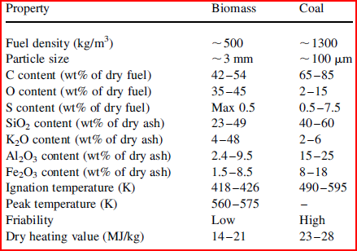

One implication of the discrepancies between fuel density of biomass and coal is that about three times more biomass is required to produce the same amount of energy as coal. The low ignition temperature of biomass compared to coal is a consequence of the fact that the amount of volatiles is higher in biomass than coal.

*Bulk density*

When determining transportation cost, storage, and handling, bulk density is an important factor that should be considered. This is defined as the mass of biomass per volume, and the higher it is the lower the transportation cost. Pelletized wood has high bulk density of 600-700kg/m3, softwood chips density is about 200-340 kg/m3, and agricultural residues are between 50-200 kg/m3 [14].

***Biomass Conversion***

Biomass can be converted into electricity in various ways. Combustion is the burning of biomass to create steam which is converted to electrical energy by steam turbines. Gasification is the heating of biomass in an oxygen-starved environment to produce gases such as CO and H2, which have higher combustion efficiencies than the original fuel. Co-firing is the combustion of two different fuels at a time. Usually biomass is fired with coal to reduce emissions. Cogeneration is the simultaneous production of electricity and heat from a single biomass fuel. This is believed to be more efficient than combustion of biomass to produce electricity[15].

***Advantages and Drawbacks of Biomass***

As previously mentioned, biomass comes from a renewable source, so it is produced in a shorter time period when compared to fossil fuels. Its use reduces dependency on fossil fuels, and also reduces the amount of waste that ends up in landfills. For biomass, intermittency is not an issue since electricity can be generated at any time, as long as biomass is available. Additionally, the burning of biomass releases CO2 that was absorbed during photosynthesis; hence there is no net gain of atmospheric CO2.

Although biomass is believed to produce zero net atmospheric CO2, this does not take into consideration emissions from the transportation of biomass to the plant. Additionally, some biomass plants have shown relatively high NOx and CO emissions compared coal plants, and particulate emissions can be a cause of concern as well. Currently, no biomass facilities have an advanced particulate emissions control installed[16]. Finally, some studies have reported a negative energy balance for the utilization of biomass.

Compared to coal-fired plants, biomass plants have lower output. This is because most biomass plants utilizes only the biomass from the regions where they operate in, so increasing their outputs would require transportation of biomass fuel from other regions[17].

1. **Wind and Biomass Resources in Centre County**
   1. ***Wind***

In order to make preliminary assessment of the wind resource in Centre County, the annual average wind speed at 80m was examined. Since wind speed is usually better at higher altitudes where there is less interference, the 80m map was used instead of the 30 or 50m[18]. Figure 2 illustrates the annual wind map of Pennsylvania, but attention was placed on Centre County.

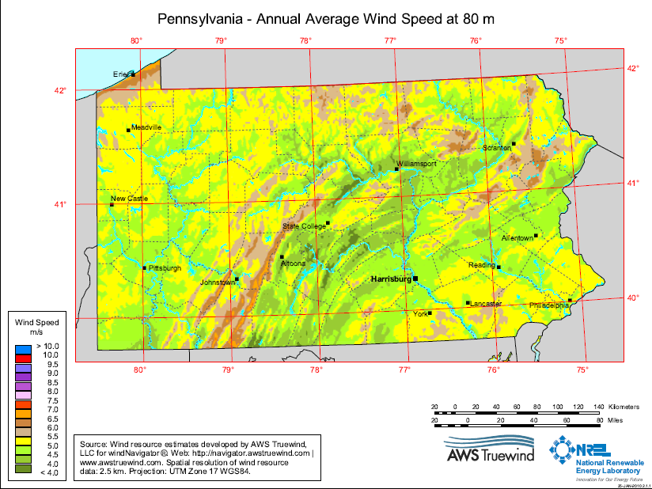

Figure 2: Annual Average Wind Speed at 80M

Ideally the location of a wind farm that would generate electricity for Penn State should be as close as possible. However, since state college is known as “happy valley” interferences might create a big problem for wind movement. Additionally, the wind map shows that the best wind speed is in the southwestern/western region of Centre County (Philipsburg/Rush Township). The average wind speed in the region is about 13.42mph, which is suitable to generate usable electricity. A physiographic map of the region also shows that it is a plateau; therefore interference is not a problem[19].

***Possible Wind Farm Location***

There are a few types of lands that cannot be developed as wind farms, and they include federal lands, state lands, airfields, urban, wetland and water areas, and three km surrounding these areas[20]. A review of land resources of the area of interest showed that most of the region is state game lands and state forests (figure 3); therefore approval for development of a wind farm is highly unlikely.

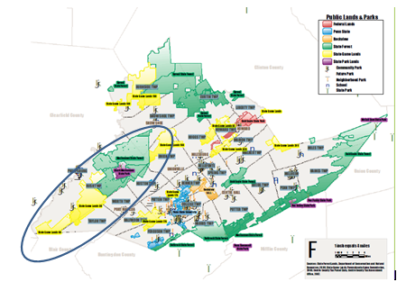

Figure 3: Centre County Land Resources

Currently a wind farm project known as the Sandy Ridge Wind Farm is under construction in Centre County. Sandy Ridge is being developed by Gamesa and consists of 9 Gamesa G90 turbines (2MW each). The wind farm is located in Taylor Township which is on the east side of Rush Township[21]. Approval of this project suggests that no disturbance was found, and subsequent approvals might be possible if the land is appropriate[22]. However, the company mentioned that it has “reached a peak in identifying potential locations for wind turbines projects”[23] around this area, hence it was concluded that wind farm development for Penn State University is currently not feasible.

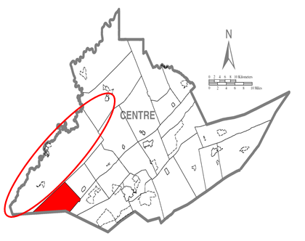

Figure 4: Sandy Ridge Wind Farm, located in Taylor Township (red region)[24]

Regions outside Centre County were not considered because of the cost of transmissions associated with installing a wind farm that is a far distance from University Park. In addition, issues may arise about installing a wind farm in a region and not utilizing the output in that same region.

Besides permitting issues and land availability in Centre County, the potential power output from a wind farm, and the amount of land required in the area of interest can also be evaluated. Using the annual average wind speed of the area, which is 6.5m/s, the power in the wind can be calculated. It should be noted that the average speed in this area is significantly less than nominal speed of a lot of turbines, which can range from 11-15m/s. For this reason, more turbines would be needed for a 10 MW wind farm than at a region with higher wind speed.

*Statistics of wind speed*

The Rayleigh distribution is a model that be used to describe wind speed behavior through the year. This model is used to calculate the power in wind, as this is realistic for wind turbines. The Rayleigh formula for the power in the wind is given as:

P/A=(6/π)(1/2)ρv3

The density of air is 1.225Kg/m3

(1/2)*( 6/π)* 1.225Kg/m3*(6.5m/s)3=321.25 W/m2

Assuming an efficiency of 30%, the power density=>0.3*321.25=96.38W/ m2

Because of the proximity of the Gamesa project, it was used as a reference for our wind farm. Details of the project are as follows:

Wind turbine nominal power: 2MW

Total installed power: 50 MW (25 turbines)

Yearly estimated production: 125 GW.h or 2500 hrs of full load.

Rotor diameter: 87m

Rotor min wind speed: 4m/s

Rotor nominal wind speed: 15m/s

Rotor max wind speed: 25m/s

Power density: 336.7 W/m2 (it is not clear if this is before or after considering turbine efficiency but this value is nonetheless higher than our calculated value)[25].

Since the power density in the area is relatively low compared to the Gamesa project (a consequence of lower wind speed), a larger rotor diameter might be required for our project. So instead of using 87m, we use 100m:

96.38W/ m2*(100m)2*π/4=7.57x105W=0.757MW

A 10MW wind farm would require: 10/.757=13.2 turbines;

The Rayleigh model can also be used to determine the amount of time that the wind farm will be operating at its rated power. Using a cut-in speed of 4m/s, a rated speed of 15m/s, and cut-out speed of 25m/s, we calculate the total hours that the wind speed would be below the cut-in speed, and the amount of hours that the turbines will be running at their rated power with an average wind speed of 6.5m/s.

The Raleigh probability equations are given as:

$F\left(vc\right)=prob\left(v≤vc\right)=1-exp⁡[-\frac{π}{4}{\left(\frac{Vc}{v}\right)}^{2}]$ (Probability that average wind speed v is less than the cut-in wind speed vc)

F(v≥Vr)= $exp⁡[-\frac{π}{4}{\left(\frac{Vr}{v}\right)}^{2}]$ (probability that the average wind speed v is greater than the rated wind speed)[26].

It is calculated that the probability that the wind speed is below the cut-in speed is about 0.2573, and with 8760 hours in a year, this amounts to 2253.95 hours or about 94 days a year. The probability that the average wind speed is higher than the rated wind speed is calculated to be 0.01526 which is about 133.59 hours or 5.6 days. With the wind farm only operating at full load for 133.59 hours per year, and 14 machines of about 0.757MW rated power each, only about 1415.8MWh of energy can be generated per year. This led to the conclusion that wind energy in this area might not be the optimum solution of an alternative electricity source for Penn State.

* 1. ***Biomass***

The state of Pennsylvania has an abundant amount of biomass resources that can used to generate electricity. Particularly Centre County has various biomass resources such as forestry and agricultural residues. The total amount of livestock manure that is available each year is about 324965 tons, timberland covers an area of 527002 acres, mill residue is in the amount of 1133929ft3, and logging residue in the amount of 3131514ft3 [27]. Each year, the amount of biomass available in Centre county is as follows: primary mill residue (wood and bark from manufacturing plants) produced each year is about 10-25 thousand dry tons per year, secondary mill residue such as sawdust and wood scraps account for about 500-100 0 tons per year, and forest residue, crop residue, and urban wood waste are about 25-50, 20-50, and 10-25 thousand dry tons per year, respectively[28]. Also, about 100000 tons of municipal waste is transported to landfill each year from Centre County[29]. These are resources that are readily available in Centre County alone that can be converted to energy.

With this information the feasibility analysis of installing a biomass power plant in University Park to provide power for Penn State University is being done. The analysis considers issues associated with procurement and transport of the biomass fuel, the economics of the system chosen, environmental considerations of the process, regulations and permitting issues, and calculation of the energy balance of the overall process.

* + 1. ***Fuel Type***

The type of biomass that will be used as fuel is wood, which is assumed to have a moisture content of approximately 50 percent. The fuel was chosen because of its ease of handling compared to other types of biomass. Municipal Solid Waste was also considered but this involves the use of incinerators, which are strictly regulated. Also the use of MSW would introduce problems of toxins in the waste. The wood will be dried at the plant to reduce the moisture content to 20 percent, making the energy content about 6400Btu/lb[30].

* + 1. ***Drying the Fuel***

Utilization of wood with high moisture content means some of the heat of combustion will be used to evaporate water, leaving less heat for heating the air and combustion products. Dry fuels generally have higher flame temperature ranging from 2300-2500F, compared to moisture containing fuels with flame temperature of about 1800F. A higher flame temperature increases the temperature gradient in the boiler, producing more steam by up to 50 percent and increases efficiency by up to 15 percent.

It is noted that the higher the flame temperature gets, it reaches the fusion temperature of ash, and the formation of ash can be detrimental to the system. Hence the wood will only be dried down to 20 percent moisture[31].

* + 1. ***Fuel Procurement***

With sustainability as one of the goals, it is certainly not possible to use biomass from Centre County from year to year without affecting local uses or depleting the resource at some point. It may be necessary to transport fuel from outside Centre County. Nonetheless, ideally procurement of fuel would be kept within 50 miles of UP, since the transportation of fuel will have cost and environmental ramifications.

Purchasing wood pellets from an outside company is considered for this process. Since the pellets are condensed and uniformly sized, they are easier to store and transport compared to their precursors (woodchips and sawdust). Wood pellets also generally have low moisture content[32]. Hence with the fuel coming into the plant already low in moisture content, drying will not be necessary, and this can decrease total system cost.

Currently in Pennsylvania, the average cost of wood pellets with transport is about $223/ton[33]. A long term contract with a pellet manufacturer might lower this price and ensure fuel availability for some time.

* + 1. ***Conversion Technology***

The method that will be used to convert the wood biomass to electricity is called gasification. In this process, the wood is heated at high temperatures to produce a mixture of gases (such as carbon monoxide, hydrogen, and some methane), which are then combusted to create electricity. The Integrated Gasification Combine Cycle (IGCC) will be used to produce electricity from a gas and steam turbine. This process increases combustion efficiency (up to 50%), as well as reduces investment costs with the use of gas turbine[34].

In gasification, gaseous fuel with low to medium heating value is produced. Volatile components of the biomass are first released, leaving by-product known as char, which contains fixed carbon and ash. The char is then combusted, and this provides the heat that pyrolyzes the char. In a direct gasifier, the pyrolysis, gasification, and combustion take place in the same equipment. About 75 to 88 percent of the heat the original fuel is available in the fuel gas when the biomass is gasified.

Gasification reaction produces CO, CO2, H2, and CH4 in the following processes[35]:

1. Carbon-oxygen reaction

C +1/2 O2  CO

C + O2  CO2

1. Hydrogenation reaction

C +2H2  CH4

1. Boudouard reaction

C +CO2  2CO

1. Carbon-water reaction

C +H2O CO

Gasification increases the heating value of the biomass by leaving behind the non-combustible components such as water and nitrogen. It also helps reduce the hydrogen-to-carbon mass ratio which reduces the vaporization temperature. The process also removes oxygen, thus increasing the energy density of the fuel[36].

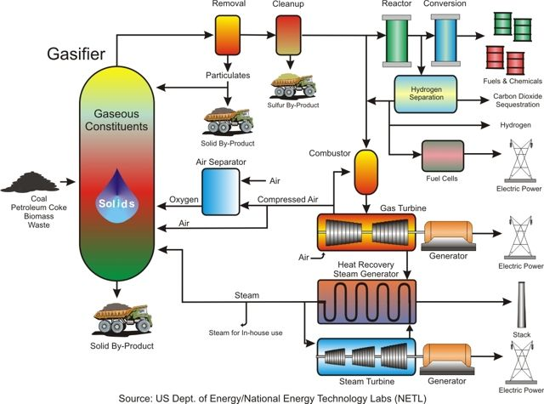

Figure 5: IGGC system[37]

As shown in Figure 5, the biomass is gasified at temperatures between 1550F and 1750F. Compressed air and steam are the fluidizing and gasifying agents that generate the gas. The fuel gas is cooled to about 1000F to condense any vapor-phase alkali substances on the particulates. The particulates are then removed fuel gases combusted in the gas turbine, which produce electricity and high temperature steam.

***Fluidized-bed gasifier***

Fluidized bed is comprised of granular solids that are “semi-suspended” by the movement of the gasifying medium. Solid Fuel enters from the top and comes into contact with the hot solids in the bed and is heated to the bed temperature. The gasifying medium (oxygen and steam) enters through the bottom of the gasifier and also serves a fluidizing agent. The biomass goes through a rapid drying process and pyrolysis, forming char and gases.

Although entrained-flow gasifier is the preferred reactor of IGCC plants because it can produce cleaner, tar-free gas, it will not be used because it requires the feed to be in powdered form. The need to grind the biomass into fine particles makes it undesirable, considering the cost of the process. Also, the short residence time associated with this gasifier may prevent complete gasification of the char.

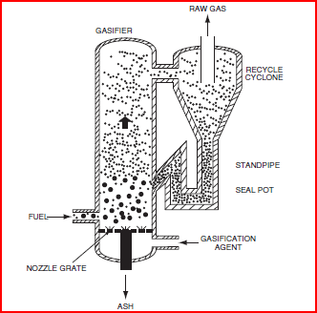

Figure 6: Circulating Fluidized-bed for Biomass Gasification[38]

In a circulating fluidized bed (CFB) gasifier, solids are mixed intensely which operates at temperatures between 800 and 1000C. The relatively low temperature is adequate for biomass gasification with low chance of ash sintering or agglomeration in biomass with ash content. It is also insensitive to fuel quality, so it can be used for biomass with low fuel quality. This equipment is suitable for a mixture of biomass because of the vigorous mixing involve and the temperature uniformity. Additionally, the CFB allows for a long gas residence time, and compatible with fuels with high volatiles, making it suitable for biomass gasification.

The bed is first heated by an overbed burner or burning gas, and when the temperature reaches the ignition temperature of the biomass the fuel is fed into the gasifier. One issue with fluidized-bed is that char particles can escape with the fuel gas causing carbon loss. A cyclone can be used to return the char particles to the gasifier.

***Air Separator***

An air separator is used to produce oxygen which is used as the gasifying medium, instead of air. This is essential, because the heating value of product gas is higher when oxygen is used as opposed to air (12-28 MJ/Nm3 compared to 4-7 MJ/Nm3). The nitrogen in air dilutes the product, which decreases the heating value of the gas.

***Emissions***

Emissions from a gasification system for biomass include particulates, NOx, CO, SOx, and ash. The fuel gas exiting the gasifier contains gases as well as particulates. These particulates would first need to be removed from the gas before use to prevent system degradation. A cyclone can be used to remove the larger particulates, followed by the electrostatic precipitator to remove the smaller particulates. Another option would be to use candle filters, which can remove all solids from the gas by depositing the solids on the side of the candle. Upon removal of particulates, the fuel gas composition is similar to what is shown in Table 3 below.

Table 4: Fuel gas composition[39]



As the table shows, the fuel gas contains a significant amount of CO2. Before combusting the gas, CO2 can be separated from the syngas, and this will decrease the amount that comes out of the stack. For this a membrane will be used to separate the CO2 before sending the gas into the turbine.

1. **Biomass IGCC Plant Design**

As previously mentioned, the proposed Biomass IGCC plant is intended to supply about 25 percent of Penn State’s electricity consumption. The 10MW plant is assumed to have an efficiency of 40 percent and a capacity factor of 85 percent.

* 1. ***Plant Location***

The plant will be located next to an existing generating plant. This is vital as it allows for the sharing of the electrical substation[40]. The biomass plant can be located next to the West Campus Steam Plant on Burrowes Road. This location is ideal as it is close to road, hence convenient for fuel delivery. Land requirement for a typical IGCC plant is around 0.541 acre/MW[41]. A 10MW biomass plant will require approximately 5.41 acres of land.

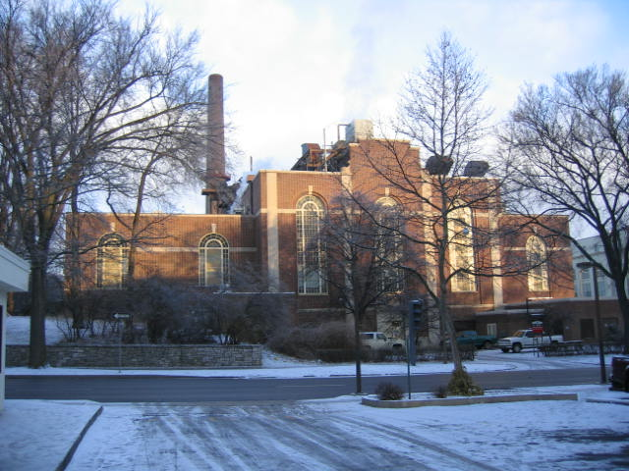

Figure 7: PSU West Campus Steam Plant

* 1. ***Fuel Supply & Handling***

The objective is to acquire biomass fuel within 50 miles radius of State College in order to minimize transportation cost as much as possible. To assure constant and reliable supply of fuel, it would be preferred to have a partnership with a supplier that would assure fuel availability. During the course of our assessment, we discovered **Energex,** a pellet manufacturing company in close proximity to the University Park campus (a little over 40 miles). Upon initial contact with a representative from the company the cost of delivery of biomass was reported at $150 per short ton. The company’s capacity is 120,000 short tons per year, and it is deduced that it is willing to form a partnership with Penn State in regards to biomass supply[42].

The wood pellets, which will be delivered via trucks, has a low moisture content between 5 and 6 percent and ash content of about 0.5 percent, and heating value of about 8300 Btu/lb, which is higher than the 6400 Btu/lb for most wood biomass. Since the moisture content is already low, drying will not be necessary. Additionally, it is assumed that the sulfur content is negligible, therefore sulfur removal will not be implemented in the biomass IGCC plant[43].

The amount of fuel that will be needed for the plant is calculated to be about 50,000 tons per year (see Appendix for calculations). Although the heat content reported for the pellets is 8300 Btu/lb, the literature value of 6400Btu/lb was used for the “worst case scenario” analysis. The wood storage unit is designed to hold a 3-week supply of biomass (about 2822 tons).

* 1. ***Gasifier***

A Circulating Fluidized Bed Gasifier is used with silica sand and 20 wt. % calcinated dolomite

as the circulating and stationary bed material. An additive (limestone) is also added for tar cracking. Commercial CFB are not common place so there are no standards for detailed design. Therefore information gathered from literature review was used to optimize the gasifier design.

The primary oxidant is fed through the bottom of the gasifier, and a secondary oxidant is fed towards the top of the gasifier (see figure). This is to help increase the gasifier temperature at the top, which decreases tar formation in the gas flow. The gasifier will be operated at 1000oC, as any lower than that will increase tar formation. Using a throughput of 1740kg a.r/h m2, and a gasifier height of 14.8m, the diameter was calculated as 1.94m (see Appendix for calculations)[44].

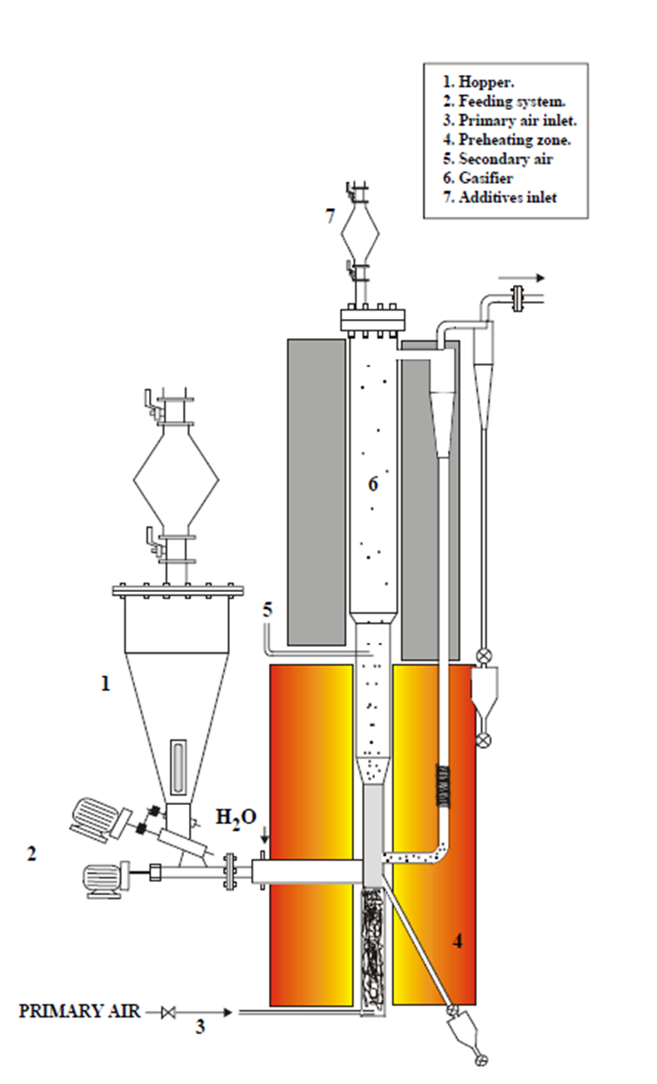

Figure 8: The gasifier design depicting the primary and secondary oxidant inlet

The biomass is fed through a hopper (number 1 in the figure 8) and the gasifier is at a pressure of 18 bar. The high pressure makes the process more complex and can potentially increase the capital cost, however the fuel gas that will be combusted will be at pressure, eliminating the need to pressurize it[45]. The producer gas carries the bed material and the char to the top of the gasifier into the cyclone, which separates the solids from the gas and returns the solids to the bottom of the gasifier. The char is combusted at the bottom of the gasifier to maintain the temperature[46].

* 1. ***Air Separation Unit***

The use of an air separation unit is favorable because using oxygen as the oxidant prevents the dilution of the fuel gas with nitrogen. It also reduces the formation of NOx and produces medium heating value gases rather than low heating value gases[47]. The reduction of nitrogen also increases the cold gas efficiency, however, the increase in efficiency cannot pay for the investment of incorporating an ASU unit[48]. Therefore the gasifier will be air-blown.

* 1. ***Gas Clean-Up***

The hot gas exiting the gasifier will be cooled to a temperature of about 500oC through direct injection of water. This also condenses the alkali species in the gas. Although the injection of water dilutes the fuel gas, it is the simplest and least expensive method. In addition, it will help to reduce the formation of NOx in the combustor[49]

The two particulate removal systems that were considered are hot candle filter and an electrostatic precipitator. The hot candle filter removes particulates by depositing the solids of the candle. A Westinghouse ceramic candle filter can cost about $36/kw, and an electrostatic precipitator can cost up to $50/kw[50][51].

* 1. ***CO2 Capture***

The separation of CO2 is an option that was considered to minimize the amount of that the system eventually releases into the environment. Pre-combustion capture of CO2 (removal before fuel gas is combusted) was considered for the design of this plant. Since air is being blown in the gasifier, the dilution of the fuel gas by nitrogen greatly lowers the benefits of capturing CO2. The amount of carbon emissions avoided is about 0.14kg/kWh, but carbon capture can decrease efficiency by up to six percent, and increase capital cost of by up to 38 percent, and operating and maintenance cost by 31 percent. Additionally, the cost of carbon mitigation is about $123 per ton of carbon captured[52].

Upon capturing CO2, decision must be made regarding whether to utilize or sequester it, and this is beyond the scope of such a small IGCC plant. A biomass IGCC plant already has its environmental benefits, and although a CO2 capture can only make it more environmentally friendly, this would create an economic burden on the system. As a result, the biomass plant will simply be an air-blown standard IGCC plant.

* 1. ***Gas Turbine***

For our small plant**,** the GE10 gas turbine can be used. This heavy-duty machine has an el**ec**trical output of 11.25 MW and an efficiency of 31.4 percent. The engine’s flexibility allows for the application of a variety of fuels, and is ideal for gases with low heating value, so it is appropriate for our design. The turbine has a pressure ratio of 15.5, and consists of three reaction stages. During the first two stages, the hot gas is cooled with the air that is extracted by compressor, and the second and third stages are designed to have interlocked shrouds in order to limit blade vibrations and tip leakage[53].

* 1. ***Heat Recovery Steam Generator (HRSG)***

The design of the HRSG is based on characteristics of the exhaust gas exiting the gas turbine. Heat is produced in the HRSG drum and then mostly sent to the steam turbine to generate additional electricity.

* 1. ***Water Supply***

IGCC plants use approximately 360-540 gallons of water per megawatt[54]. This is equivalent to about 27-40 million gallons per year needed for the plant. Like the PSU west campus steam plant, our plant can have its water sources from both borough water as well as campus water. This water contains 550 ppm of total dissolve solids and 350 ppm hardness. The water will be softened by removing calcium and magnesium and demineralized prior to use[55].

1. **PERMITTING, REGULATIONS AND CAPACITY ISSUES**
   1. ***NPDES – National Pollutant Discharge Elimination System***

The NPDES permit program is authorized by the Clean Water Act (CWA) section 402. This permit program is in control of water pollution and regulates point sources that discharge pollutants into waters of the United States. Point sources can be defined as anything that carries or has the potential of carrying pollutants; examples of such are pipes or man-made ditches. Individual homes do not need an NPDES permit due to their connection to a municipal system; however, industrial, municipal, and other facilities must obtain permits if their discharges go directly to surface waters (EPA, 2009). This permit has to be granted in order to get the ball rolling on this project implementation.

* 1. ***PCSM – Post Construction Storm-water Management***

This refers to permanent storm water management measures that will stay in place once the project is built and it is not just limited to during construction. A post-construction permit is required in addition to a general permit for the construction activity. A storm water permit governs the design, installation, and construction of storm water management and control practices on the site. These measures don’t just include structural Best Management Practices (BMPs), but also other elements of site design for storm water management. The permit is intended to provide a mechanism for the review, approval, and inspection of the proposed storm water management methods for the development or redevelopment site, including structural BMPs and other techniques such as low-impact or low-density design. Requirements for deed restrictions, operation and maintenance, annual inspections, and reporting and record-keeping are also part of the permit.[56] Also, other local post-construction requirements may apply.

* 1. ***MACT- Maximum Achievable Control Technology***

There are standards set and governed by the Environmental Protection Agency (EPA) that are to be followed due to the potential increase in fatalities or serious illnesses that may result from emissions. These standards are referred to as the National Emissions Standards for Hazardous Air Pollutants (NESHAPs). And the EPA decides for a particular source what the maximum achievable decrement in emissions can be reached based on the technology and new methods available. This is called the Maximum Achievable Control Technology[57].

* 1. ***Electrical capacity compatibility***

Whenever power is generated in the plants, the electricity is stepped up by a transformer to high voltages of 230,000KV and 500,000KV to be transmitted to the substations. The stepping up of the voltage is to prevent potential losses in energy from heat and through the transmission lines[58]. The electricity produced can be used to serve the consumers immediately or stored for future use.

The Pennsylvania State University has a policy of using the power it produces without having to worry about storing for future use. This makes the process of supplying 25% of the total campus electricity demand interesting and much more tasking. After generating and transmitting the electricity, a substation is needed to step it down to be able to be used. Below is a schematic diagram of an electrical system from the generation of electricity to the distribution to the customers.

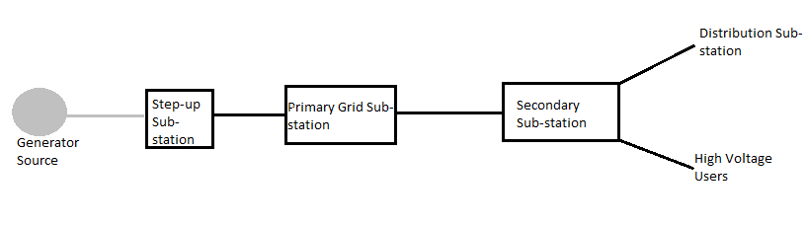

**Figure 9: Schematic Diagram of a model electrical system**

Sub-stations are very essential to the transmission and distribution process and we face an arduous task in incorporating that into this project. The substation on Penn State campus that similarly models the sub-station needed will be the West Campus sub-station which is a secondary sub-station and has a capacity of 6MW at the moment. Some components that make up this sub-station include circuit breakers, current transformers, isolators, conductor systems, insulators, power transformers and overhead line terminations. Each one of these components is rated for a specific range of values on the transmission side and distribution side; therefore having the necessary rated components is crucial to avoid any safety issue. The Penn State distribution system is special in such a way that included in it is a contingency plan to pick up loads at any point in the network. Each distribution point has two ways in which electricity is fed to it and one remains open without carrying any load while the other carries the entire load. In case of an outage of maintenance, there will be a switch to the normally open feed to accommodate the load. Inputting 25% of the entire capacity on this network will pose an issue of assigning loads to the different points in the distribution network. This issue can be resolved by changing out the components of the West Campus sub-station to adequate rated components to satisfy the capacity of electricity coming through or build a new sub-station to satisfy those needs.

The idea we are going with of retro-fitting involves the addition of 4MW more of electrical capacity to the system being delivered by the WCSP. This can create a wide array of issues like stressing of the existing equipment which could lead reduce the quality and capacity of these equipment. To combat those issues for an efficient and reliable production of electricity, retro-fitting the power plant to fit the needs of a 10MW capacity will be best for this proposed biomass plant.

Some of the equipment that will be affected is the switch boxes, sectionalizers, CT’s, circuit breakers, fuses and the entire wiring for distribution to suit the generated capacity. This will no doubt have its advantages such as overall cost reduction in the long term (even though we will incur some additional initial costs associated with this procedure), compliance with the latest environmental and safety regulations which will serve as a double entry check method for complying with Act 213 and also reduction in maintenance related issues. While doing this, one factor we have to consider will be current policies that Penn State has through the Office of Physical Plant (OPP). Penn State OPP policy is to have the allotted demand on the electrical network system so this means that each point of distribution has a normally open switch and a normally closed switch. There is even distribution of load across the system. To keep this policy this way, we have to ensure that while retro-fitting the plant we keep a balanced load structure on the system with the normally closed and normally open points to account for system contingency in the event of a failure.

1. **Environmental Considerations**
   1. ***Life Cycle***

Biomass absorbs about 890g of CO2/kWh. The reason they are considered carbon neutral is the fact that CO2 released during the conversion of biomass to energy is simply the carbon they absorb during photosynthesis. Hence a biomass IGCC power plant will release the 890g CO2/kWh that was previously absorbed. Other processes involved in between the harvesting of biomass to its utilization must be considered, nonetheless. This includes biomass production, transportation, etc. These processes release about 49g of CO­2/kWh[59]. The net emission of CO2 from a biomass IGCC plant is about 49g/kWh, not zero.

The amount of fossil energy consumed is approximately 231KJ/kWh. Given that there are 3600 mega joules in one megawatt-hr, the energy ratio of the biomass IGCC plant is 15.6 (3600/231). It must be noted that this only considers the amount of fossil energy consumed by the plant and relates it to the energy output of the plant. The energy consumed from biomass is not considered.

* 1. ***Wastes***

The tar produced can either be combusted in a separate combustor to produce steam for the plant, disposed, or left in the fuel gas. Combusting the tar will require extra equipment, which means higher cost, and disposal of tar generates cost wastewater and tar disposal. The tar will be left in the fuel gas and combusted with the fuel gas to save cost. At high temperatures tar accumulation in the filter is greatly minimized[60].

One of the by-products that will require specific attention is the bottom ash which is non-combustible residue form the process. Adequate attention should be given to the handling of this product from the removal to the disposal or secondary use. Contracts may be signed with existing mine companies to dispose this product in their unused mines and if there are changes to the quantity produced, the companies should be made aware beforehand so that the contract may be altered and an agreement reached. This by-product may be used in part for road construction and also the manufacture of cinder blocks. Companies that need this by-product should be investigated to avoid mass disposal of this waste. Attention must be paid to the local, state and federal regulations surrounding this product and care should be taken to follow suit.

* 1. ***Act 213***

This act ensures that all qualified alternative energy sources meet all applicable environmental standards and shall verify that an alternative energy source meets the standards. Section 7(b) of Act 213 provides for the following responsibilities for the Pennsylvania Department of Environmental Protection: “The Department shall ensure that all qualified alternative energy sources meet all applicable environmental standards and shall verify that an alternative energy source meets the standards set forth in section 2[61].”

* 1. ***Anticipated Environmental Requirements*** 
     1. ***Air Pollution***

The state of Pennsylvania has regulations that currently impose standards on pollutant emission sources under the Air Pollution Control Act (APCA)[62]. This act aims to provide better protection of the health, welfare and property of people of the commonwealth by the control, abatement, reduction and prevention of the pollution of air. This biomass plant will have some pollution and we are faced with the task of achieving compliance with the ambient air quality standards.

* + 1. ***Ambient Air Quality***

Pennsylvania State University is located in Centre County, which is in the Central Pennsylvania Interstate Air Quality Control Region (AQCR-195). The EPA (Environmental Protection Agency) has designated standards to control the ambient air quality. However, due to the fact that Pennsylvania is located in the Northeast Ozone Transport Region some exceptions and rule differential may apply.

* + 1. ***Environmental Control Definition***

Identifying what is to be controlled and evaluating how it is going to be controlled will be the approach to this process. The New Source Performance Standards (NSPS) is issued by the Environmental Protection Agency (EPA) to control pollution under the Clean Air Act (CAA) and the Clean Water Act (CWA). Under the CAA, the NSPS controls the pollutions from a new source; and is grouped into categories of which boilers is one. Under the CWA, the NSPS sets the level of wastewater discharge from new facilities. These are the allowable emissions for the major volatile organic compounds that we will encounter:

* PM10 15TPY (tons per year)
* SO2 40TPY
* NOX 40TPY
* CO 100TPY
* VOC 40TPY
  1. ***Good Engineering Practice (GEP) Stack Height***

The EPA has generated formulae for the calculation of the maximum stack height that does not exceed good engineering practice (40 CFR 51.100(ii)) which states that GEP stack height means the greater of:

1. 213 feet, measured from the ground-level elevation at the base of the stack, or
2. Hg = H + 1.5L

Where

Hg = GEP stack height, measured from the ground-level elevation at the base of the stack

H = Height of nearby structure(s) measured from the ground-level elevation at the base of the stack

L = lesser dimension, height or projected width, of nearby structure(s)

The design structure of the source must be in accordance with this GEP standard.

* 1. ***Water Pollution***

There are two types of scenarios to be considered in regards to water pollution; one being for wastewater discharged into water bodies and the other being wastewater discharged into a Sewage Treatment Plant (STP). The NPDES is the permit that governs the wastewater discharges to water bodies while the following rules typically apply to discharges to an STP however, the specific local requirements will be examined:

* Should not contain wastewater with a pH of less than 5 or greater than 10;
* Should not contain pollutants which create a fire or explosion hazard;
* Should not contain polychlorinated biphenyls (PCBs);
* Should not contain solid or viscous pollutants in amounts that will cause obstruction to the flow;
* Should not contain heat in amounts which will inhibit biological activity;
* Should not contain pollutants in concentrations greater than those listed below:

Substance Concentration (mg/l)

Arsenic 0.1

Cadmium 0.07

Chromium 0.2

Copper 0.005

Lead 0.1

Mercury 0.02

Silver 3.0

Zinc 0.08

Cyanide 0.1

Nickel 0.25

* 1. ***Noise***

There are no specific noise requirements or standards under the Pennsylvania regulation but these concerns are usually taken into consideration under the nuisance statutes. Due to the location of the plant around campus there will be increased noise levels especially from the truck traffic of delivering the biomass feedstock. Noise levels of 45 decibels are associated with indoor residential areas, hospitals and schools, whereas 55 decibels is identified for certain outdoor areas where human activity takes place. The level of 70 decibels is identified for all areas in order to prevent hearing loss[63]. The decibel level attainable for this plant will be in the range of 65dB and this allows for undisturbed speech at a 3 feet distance. However, mitigation techniques and infrastructure may be used to lower the ambient noise levels.

1. **INCENTIVES**

Biomass relies on legislation or regulation to compete with fossil fuels in the near term based on the environmental attributes of renewable energy. Renewable energy certificates (RECS), represent the environmental attributes of renewable energy are being sold in wholesale and retail markets across the U.S. The electricity generated by biomass can be sold at market price and the RECs typically sell from 1.5-2.5¢/kWh which could provide an additional revenue stream.

* 1. ***Modified Accelerated Cost-Recovery System (MACRS) & Bonus Depreciation (2008-2012)***

Under this system, certain businesses are allowed to recover investments for their properties through depreciation deductions. These deductions range from a period of five years, seven years up to ten years in some cases. The allocation of the deduction schedule is mainly dependent of the types of property in question. Based on our proposed power plant, we are choosing a five year depreciation schedule for the MACRS we are incorporating into the economic model. For the proposed biomass plant to be eligible for this incentive, it has to satisfy the criteria given below[64].

* The property must have a recovery period of 20 years or less under normal federal tax depreciation rules;
* The original use of the property must commence with the taxpayer claiming the deduction;
* The property generally must have been acquired during the period from 2008 - 2012; and
* The property must have been placed in service during the period from 2008 - 2012.

To obtain the depreciation schedule to fit the proposed biomass plant, we used a general depreciation system (GDS) with a 200% depreciation method and a half-year convention.

Table 5: Depreciation Schedule for a 5-year MACRS[65]

|  |  |
| --- | --- |
|  |  |
|  | Fraction |
| Year 1 | 0.2000 |
| Year 2 | 0.3200 |
| Year 3 | 0.1920 |
| Year 4 | 0.1152 |
| Year 5 | 0.1152 |
| Year 6 | 0.0576 |
| Year 7 | 0.0000 |
| Year 8 | 0.0000 |
| Year 9 | 0.0000 |
| Year 10 | 0.0000 |
| Year 11 | 0.0000 |
| Year 12 | 0.0000 |
| Year 13 | 0.0000 |
| Year 14 | 0.0000 |
| Year 15 | 0.0000 |
| Year 16 | 0.0000 |
| Year 17 | 0.0000 |
| Year 18 | 0.0000 |
| Year 19 | 0.0000 |
| Year 20 | 0.0000 |
| Total | 1.0000 |

* 1. ***Renewable Electricity Production Tax Credit (PTC)***

Under this system, tax credit amounts are given to eligible energy resource facilities per kilowatt hour of production and sold by the facility during the taxable year. This will be an incentive incorporated into economic analysis and it will be easy to model due to the credit amount given in $/kWh which will be the base of comparison of the biomass plant with the current price of electricity. Based on the biomass plant we will be proposing, there will be an important consideration that has been identified and should be noted; the duration of this credit will be for five years only due to the facility being an open-loop biomass facility and it’s going to be placed in service after October 22, 2004 [66].

Table 6: Credit Amounts Under the PTC

|  |  |  |
| --- | --- | --- |
| **Resource Type** | **In-Service Deadline** | **Credit Amount** |
| Wind | December 31, 2012 | 2.2¢/kWh |
| Closed-Loop Biomass | December 31, 2013 | 2.2¢/kWh |
| Open-Loop Biomass | December 31, 2013 | 1.1¢/kWh |
| Geothermal Energy | December 31, 2013 | 2.2¢/kWh |
| Landfill Gas | December 31, 2013 | 1.1¢/kWh |
| Municipal Solid Waste | December 31, 2013 | 1.1¢/kWh |
| Qualified Hydroelectric | December 31, 2013 | 1.1¢/kWh |
| Marine and Hydrokinetic (150 kW or larger)** | December 31, 2013 | 1.1¢/kWh |

1. **Economic Analysis**

The cost of electricity generation, whether it is the current cost or projected future cost, is crucial to the development of energy plans and the analyses that ought to follow. This economic analysis showing the cost of electricity for the proposed biomass plant will also help to determine the plant will compete against the existing price of electricity, and how the plant will perform with environmental controls imposed and standards associated with new technology that will be required in the design of the biomass plant. The current and future costs of energy-related capital projects, including but not limited to new electricity generation plants, have been subject to considerable change in recent years; so to perform a thorough analysis some key considerations will be made and are outlined in the table below. However, one crucial factor that should be pointed out is that the focus of the analysis will be based on “overnight” costs.

Overnight cost is an estimate of the associated costs with which a plant could be constructed assuming the entire construction process occurs in one day. This is a useful concept because it avoids fluctuations in the associated costs which will greatly impact the final output of the analysis. Where possible, cost estimates were based on information regarding actual or planned projects available. When this information was not available, project costs were estimated using costing models that account for labor and material rates that would be necessary to complete the construction of a generic facility. Although the costs are based on “overnight” values, effects of inflation and real market situations will be modeled into the calculations to come up with more accurate figures.

While estimates of the current cost of electricity generation is essential to the analysis of the market for feasibility studies, factors including the projected evolution of capital costs over the modeling horizon, additional costs stemming from environmental control requirements, projected fuel costs and load growth also contribute to the electricity mix for the analysis of a project. Levelized cost is often cited as a convenient summary of the overall competitiveness of different electricity generating technologies. Levelized cost represents the present value of the total cost of building and operating a generating plant over an assumed economic life, converted to annual payments and expressed in terms of real dollars.

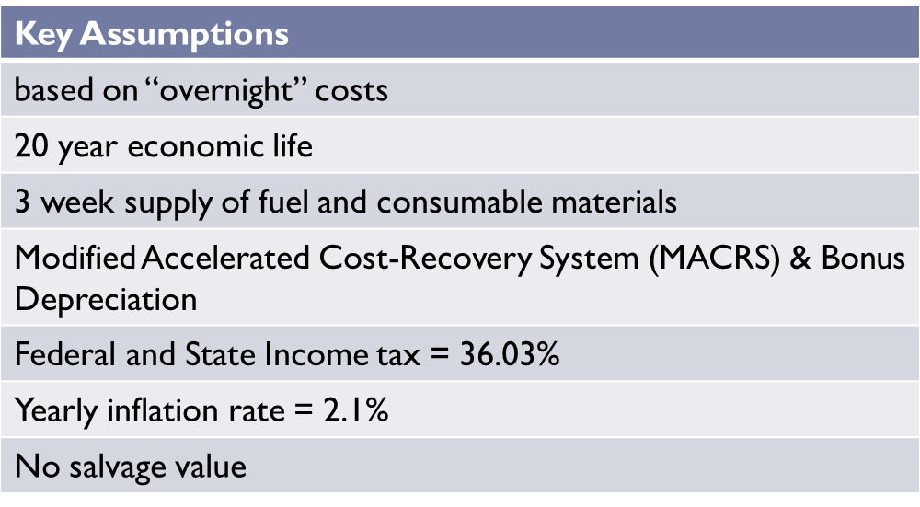

From the literature, the capital cost associated with a biomass IGCC power plant is about $3565/KW (USEIA, 2010)[67]. This includes equipment costs from the wood handling, gasification, particulate cleanup, HRSG and the other systems that make up the biomass plant. Also construction, electrical, fees and contingency costs were also included in the calculation of the capital cost. To get a more accurate estimation of the individual capital costs of the systems associated with the biomass plant, a breakdown of the percentages of costs was adapted and is listed below[68].

Table 7: Capital Cost Breakdown

|  |  |
| --- | --- |
| **PLANT SECTION DESCRIPTION** | **EQUIPMENT COST ($)** |
| Wood Handling | 906815.681 |
| Gasification | 8751835.464 |
| Particulate Cleanup | 1126738.306 |
| Quench System | 6259.657255 |
| Gas Turbine | 5492223.276 |
| HRSG | 921421.548 |
| Steam Cycle | 1307433.745 |
| Air Boost Compressor | 246213.1854 |
| Char combustor | 507032.2377 |
| B.O.P | 4080461.909 |
| General Plant Facilities | 2448360.608 |
| Engineering Fees | 3672332.256 |
| Project Contingency | 4039565.482 |
| Adjustment for Interest and Inflation | 83462.09674 |
| Prepaid Royalties | 122271.9717 |
| Startup costs | 938948.5883 |
| Spare parts | 173183.8507 |
| Working Capital | 825440.1367 |
| **Total** | **35650000** |

The price of the feedstock for the biomass plant obtained from a vendor was $150/short ton of wood pellets. This converts to $165.35/ton; and together with other expenses such as labor, maintenance, insurance, ash disposal, management and utility costs, the total O & M expenses cost $13,243,524. Inclusion of the CO2 capture technology system increases the capital costs by 38% bringing it to $49,197,000 and also increases expenses by 31% totaling $17,349,016.44. Based on the costs obtained above, yearly cash flows were generated from the model adapted for the economic analysis[69]. The present worth calculated for the life span of the biomass plant assuming a 20 year period was based on the formula below:

NPV = $\sum{{(1+i)}^{-N}}$

This when calculated gives a value of $111,586,162. A capital recovery factor, which is the ratio of constant annuity to the present value of receiving that annuity for a given length of time, is used to generate the current and constant annual revenue requirements which in turn give the current and constant Levelized Annual Cost (LAC) of energy. Those values are $0.2394/kWh and $0.2087/kWh respectively.

1. **Sensitivity Analysis**

In a competitive market, demand and supply change with respect to many variables; and this in turn affects the price of the commodity demanded and supplied. The proposed biomass plant has costs associated with feedstock price, yearly costs from maintenance and technology up-keep, and most importantly in present day society the compliance with environmental standards. All these factors may create disruptions in the constant prices that have been incorporated into this model for the calculation of the LCOE. For this biomass plant, disruptions in fuel supply, quantity and quality, technology choice, efficiency, operating performance and reliability will be considered for the sensitivity analysis. The sensitivity analysis for the capital cost as shown in TABLE A3 in the appendix proves that increase in the capital cost will increase the LCOE for the biomass plant. The analysis of the fuel cost in TABLE A4 also in the appendix showed the same trend; however, the analysis of the efficiency of the plant showed the inverse where an increase in the net efficiency will reduce the LCOE shown in TABLE A5 in the appendix.

1. **Conclusion**

This biomass system for production of electricity proves to be advantageous in the environmental aspects with reduced levels of CO2 and other pollutants that the conventional methods of electricity production deal with. The LCOE of this biomass plant is about twice the current market price for electricity at 10c/kWh which puts this plant at an economic disadvantage. It will be difficult to justify implementing this facility on Penn State’s campus due to the effect of the higher cost on the university’s budget which will spill over to the tuition paid by the students. In intricate economic times like this it is not feasible, however, with better incentives and an improvement of some factors such as the net station efficiency, interest rate and debt ratio, the proximity of the LCOE of this plant can be brought closer to the current market cost of electricity.

# Appendix

1. **Fuel Requirements Calculations**

H2: 17%=> 10344.25 Btu/lb

CO: 22%=> 892.4 Btu/lb

CH4­: 3%=> 717.821 Btu/lb

**Total Heating value of gas**=> 11954.5 Btu/lb

**Heating value of wood**=>6400 Btu/lb

**Energy requirements** (85 percent capacity factor) =10MW*0.85*365*24=74460 mWh

74460Mwh*3412141.63=254,068,065,769.80 Btu/year

**Mass of gas per year** (40 percent efficiency): 254,068,065,769.80 Btu/(11954.5Btu/lb*0.4)= 53132516.34lb/yr

Lb wood/lb gas= (11954.5Btu/lb)/(6400Btu/lb)=1.867

Mass of wood= (1.867lb wood/lb gas)*(53132516.334lb gas) =99245338.19lb/yr

Mass of wood needed= 99245338.19lb*(1ton/2000) =49,622.66tons/yr

|  |  |  |  |  |  |
| --- | --- | --- | --- | --- | --- |
| Components | Heating Value | Composition |  |  |  |
|  | MJ/kmol | % | MJ/kmol | Molar weight (Kg/kmol) | HHV (btu/lb) |
| H2 | 285.84 | 17 | 48.5928 | 2.02 | 10344.25244 |
| CO | 282.989 | 22 | 62.25758 | 30 | 892.3793992 |
| CH4 | 890.3 | 3 | 26.709 | 16 | 717.8210681 |
|  |  |  |  | HHV gas | 11954.45291 |
|  |  |  |  | HHV wood | 6400 |
| Energy | 254,068,065,769.80 | Btu/yr |  |  |  |
| Mass per year | 53132516.34 | lb/yr |  |  |  |
| lb wood/lb gas | 1.867883267 |  |  |  |  |
| lb wood | 99245338.19 |  |  |  |  |
| ton wood | 49622.6691 | ton/yr |  |  |  |
|  | 5.664688253 | ton/hr |  |  |  |

1. **Gasifier Sizing**

Throughput: 1740 kg/h*m2

Cross-sectional area= Mass inlet/throughput

Diameter= (Area*4/3.14)1/2

|  |  |  |
| --- | --- | --- |
| Gasifier Sizing | Modeling circulating fluidized bed |  |
| **Throughput** | 1740 | kg/h*m2 |
| **Mass inlet** | 5149.716594 | kg/hr |
| **cross-sectional area of gasifier (dilute zone)** | 2.959607238 | m2 |
| **diameter** | 1.941700364 | m |

**TABLE A1: SPREADSHEET CALCULATIONS AT $3565/KWH**



**TABLE A2: FINANCE TERMS**



**TABLE A3: SENSITIVITY ANALYSIS OF THE CAPITAL COST**



**TABLE A4: SENSITIVITY ANALYSIS OF THE FUEL COST**



**TABLE A5: SENSITIVITY ANALYSIS OF THE EFFICIENCY**



1. "Green Power: Penn State's Procurement of Renewable Power." *Penn State Office of Physical Plant*. Penn State University, n.d. Web. 3 Mar 2011.
2. Jeffrey Logan, Stan Mark Kaplan. “Wind Power in the United States: Technology, Economic, and Policy Issues” CRS Report for Congress, June 20, 2008
3. Michael Schmidt. “Wind Turbine Design Optimization” Strategic Energy Institute
4. "Wind Electricity Generation." *Practical Action; Technology challenging poverty*. The Schumacher Centre for Technology and Development, n.d. Web. 3 Mar 2011
5. Quaschning, Volker. *Renewable Energy and Climate Change*. West Chester: Wiley-IEEE Press, 2010. Print.
6. "Wind speed and Wind Energy." *Wind Energy*. Energy Bible, 2010. Web. <http://energybible.com/wind_energy/wind_speed.html>.
7. Courtney, Richard. "Wind Farms Provide Negligible Useful Electricity." Center for Science and Public Policy, 03/2006. Web
8. Jeffrey Logan, Stan Mark Kaplan. “Wind Power r in the United States: Technology, Economic, and Policy Issues” CRS Report for Congress, June 20, 2008.
9. EIA “Renewable Biomass” <http://www.eia.doe.gov/kids/energy.cfm?page=biomass_home-basics-k.cfm>
10. Quaschning, Volker. *Renewable Energy and Climate Change*. West Chester: Wiley-IEEE Press, 2010. Print
11. Dhaneswar, Sakhivale, Heather Fennessey, and Hari Jammulamadaka. "IMPLEMENTATION OF BIOGAS OR BIOMASS AT THE PENNSYLVANIA STATE UNIVERSITY’S WEST CAMPUS STEAM PLANT." *Integrative Design of Energy and Mineral Engineering Systems*. (2010): Print
12. Cheng, Jay. *Biomass to Renewable Energy Processes*. Boca Raton: CRC Press, 2010. Print
13. Demirbas, Ayhan. "Combustion characteristics of different biomass fuels." *Progress in Energy and Combustion Science* 30. (2004): 219-230. Web
14. Cheng, Jay. *Biomass to Renewable Energy Processes*. Boca Raton: CRC Press, 2010. Print
15. "Techline." *Wood Biomass for Energy*. Forest Products Laboratory, 2004. Web.
16. Power Scorecard. “Electricity from: Biomass” http://www.powerscorecard.org/tech_detail.cfm?resource_id=1
17. Quaschning, Volker. *Renewable Energy and Climate Change*. West Chester: Wiley-IEEE Press, 2010. Print.
18. United States. *Pennsylvania-Annual Average Wind Speed at 80m.* , 2010. Web
19. Centre County Planning Commission, *Physiographic Regions of Centre County*. , 2002. Web.
20. United States National Renewable Energy Research Laboratory. *Estimates of Windy Land Area and Wind Energy Potential by State for Areas >=30% Capacity Factor at 80m*. , 2010. Web
21. Commonwealth of Pennsylvania... *Sandy Ridge Wind Farm Project*. , Web. 24 Feb 2011. <http://recovery.pa.gov/portal/server.pt?open=514&objID=525527&mode=2&projectId=DEP35368
22. Personal interview with Dr. Susan Stewart, Applied Research Lab. February 14, 2011
23. "Blair County wind projects reach peak." *National Wind Watch*. National Wind Watch, Inc., 28102010. Web. 24 Feb 2011. <http://www.wind-watch.org/news/2010/10/28/blair-county-wind-projects-reach-peak/>.
24. "Map of Taylor Township, Centre County, Pennsylvania Highlighted." *WikiMedia Commons*. Web. 24 Feb 2011. <http://commons.wikimedia.org/wiki/File:Map_of_Taylor_Township,_Centre_County,_Pennsylvania_Highlighted.png>
25. "Sandy Ridge Wind Farm windfarm, USA." *The Wind Power: Wind Turbines and Windfarms database*. N.p., 12/2010. Web. <http://www.thewindpower.net/wind-farm-15511.php>.
26. M., Gilbert. *Renewable and efficient electric power systems*. Wiley-IEEE Press, 2004. Print.
27. http://www.pabiomass.org/aboutus.html
28. United States National Renewable Energy Research Laboratory. *Dynamic Maps, GIS Data, &Analysis Tool: Biomass Maps June 15, 2010*. Web
29. ### Centre County Solid Waste Authority Advisory Commission. <http://www.co.centre.pa.us/commissioners/abc.asp>.

   
30. Dhaneswar, Sakhivale, Heather Fennessey, and Hari Jammulamadaka. "IMPLEMENTATION OF BIOGAS OR BIOMASS AT THE PENNSYLVANIA STATE UNIVERSITY’S WEST CAMPUS STEAM PLANT." *Integrative Design of Energy and Mineral Engineering Systems*. (2010): Print
31. Amos, Wade. United States National Renewable Energy Research Laboratory. Report on Biomass Drying Technology. *November, 1998*. Web
32. Massachusetts Division of Energy Resources. *Wood Pellet heating.* , 2007. Web.
33. "PA Pellet Listing." *WoodPelletPricing*. N.p., n.d. Web. 4 Mar 2011. <http://www.woodpelletprice.com/index.php?option=com_fabrik&view=table&tableid=30&resetfilters=0&WP_pellets___pell_in_state=PA&on>.
34. Demirbas, Ayhan. "Combustion characteristics of different biomass fuels." *Progress in Energy and Combustion Science* 30. (2004): 219-230. Web
35. Cheng, Jay. *Biomass to Renewable Energy Processes*. Boca Raton: CRC Press, 2010. Print
36. Basu, Prabir. *Biomass Gasification and Pyrolysis: Practical Design and Theory.* London: Elsevier Inc, 2010.
37. "Technologies at work in RansonGreen." *Ranson Green* . Web. 24 Feb 2011. <http://www.ransongreen.com/Technology.htm
38. Higman, Christopher & Van der Burgt, Maarten. *Gasification*. 2nd. Elsevier Inc, 2008. Print
39. Basu, Prabir. *Biomass Gasification and Pyrolysis: Practical Design and Theory.* London: Elsevier Inc, 2010.
40. Craig, K. R., & Mann, M. K. (1996). Cost and Performance Analysis of *Biomass-Based Integrated Gasification Combined-Cycle (BIGCC) Power Systems.* Golden, Colorado: National Renewable Energy Laboratory
41. http://teeic.anl.gov/documents/docs/library/DesertRockDraftEIS_Chapter2.pdf
42. Rehorst, Jack. E-mail Interview by Olaide Oyetayo.
43. "Wood Pellets Review." *Energex Wood Fuel Pellets - Premium Grade Residential Pellets*. N.p., n.d. Web. <http://pelletreviews.com/Reviews/Wood-Pellets/Energex-Wood-Pellets.html>
44. Corella, Jose, and Alvaro Sanz. "Modeling circulating fluidized bed biomass gasifiers. A pseudo-rigorous model for stationary state." *Fuel Processing Technology* 86. (2005): n. pag. Web
45. Ciferno, Jared, and John Marano. United States. *Benchmarking Biomass Gasification Technologies for Fuels, Chemicals and Hydrogen Production*. , 2002. Web.
46. Stahl, Krister. "Biomass IGCC at Varnamo, Sweden-Past and Future." *GCEP Energy Workshop* (2004): n. pag. Web.
47. Ciferno, Jared, and John Marano. United States. *Benchmarking Biomass Gasification Technologies for Fuels, Chemicals and Hydrogen Production*. , 2002. Web.
48. Higman, Christopher & Van der Burgt, Maarten. *Gasification*. 2nd. Elsevier Inc, 2008. Print
49. Craig, K. R., & Mann, M. K. (1996). Cost and Performance Analysis of *Biomass-Based Integrated Gasification Combined-Cycle (BIGCC) Power Systems.* Golden, Colorado: National Renewable Energy Laboratory
50. United States. Department of Energy. Office of Fossil Energy. *Optimization of Advanced Filter Systems*. By R.A Newby, G.J. Bruck, M.A. Alvin, and T.E. Lippert. Pittsburgh: Westinghouse Science and Technology Center, 1998. Print.
51. Cichanowicz, Edward J. "Public Power." *The Trouble with Being Coal* Jan. 20011. *American Public Power Association*. Web.
52. Rhodes, James, and David Keith. "Engineering economic analysis of biomass IGCC with carbon capture and storage." *Biomass & Bioenergy* 29. (2005): n. pag. Web.
53. GE Oil & Gas "GE10-1 Gas Turbine" 2005.
54. "Water." *Generating Power Using Less Water*. FutureGenTexas, n.d. Web. 30 Apr 2011. <http://www.beg.utexas.edu/futuregentexas/pdf/FGT_water.pdf>.
55. "Steam Services-Fact Sheet." *Office of Physical Plant*. Penn State University, 03/2007. Web. <www.opp.psu.edu/about/divisions/operations/us/steam.cfm>.
56. U.S Environmental Protection Agency. National Pollutant Discharge Elimination System (NPES) . Post-Construction Stormwater Management in New Development and Redevelopment. <http://cfpub.epa.gov/npdes/stormwater/menuofbmps/index.cfm?action=min_measure&min_measure_id=5>
57. U.S Environmental Protection Agency. CAA Section 112(d)-Emission Standards <http://www.epa.gov/ttn/atw/112dpg.html>
58. **Jurado Francisco and Cano Antonio** Assessing power losses in gas and electricity distribution systems [Report]. - Benalmádena (Málaga) : IEEE MELECON, 2006
59. En Mann, Margaret. United States. *Comparison of the Environmental Consequences of Power from Biomass, Coal, and Natural Gas* . Colorado: , Web.
60. Craig, K. R., & Mann, M. K. (1996). Cost and Performance Analysis of *Biomass-Based Integrated Gasification Combined-Cycle (BIGCC) Power Systems.* Golden, Colorado: National Renewable Energy Laboratory.
61. Department of Environmental Protection. (n.d.). *Alternative Energy Portfolio Standards Act, Act 213.* Retrieved April 19, 2011, from Department of Environmental Protection: http://www.dep.state.pa.us/dep/deputate/pollprev/PDF/Section%202%20Technical%20Guidance%20Final.pdf
62. AIR POLLUTION ACT CONTROL Act of 1959, P.L. 2119, No. 7.87 <http://www.dep.state.pa.us/dep/deputate/airwaste/aq/regs/apca.pdf>
63. U.S Environmental Protection Agency. EPA Identifies Noise Levels Affecting Health and Welfare - <http://www.epa.gov/history/topics/noise/01.htm>
64. *DSIRE*. (2011, April). Retrieved April 19, 2011, from Database of State Incentives for Renewables & Efficiency (DSIRE): http://www.dsireusa.org/incentives/incentive.cfm?Incentive_Code=US06F&re=1&ee=1
65. Internal Revenue Service. (2010). *Department of the Treasury: Internal Revenue Service.* Retrieved April 29, 2011, from Internal Revenue Service: How to Depreciate Propoerty: http://www.irs.gov/pub/irs-pdf/p946.pdf
66. *DSIRE*. (2011, April). Retrieved April 19, 2011, from Database of State Incentives for Renewables & Efficiency (DSIRE): http://www.dsireusa.org/incentives/incentive.cfm?Incentive_Code=US06F&re=1&ee=1
67. USEIA. (2010). *Updated Capital Cost Estimates for Electricity Generation Plants.* Washington, DC: U.S. Department of Energy.
68. Craig, K. R., & Mann, M. K. (1996). Cost and Performance Analysis of *Biomass-Based Integrated Gasification Combined-Cycle (BIGCC) Power Systems.* Golden, Colorado: National Renewable Energy Laboratory.
69. California Biomass Collaborative. (2011). *University of California.* Retrieved April 19, 2011, from Dept. of Biological & Agricultural Engineering: http://www.biomass.ucdavis.edu/.../EconCalculator_GenericPowerOnly.xls