Two-dimensional finite element simulation of landslide generated impulse waves: Source comparison and consequences for Lituya Bay and La Palma

Josh Taron

Abstract
A level-set finite element method is developed to evolve the Navier-Stokes and advection-diffusion equations across the three phase interfacial environment of sub-aerial landslide-tsunami systems in two dimensions. Landslides are modeled from shear rate dependent, granular, viscoplastic flow theory. The formulated model is applied to the 1958 historic occurrence of Lituya Bay, Alaska, and is then utilized to predict the behavior of a potentially massive flank failure at Cumbre Vieja volcano on the island of La Palma, Canary Islands. Lituya Bay behavior is reproduced, where an impact slide velocity of 65 m/s generated a free wave height near 200m and a run-up on the opposite shore of approximately 500m. Subsequently, La Palma collapse scenarios are examined for detachment faults inclined to various angles of repose. Failure inclination is shown to have less effect on the resulting tsunami than surface slope, such that the balance of landslide velocity and volume for each case produces similar near field tsunami characteristics. Maximum velocity of a massive monolithic failure at La Palma is narrowed to approximately 30 m/s while the gravity wave rises to 2km above sea level, atop a 1.5km landslide thickness, at an offshore distance near 20km. The landslide is shown to separate into several unified masses beginning 15km from the shoreline, and the leading portion maintains the highest submarine velocity.

Introduction
On the evening of July 9, 1958 a magnitude 7.7 (USGS archived data) earthquake propagated along Alaska’s Fairweather Fault, releasing an approximately 30.6 Mm³ amphibole and biotite schist rockslide (Miller, 1960) from the northeast face of Gilbert Inlet, Lituya Bay. Impact with the waters below generated an impulse wave that achieved a maximum run-up height of 524m on the opposite face of Gilbert Inlet, tearing approximately 100m from the face of the Lituya Glacier and careening through the remainder of the bay with a velocity near 100mph (Miller, 1960).
Increasing computational capacity in recent years has made complex numerical simulation of such events a reality on even modest computer systems (Walters, 2005), and the influx of literature examining these methods has increased significantly (Bardet et al., 2003). With the ability to model efficiently the equations of fluid motion, understanding of the mechanisms that govern impulse tsunami has risen, and with it have fears surrounding the possibility of their occurrence. Consequently, contemporary tsunami theorists have focused significant attention on predicting impulse wave generation and impact on the global population.
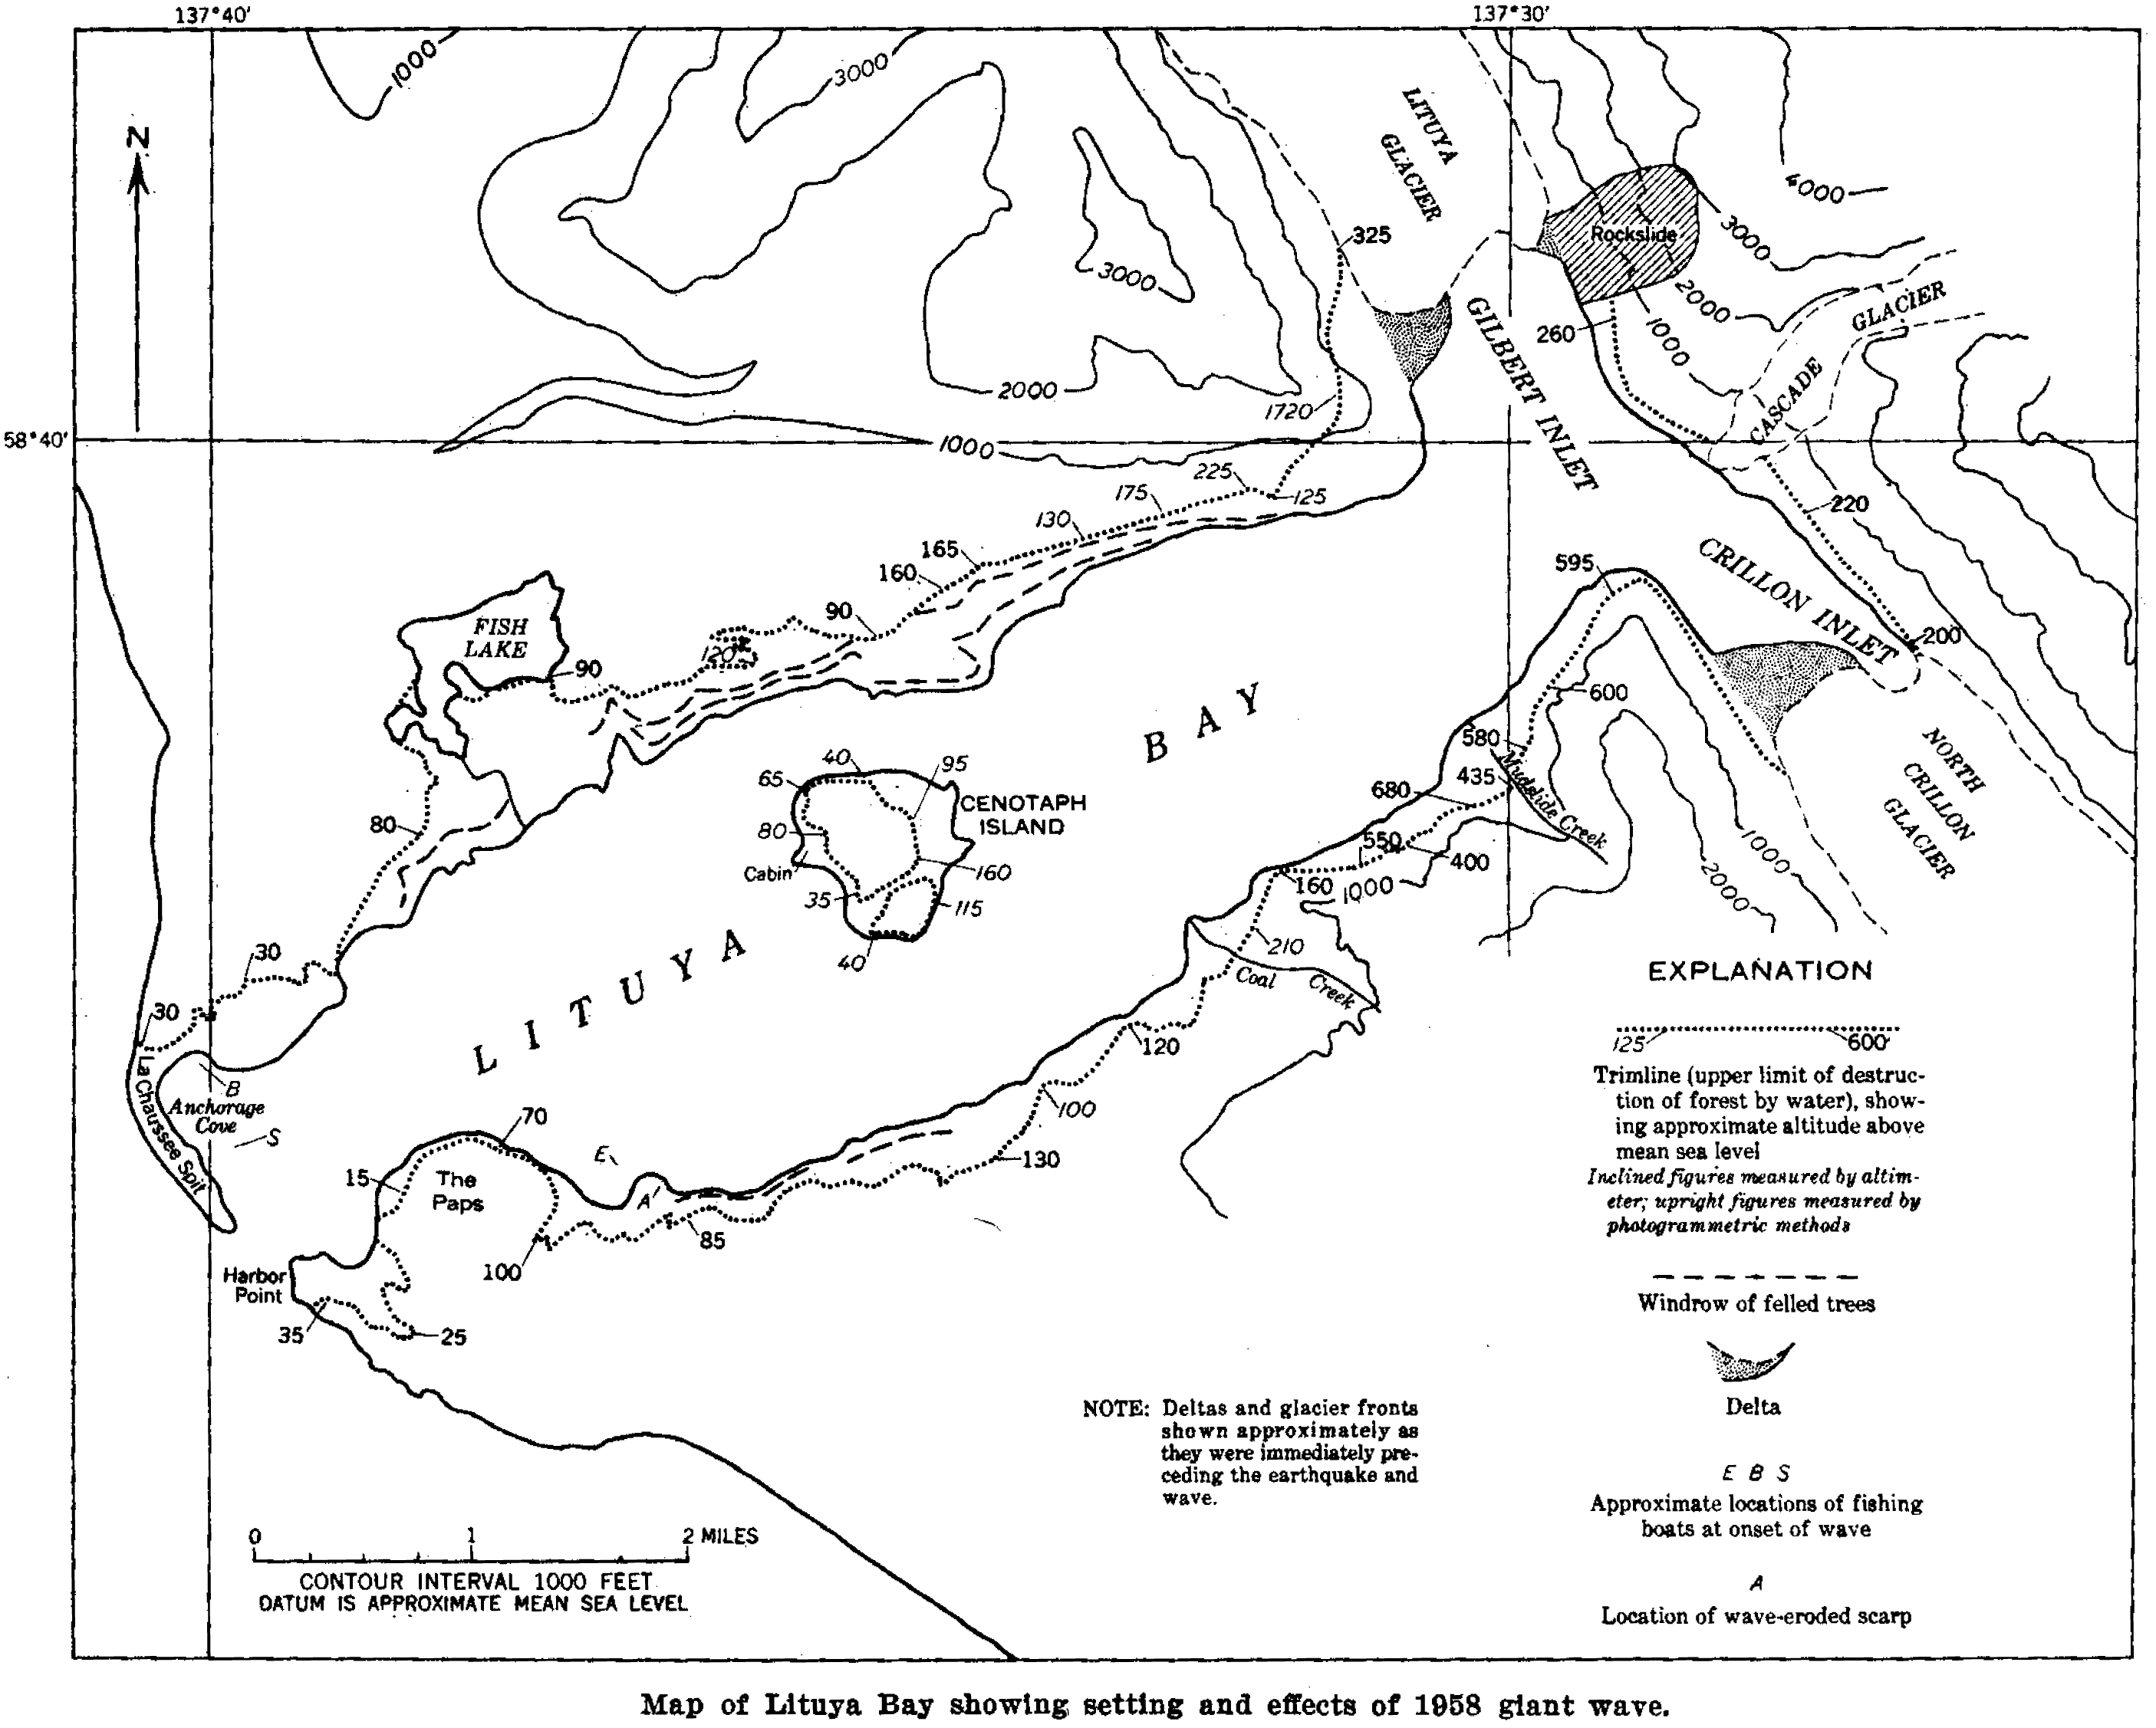
While the remote location of Lituya Bay implies little human threat, the alternate setting of the Cumbre Vieja Volcano in La Palma, Canary Islands, maintains directional proximity to populated coastal areas. Recent examination of possible slope failure on Cubre Vieja (Carracedo, 1996; Elsworth and Day, 1999) has been extended to the prediction of large impulse waves with the dire consequence of a 3-8 m wave impact with the coast of the Americas (Ward and Day, 2001). However, such predictions are dependent on near-field characteristics of the resulting non-linear wave as well as the impeding granular slide, for which center of mass based, crustal block landslide models and classical linear wave theory such as the shallow water approximation (Ward and Day, 2001) may prove to improperly diagnose.
Figure 1: Image from Miller (1960) showing layout of Lituya Bay. Gilbert Inlet in upper arm adjacent to Lituya Glacier. Dark shaded region on northeast face shows location of dislodged slide.
The following examines a level-set method for finite element simulation of the Navier-Stokes and advection diffusion equations applied to such occurrences. The landslide is modeled as a granular, viscous flow after the viscoplastic fluid model of Iverson (1985). Internal model verification is achieved via general mass movement equations and externally via the well documented behavior of Lituya Bay, for which the extreme wave characteristics allow for drastic comparison of input parameters. Further extension is achieved through analysis of a possible failure at La Palma.

Numerical Background
Parallel to the resurgence of tsunami research, developments in the field of computational fluid dynamics over the last three decades have lead to effective removal of oscillatory solutions that plagued numerical solutions to the shallow water equations and pressure modes within the Navier-Stokes equations in the early 1970’s (Walters, 2005). From these refinements, several methods have been developed and applied successfully in landslide induced scenarios. Lynett and Liu (2005), for example, provided a sensitivity analysis of wave run-up, utilizing a depth integrated, two horizontal dimension finite difference method in conjunction with a lumped mass, infinite slope landslide model.
Application of the shallow water equations, both linear and non-linear, with various, site-specific enhancements, such as forcing terms due to sea floor movement (Liu et al., 2003) and landslide impact (Tinti et al., 1999), has been conducted in certain scenarios, although caution should be taken with their application at the sub aerial, three phase boundary, where steep slopes and uncertain bathymetry can decrease accuracy (Quecedo et al., 2004). Alternately, Quecedo et. al. (2004) utilized a level set approach (Quecedo and Pastor, 2001; Sussman et al., 1994) in finding numerical solutions to the Navier-Stokes and advection-diffusion equations for the Lituya Bay incident. The proposed method creates a representation of the multi-phase interface as the zero level set of a smooth function. The impacting landslide is thus assumed to behave as a viscous, dense, incompressible fluid at the three phase interface, where the sharp concentration gradient can be tracked as a smooth function, and the interface curvature can be easily computed (Zimmerman, 2004).

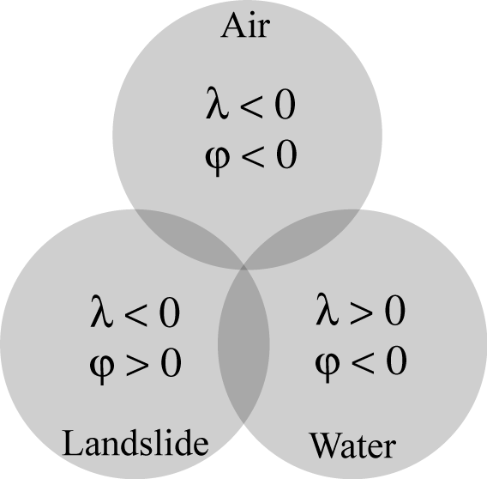
Governing Equations
The level set approach to multi phase flow utilizes indicator functions advected with Navier-Stokes velocity to track phase boundaries. To avoid the drastic step change in concentration that is incurred across the fluid interface, smooth approximations disperse this change across a pre-defined distance laterally from the interface. The indicators, and in this paper, are subjected to the constraints of the Heaviside function to demarcate the steep transition of physical properties in terms of the level set function,,
Figure 2: Interaction of the three bulk fluid properties is identified by the use of the two indicator functions.

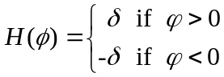,

for some pre defined distance, . Assuming immiscibility for three interacting fluids, where the landslide is modeled as a fluid-like mass, motion is governed by the evolution of the Navier-Stokes equation for incompressible flow,

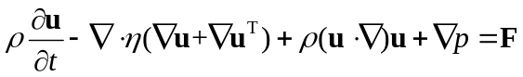,

with continuity satisfied for,

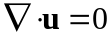,

where u is the velocity field, is viscosity, ρ is fluid density, p is pressure, and F is the body force. To avoid instability due to contrasting parameter magnitudes, the equation can be normalized to the non-dimensional parameters of velocity,, pressure, 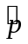, and time, , as,

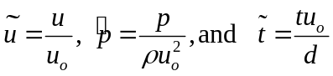,

resulting in an expression for the defined scaling factors 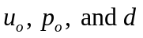for velocity, pressure, and distance, respectively,

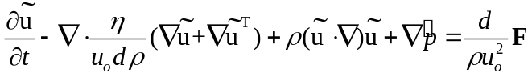.

For the three-phase interface system intrinsic to a sub-aerial landslide, introducing a second indicator function,, with the same properties of provides the necessary range of indicators (Figure 2). Defining, then, a smooth Heaviside function in terms of the hyperbolic tangent for or as,

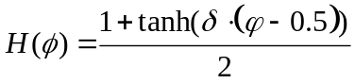,

where is a parameter specifying the limits of transition, allows a smooth approximation of the interface to be advected by the standard advection equation,

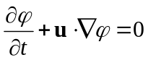.

Density and viscosity will be constant within each fluid as a function of the fluid concentration range from 0 to 1, but will vary across the interfacial environment of Eulerian grids as determined by each indicator function for a physical property, P, by,

,

where the subscripts refer to air, water, and soil, and, as the properties are advected with fluid flow, conservation requires,

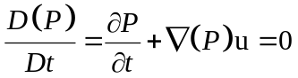,

for the substantial derivative D. The above system of equations can then be solved with constraints on the initial domain of each indicator function (Figure 2).
Further attention is given to the indicator functions, which will, in a harshly non-linear system with widely varying advection velocity, absolve classification as distance functions (Quecedo and Pastor, 2001; Quecedo et al., 2004; Sussman et al., 1994), resulting in dispersion of the interface and mass loss as time progresses. Sussman et al., (1994) proposed an iterative solution to this problem via substitution of a sign function into the advection-diffusion equation system, such that the indicators will be reinitialized as distance functions at the onset of each iteration. The sign function,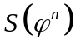, for the solution, 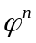, of at time t , may be incorporated (Quecedo and Pastor, 2001; Sussman et al., 1994) by resolving,

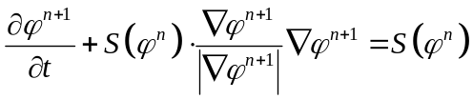,

to steady state, thus introducing the velocity field,

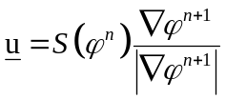,

for the new distance function, 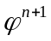.

Landslide Model
Common practice in sub-aerial impulse wave modeling dictates the use of some assumption of pre-impact slide velocity utilizing constitutive analysis of a lumped mass, “infinite slope” failure aloft a frictional inclined plane. While rough determination of slide velocity from this means is justified, abolishing consideration of internal frictional forces may, certainly in cases where absolute, center of mass free fall velocity is used, over predict slide velocity and the resulting tsunami. Additional inconsistencies may result if turbulence considerations are excluded from the trailing portion of the sinking mass. The model utilized in this paper, therefore, considers the case of viscous granular flow where all fluid behaviors may be conditioned via Navier-Stokes evolution.
Stresses within the model are analyzed utilizing the full stress tensor,

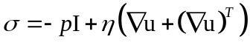,

where I is the unit diagonal matrix and all other terms are as previously defined. From this basis it is necessary to develop a strain rate dependent model of granular flow. Assuming an isotropic, incompressible medium where water migration is fast relative to soil deformation rate, Iverson (1985) developed a constitutive equation for two-dimensional simple shear flow under a coulomb yield criterion, where the modified exponential term was utilized by Chen and Ling (1996) for data extraction from Bagnold’s (1954) experiments,

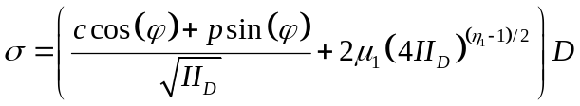,

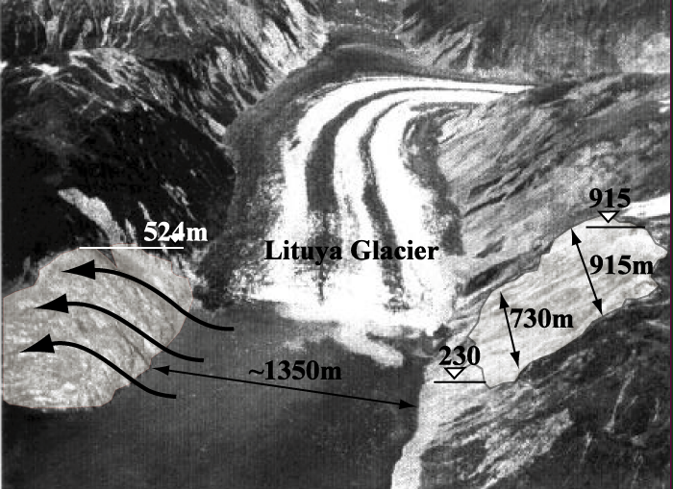
where c is cohesion or yield stress, II_{D} is the second invariant of the strain tensor D and 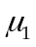 and 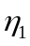 are experimental, viscosity like parameters. An incompressible assumption, valid in a fluid-solid mixture only for the case of neutrally buoyant solid grains (Chen and Ling, 1996), as in the case of Bagnold’s (1954) shear-rate experiments, definitively infers that II_{D} is equivalent to the deviatoric invariant II_{D’}. As discussed extensively in Chen and Ling (1996), appropriately chosen values for and may represent the transition between the grain inertia regime (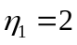) of high solids concentration and the macroviscous regime (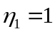) where interstitial fluid dominates behavior. And while the experiments of Bagnold (1954) only partially approach the grain inertial regime (Chen and Ling, 1996) of coulomb yield criterion and of interest to our highly granular landslide before inconsistencies arise, choosing from the upper range of solids volume fraction for well-fitted results, namely 0.555, yields values of 1.580 and 42 for and, respectively (Bagnold, 1954; Chen and Ling, 1996). The stress tensor may be modified as such to represent the case of a highly non-Newtonian landslide whilst maintaining Newtonian behavior in the water and air domains.

Application to Lituya Bay
Figure 3: Aerial photograph (modified from Fritz et al., 2001; USGS) of Gilbert Inlet showing landslide release point (northeast face, right portion of image) and wave run-up location (southwest face, left portion of image) following the 1958 tsunami.

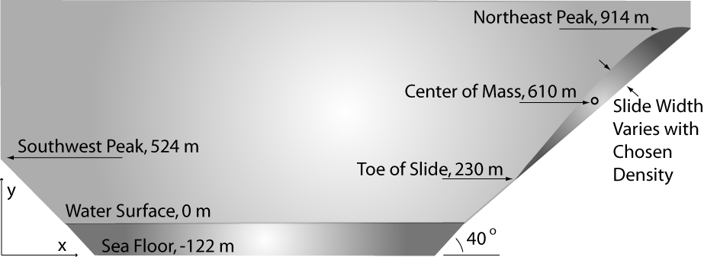
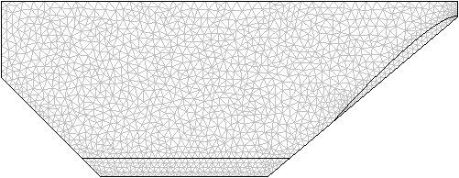
Gilbert Inlet’s residence within Lituya Bay is illustrated in Figure 1, where the shaded region on the northeast face of the inlet shows initial landslide location. Initial volume was estimated as 30.6 Mm³, based on an initial density of 2700 kg/m³, with a maximum height of 915m and other dimensions (Fritz et al., 2001; Miller, 1960) as indicated in Figure 4. Final slope inclination on the northeast face, following the landslide, was placed at 40º (Miller, 1960), and it is this slope that comprises the failure plane within the model. In the physical model of Fritz et al. (2001) a granular material of bulk density 1610 kg/m³ met the requirements of achieving granular mass movement. This scenario was investigated herein, with proportionally adjusted landslide volume, in addition to an analysis of the actual rockslide volume and density suggested by Miller (1960) and the most likely, mid-range scenario of a 2200 kg/m³, 37.6 Mm³ slide.
Figure 4: Idealized Gilbert Inlet as utilized in the subsequently developed finite element mesh. Center of mass value, angle of slope failure plane, and other dimensions from Miller (1960). Meshing consists of 23,954 degrees of freedom, represented by 2,736 domain and 219 boundary triangular elements.
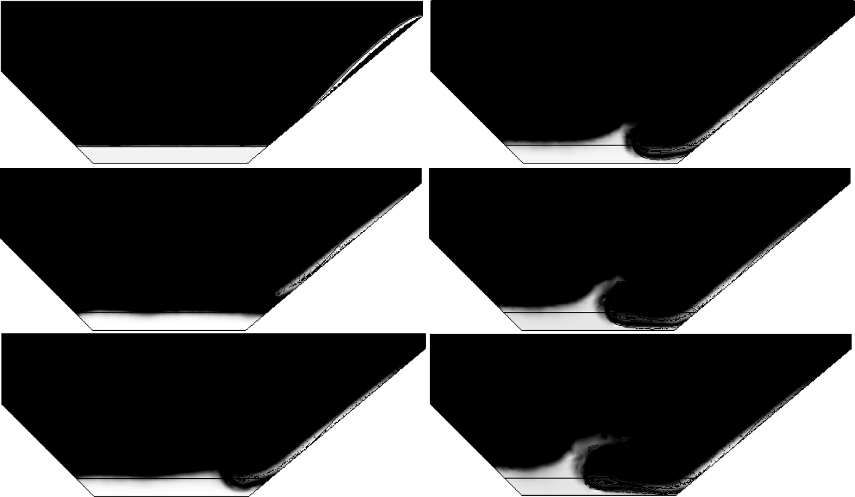
Simulations were conducted with COMSOL Multiphysics 3.2 finite element modeling software. Standard values (25ºC) for the properties of air and water were applied within respective domains, and atmospheric pressure was applied to the geometry at a singular point at the upper leftmost corner, to avoid possible interference from an open air upper boundary.
Figure 5: Snapshot of Gilbert Inlet simulation for 1610 kg/m³ landslide (grey countours) released at center of mass height of 610m with initial velocity zero. Water (grey surface) depth is 122m.
With initial dimensions from Figure 4, simulations were subjected to parameterization from which Figure 5 represents a slide density of 1610 kg/m³ with friction angle 15º and no-slip boundaries. No-slip boundary behavior is apparent as the landslide slows and eventually halts near the base of the slope, while all three fluids maintain immiscibility, a primary requirement of the above calculation sequence, for the given scaled time. Beyond this time, the numerical representation begins to falter with increasing interface complexity. Diffusion, which must remain at a significant magnitude for success of the advection diffusion equations, begins to dominate, and the results diverge. However, as the focus of this analysis is upon the initial impulse, and far field predictions require alternate methods, the results are, visually, very good, where the maximum run-up approaches 500m, or within 24m of the estimated 1958 value.

Validation and Parameter Analysis: Lituya Bay
To validate model behavior we begin with the slope directional component of the simple equation of gravity motion,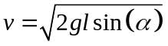, where v is object velocity, g is gravitational acceleration, l is length of the slide path (distance from slide toe to water surface), and α is failure plane inclination, and modify the behavior for the case of frictional resistance. N. M. Newmark (1965) defined a minimum resisting force for a cohesionless, free-draining mass on an inclined plane as, 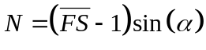, with the dynamic factor of safety, 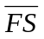, is defined as, 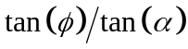, where is internal angle of friction. Summing the component of downslope velocity with that of resistance yields,

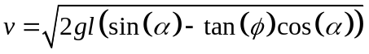,

which is the same expression presented by (Slingerland and Voight, 1979) for an upper-bound slide velocity. The modeled behavior of a granular, viscous flow will, of course, differ from this value, but a general range can be estimated as such. Table 1provides a comparison between the simulation and the failure block model of for simulations under varying constraints. Because a significant amount of internal resistance is encountered in granular flow that is absent in , we would expect a slightly lower value in the general sense. This proves to be the case for simulations 1 to 4 where a density of 1610 kg/m³ was utilized and is most pronounced for lower angles of friction. The opposite is true for simulations 5 to 8, where higher densities and slip boundary conditions (simulation 7) increase the velocity of the granular model, but do not influence the failure block model. In comparison with the literature, the physical model of Fritz et al. (2001) utilized a pure free fall velocity from the center of mass of 110 m/s, while Quecedo et al. (2004) reported values from 80 to 87 m/s for a similar numerical analysis under slip boundary conditions, such as simulation 7, where the 69 m/s in Table 1 is strongly comparable to a value of 87 m/s from Quecedo et al. under similar constraints.
Table 1: Simulation results with varying input parameters.
Simulation Number | Slide Volume (Mm³) | Slide Density (kg/m³) | Friction Angle  (deg) | Simulation Velocity (m/s) | Predicted Velocity from  (m/s) | Simulation Wave Height (m) | Wave Height Prediction (m)
 |  |  |  |  |  |  | Noda* | S&L**
1 | 51.3 | 1610 | 25 | 44 | 45 | 240 | 81 | 89
2 | 30.6 | 1610 | 15 | 50 | 55 | 170 | 60 | 74
3 | 51.3 | 1610 | 15 | 52 | 55 | 230 | 89 | 112
4 | 51.3 | 1610 | 5 | 53 | 64 | 240 | 110 | 116
5 | 30.6 | 2200 | 15 | 61 | 55 | 200 | 71 | 122
6 | 37.6 | 2200 | 15 | 65 | 55 | 230 | 85 | 155
7 – Slip Boundaries | 51.3 | 1610 | 15 | 69 | 55 | 220 | 152 | 168
8 | 30.6 | 2700 | 15 | 69 | 55 | 250 | 76 | 168
*Wave equation from Noda (1970) calculated using landslide characteristics as obtained from each corresponding simulation.
**Wave equation from Slingerland and Voight (1979). Again using simulation slide characteristics.
Further verification can be obtained by examining near field wave behavior in the literature. Utilizing a dimensionless kinetic energy, KE, wave height can be estimated for landslide volume,, water depth, d, impact velocity, v, density, ρ, and the regression parameters, 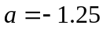, and, 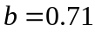, which were determined empirically from studies on the Mica Reservoir in British Columbia, as (Slingerland and Voight, 1979),

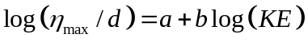,
where,

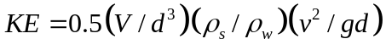.

An alternate wave height estimation was presented by Noda (1970) in terms of the Froude number, 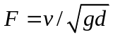, as,

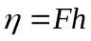.

Utilizing parameters from our numerical model, simulation results are compared to the two wave height equations in Table 1, where the simulation values are notably larger than either prediction. This discrepancy could be attributed to the effect of diffusion at the landslide front, where an expanded slide will serve to increase wave height. However, reported values from Quecedo et al. (2004), ranging from 195 to 232 m, agree closely with our model, where simulation 7 produced a wave height of 220m, as compared to 215m in Quecedo et al. More importantly, the physical results of Fritz et al. (2001) showed wave heights greater than 200m. Therefore, it could be possible that for the case of Lituya Bay, where cross sectional landslide dimensions closely resemble those of the impacted body of water, wave height is increased in a manner not accounted for in either or . Additionally, as the fitted parameters a and b in are specific to the impulse geometry, and as momentum is neglected from , the results should differ slightly from a comprehensively modeled analysis.

The Cumbre Vieja Volcano, Canary Islands
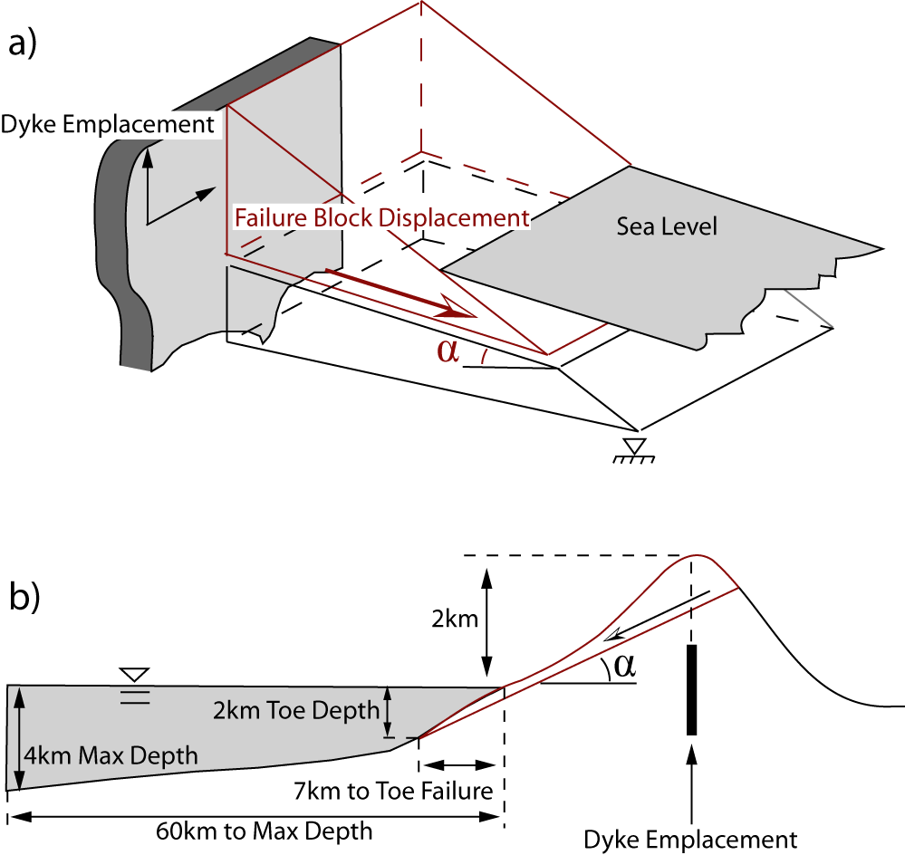
Having achieved a model that accurately represents the events of Lituya Bay, the objective remains to investigate possible impact from a massive flank failure at La Palma. To accomplish this task, we adopt the proposed failure mechanism of an intruding dyke (Elsworth and Day, 1999) which detaches a massive portion of the volcano along a predefined failure plane. A simplified geometry of this occurrence is presented in Error: Reference source not found, where, while the vertical detachment plane will likely transect nearly the center line of maximum elevation, it is assumed that failure will continue to the opposing side of Cumbre Vieja once the front portion is released. To define toe failure, we adopt the average characteristics proposed by Ward and Day (2001). These values place the slide toe 2km below sea level at a horizontal distance of 7km from the shoreline of La Palma. Surface slope of Cumbre Vieja is taken as 20 degrees.
Figure 6: (a) Generalized geometry of failure plane release from forcing of an intruding dyke (Elsworth and Day, 1999). (b) Relation of failure to surrounding bathymetry. These dimensions were utilized in the modeling venture with varying angles of the failure plane, α.
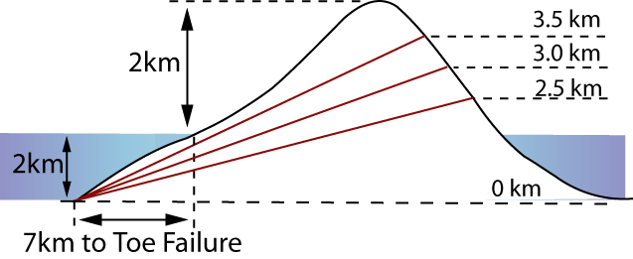
Our intent with this model is to examine the variation between a small, rapid failure advance along a steep slope, and a larger, slow advance along a gentler plane. Lituya Bay represents the extreme scenario of a fast, steep advance, while the geometry of Cumbre Vieja is expected to represent the slower advance of a much larger failure. To investigate possible scenarios of collapse, failure plane angle was pivoted from the failure toe to provide comparison
Figure 7: Variable failure plane for flank failure at La Palma. Incrementing 5km intervals from the peak of Cumbre Vieja encompasses both smaller (greater slope inclination) and larger volume (lesser slope inclination) collapse portions than have been previously predicted.
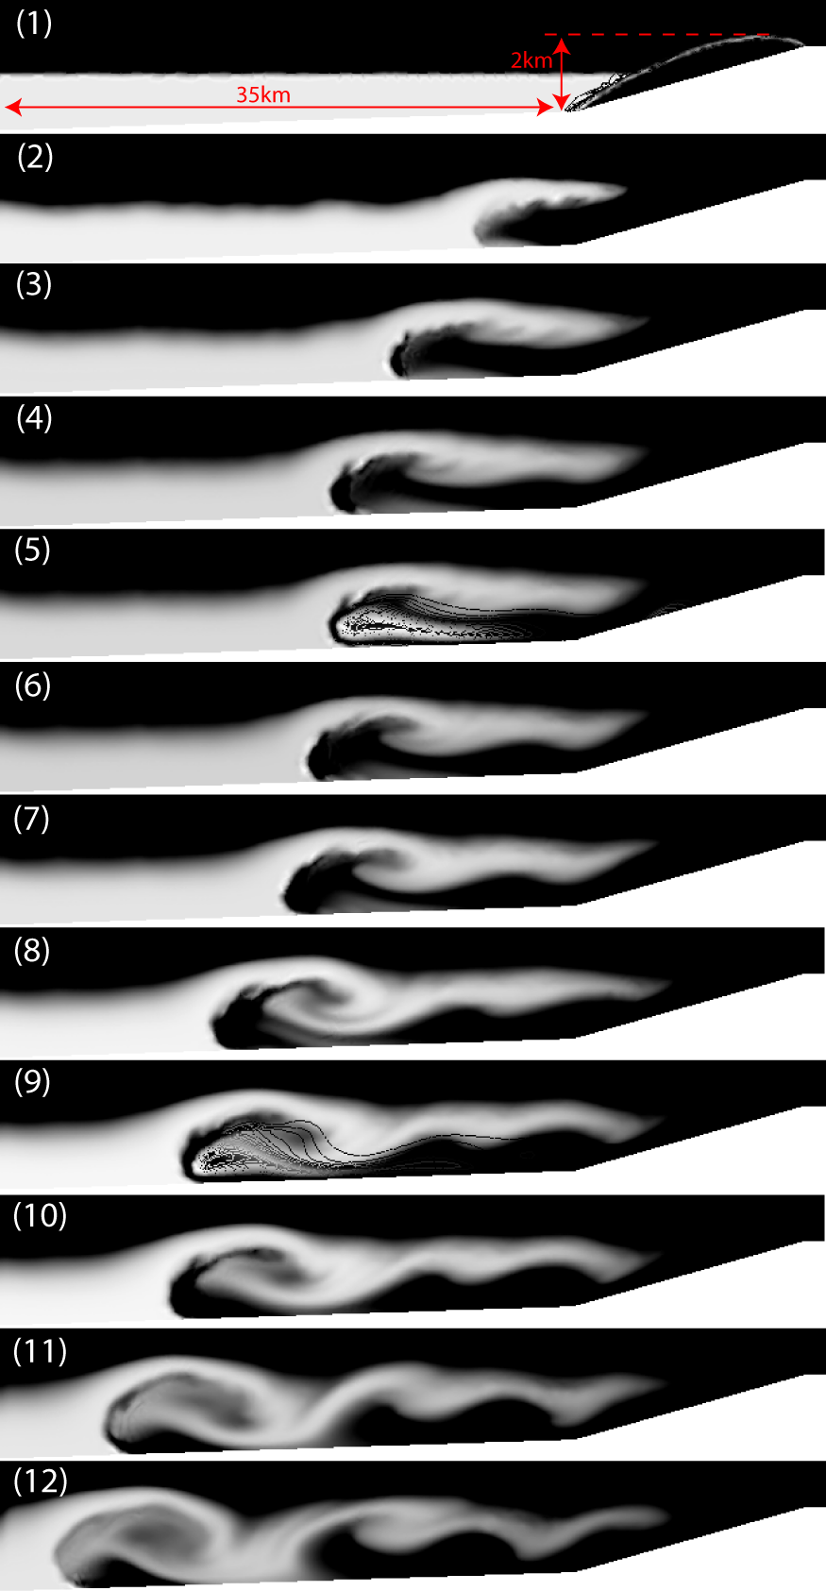
of small volume, high angle scenarios to those of large volume and low angle Error: Reference source not found. Results for the steepest angle of failure, 16 degrees, are provided in Error: Reference source not found, where a maximum slide velocity of 28 m/s produced a wave height, within the given geometric extent, of 2 km atop a sliding mass of thickness 1.5km. Note that a dominant portion of the slide splits apart and begins to settle at an offshore distance of approximately 14km, or well before reaching the flat ocean floor at 60km, while only the leading portion continues to descend. The implications of this wave height are beyond the scope of this work, as an alternate method incorporating some formulation of classical wave theory would be required to model wave propagation. It is important to consider, however, that impulse waves differ in form from those of seismic origin, such that energy dissipation will tend to occur more rapidly in the former.
Investigated failure planes are illustrated in Error: Reference source not found, where maximum plane height was decremented from the peak of Cumbre Vieja at 0.5km intervals. Varying the failure angle in this way provides a picture of flank failures that span from less than to greater than previously predicted failure volumes (Ward and Day, 2001) and, proportionally, steeper to shallower failure angles.
Figure 8: Simulation results for Cumbre Vieja flank failure. Geometry follows that of rightmost extent of Error: Reference source not found as indicated in (1). Contours of the landslide have been excluded from most images to better illustrate water behavior but were included in (5) and (9) to illustrate interfacial integrity with progression. Failure plane angle is 16 degrees from the horizontal (3.5 km failure height in Figure 11), giving a slide volume of 85 km³ for a width of 15km.
Interestingly, varying parameters in such a way did not create sharp differences in wave behavior, where for each case the maximum wave height approximated 2km (Error: Reference source not found). Maximum landslide velocity does not necessarily decrease for lower failure angles, as a larger volume fluidized landslide will achieve higher velocities at the outer slope, and so the surface slope of the failure plays a larger role in behavior than does failure angle for the range of parameters investigated. Additionally, while a smaller volume slide under higher angles of repose may achieve more rapid acceleration, it will conversely encounter rapid deceleration at water contact. This behavior results in lower velocity transfer to the wave impulse, whereas a larger landslide with a lower velocity will maintain lower submarine deceleration and transfer a larger portion of its lower velocity to the impulse.
It does appear, however, that optimum, worst case failure characteristics, with the most synergistic balance between volume and slope angle, occur near those of the 12 degree case. For this scenario, maximum landslide velocity is at its peak, the obtained offshore distance prior to deceleration is greatest, and wave height is mildly higher. All results are presented in Error: Reference source not found. While inserting a correction for landslide thickness into the results shows a mildly increasing wave height for each decrement in failure angle, the results do not ultimately indicate a strong reliance upon the failure angle, where for each case the resulting tsunami is comparable in size.

Table 2: Simulation results
Failure Angle (deg) | Landslide Velocity (m/s) | Wave Height (km) | Landslide Thickness (km) | Distance of Landslide Front from Shoreline (km) | Average Landslide Velocity (m/s) | Wave Height (km) | Landslide Thickness (km) | Distance of Landslide Front from Shoreline (km) | Average Landslide Velocity (m/s)
 | At Time of Peak Landslide Velocity |  |  |  |  | At Time of Maximum Wave Height
9 | 27 | 1.6 | 1.4 | 5.3 | 9.8 | 2.15 | 1.8 | 11.8 | 12.8
12 | 31 | 1.8 | 1.1 | 6.4 | 10.0 | 2.15 | 1.6 | 12.5 | 12.5
16 | 28 | 1.7 | 0.9 | 5.0 | 8.3 | 2.10 | 1.0 | 9.1 | 10.1

Conclusions
Finite element analysis of the three phase sub-aerial landslide-tsunami system as presented above has been shown to replicate, to a reasonable approximation, the 1958 tsunami of Lituya Bay. For the case of a 2200 kg/m³, 37.6 Mm³ landslide, an impact slide velocity of 65 m/s produced a wave with maximum free height of 230m and a run-up approximating 500m on the opposite shore of Gilbert Inlet. These characteristics are in modest agreement with the physical replication model of Fritz et al (2001) and the numerical analysis of Quecedo et al. (2004). From this basis, the same model has been applied with confidence to predict the near field consequence of a massive flank failure at Cumbre Vieja volcano.
In contrast to previous study of a La Palma failure (Ward and Day, 2001) where an assumed monolithic slide movement with peak velocity of 100 m/s, which approximates wave speed in 50m of water, prior to disintegration and eventual equilibrium at an offshore distance of 60 km, the analyses presented here indicates that a fluidized mass movement along a frictional plane would achieve a maximum velocity of approximately 30 m/s and experience pinched separation near shore. An initial wave impulse would climb to approximately 2 km above sea level atop a progressive slide mass of thickness near 1.5km. This slide velocity is far lower than wave velocity and would result in a much smaller energy transfer to the tsunami than for the 100 m/s case.

References
Bagnold, R.A., 1954. Experiments on a gravity free dispersion of large solid spheres in a Newtonian fluid under shear. Proc., Royal Society of London, Serial A, 225: 49-63.
Bardet, J.-P., Synolakis, C.E., Davies, H.L., Imamura, F., Okal, E.A., 2003. Landslide tsunamis: recent findings and research directions. Pure Appl. Geophys., 160: 1793-1809.
Carracedo, J.C., 1996. A simple model for the genesis of large gravitational landslide hazards in the Canary Islands. Volcano instability on the Earth and other planets, Geological Society special publication, No. 110: 125-135.
Chen, C.-I., and Ling, C. -H, 1996. Granular-flow rheology: Role of shear-rate number in transition regime. Journal of Engineering Mechanics, 122: 469-480.
Elsworth, D., and Day, S., 1999. Flank collapse triggered by intrusion: the Canarian and Cape Verde Archipelagoes. Journal of Volcanology and Geothermal Research, 94: 323-340.
Fritz, H.M., Hager, W. H., and Minor, H. -E., 2001. Lituya Bay case: Rockslide impact and wave run-up. Science of Tsunami Hazards, 19(1): 3-22.
Iverson, R., 1985. A constitutive equation for mass movement behavior. Journal of Geology, 93: 143-160.
Liu, L.-F., Lynett, P., and Synolakis, C. E., 2003. Analytical solutions for forced long waves on a sloping beach. J. Fluid Mech., 478: 101-109.
Lynett, P., and Liu, P.L.-F., 2005. A numerical study of the run-up generated by three-dimensional landslides. J. Geophys. Res., 110 (C3)(Art. No. C03006.).
Miller, D.J., 1960. A timely account of the nature and possible causes of certain giant waves, with eyewitness reports of their destructive capacity, Geological survey professional paper 354-C, U.S. Department of the Interior, Washington.
Newmark, N.M., 1965. Effects of earthquakes on dams and embankments. Geotechnique, 15(2): 139-160.
Noda, E., 1970. Water waves generated by landslides: Proceedings of the American Society of Civil Engineers. Journal Waterways Harbors Div, 96(4): 835-855.
Quecedo, M., and Pastor, M., 2001. Application of the level set method to finite element solution of two-phase flows. International Journal for Numerical Methods in Engineering, 50: 645-663.
Quecedo, M., Pastor, M., and Herreros, M. I., 2004. Numerical modelling of impulse wave generated by fast landslides. International Journal for Numerical Methods in Engineering, 59: 1633-1656.
Slingerland, R.L., and Voight, B., 1979. Occurences, properties, and predictive models of landslide-generated water waves. In: Developments in Geotechnical Engineering 14B: Rockslides and Avalanches, 2, Engineering Sites., Voight, B., ed.(Elsevier Scientific Publishing Company): 317-397.
Sussman, M., Smereka, P., and Osher, S., 1994. A level set approach for computing solutions to incompressible two-phase flow. Journal of Computational Physics, 114: 146-159.
Tinti, S., Bortolucci, E., and Armigliato, A., 1999. Numerical simulation of the landslide-induced tsunami of 1988 on Vulcano Island, Italy. Bull Volcanol, 61: 121-137.
Walters, R.A., 2005. Coastal ocean models: two useful finite element methods. Cont. Shelf Res., 25: 775-793.
Ward, S.a.D., S., 2001. Cumbre Vieja Volcano -- Potential collapse and tsunami at La Palma, Canary Islands. Geophys. Res. Lett.
Zimmerman, W.B., 2004. Process modeling and simulation with finite element methods. World Scientific Publishing Co. Pte. Ltd., Singapore, 382 pp.

