Stress- and Temperature-Dependent Permeability of a Dual Porosity Media

Kritika Trakoolngam
Interactions between stress, fluid flow, and heat transport are observed in geothermal reservoirs. These interactions are sufficiently strong that the coupled representation of behavior is often mandatory. In this study, a mathematical model capable of accommodating the evolution of stresses, fluid pressures, fluid and rock temperatures have been formulated. The finite element model derived from the comprehensively coupled constitutive equations has been implemented using FEMLAB to solve for the coupled behavior. Five modules have been assigned for representing this coupled behavior, these are, the mechanical stress-strain module, two Darcy’s fluid flow modules, and two thermal conduction-convection modules. The flow and heat transport in the porous and the fractured phase are simulated by each of the two fluid flow and thermal modules. The single mechanical module represents the entire mechanical response of the fractured rock mass.
So far, the model has been verified to give proper solutions for static analysis and is proven to be feasible for predicting flow behavior and heat transport in fractured porous rocks. However, further work needs to be done in order to complete the task, these are, solving for time dependent solutions, and most importantly, incorporating the dynamic changes of the fracture width due to stresses and thermal influences in order to determine the permeability of the fracture.

Introduction
Fractured porous media is one of many complex geological attributes that is of high interest. Due to its high permeability, fractured rocks are found to be the largest resource for practical geothermal development (Bowen 1989). Recently, it has also been considered for use in underground storage of carbon dioxide (Holloway 1997; Wawersik and Rudnicki 1998). In many cases, the fractured media acts as a transportation mean for the geothermal fluid or injected fluids where occurs interaction between rock and fluid flow combined with effects of high temperature, and occasionally with chemical reaction. The behavior of the system that constitutes the three main interacting processes: thermal, hydrological and mechanical, is generally referred to as Thermo-Hydro-Mechanical (THM) coupled processes. Applications regarding fractured porous media requires understanding of the relevant coupled processes in order to effectively utilize any of its applications.
Research in THM behavior of fractured porous media covers a very wide range of fields and applications, from underground nuclear waste disposal (Wang et al. 1981; Tsang et al. 2000; Yow and Hunt 2002), geothermal energy exploitation (Hicks et al. 1996; Germanovich et al. 2001; Rutqvist and Tsang 2003), rock mechanics and mining (Neaupane et al. 1999), geology and geotectonic (Faulkner and Rutter 2003; Neuzil 2003), transport of oil and gas in deep reservoirs (Koutsabeloulis and Hope 1998; Pao et al. 2001), engineering/construction material (Schrefler et al. 2002), to engineering geological barriers (Thomas et al. 1998; Collin et al. 2002). Yet, despite the amount of research being done, there is still insufficient understanding of the processes to be able to construct a feasible design or prediction regarding its behavior.
Early mathematical models developed to describe such behavior approached the problem by treating the fractured rock and the matrix as a continuous medium (Gray et al. 1976) and representing the fractured rock mass by an equivalent porous medium (Pritchett et al. 1976). However, general interaction theories are required to describe the effect of the motion of fluid on the motion of matrix and vice versa. Much of this has been satisfied through introduction of the general theory of consolidation (Biot 1941) which relates the influence of pore pressure due to the existence of fluid in a porous rock. This study made it possible for engineers and scientists to solve problems in a much wider scope. The addition of the thermal component coupled later in the mid 1980’s (Noorishad et al. 1984) formed a basis to a fully coupled THM solution. Thereafter, many computer codes using the finite element method have been developed to simulate the THM behavior in fractured porous media (Pine and Cundall 1985; Ohnishi et al. 1987; Guvanasen and Chan 1995; Kohl et al. 1995; Nguyen and Selvadurai 1995; Bower and Zyvoloski 1997; Swenson et al. 1997), each of which differ slightly in assumptions, constitutive equations, and initial conditions. Furthermore, commercially available codes, such as ABAQUS (Bึrgesson 1996), FLAC (Israelsson 1996a), and UDEC/3DEC (Israelsson 1996b) have also extended their capabilities to account for modeling coupled THM in various types of medium. Although, there has been extensive research and computer modeling in this area in the past two decades, the porosity within the fracture and the matrix has long been considered as one entity as originally formulated for a continuous body of porous medium (Biot 1941). However, this does not truly reflect the influences of fluid pressures and rock stresses on the fracture and the matrix due to the porosity within the fracture being more sensitive than that of the matrix (Wittke 1973).
The concept of “Double-Porosity” has been introduced in the early 1960’s, which considers the fractured rock mass consisting of two porous systems (Barenblatt et al. 1960; Warren and Root 1963), which are the matrix, having high porosity and low permeability, and the fracture, having low porosity and high permeability. In 1992, a dual-porosity finite element model has been developed to describe the behavior of the fractured porous medium in response to fluid flow and stress (Elsworth and Bai 1992), which accounts for two porous systems and the fluid mass transport between each system.
In order to describe the behavior of a dual-porosity medium in a geothermal environment, an equation governing the thermal behavior must be coupled to the original dual-porosity model. A Mechanical-Hydraulic-Thermal (THM) coupled equations have been formulated and discretized to form a finite element statement for the behavior of a dual-porosity medium. The developed finite element model can be numerically solved with any finite element software. For this study, a commercial finite element software, FEMLAB, is used, where predefined models are available and allows easy modification of the coupled equations. Results from the simulation will hopefully give more insights to a THM coupled environment within a fractured rock mass.

Constitutive Equations
The governing equations for the behavior of a dual-porosity medium are developed in the following section for a three-dimensional case. Equations for solid deformation, fluid pressure response due to Darcy’s flux, and thermal conduction and convection are coupled and discretized using the Galerkin Finite Element Method.

Solid Deformation

Strain and Displacements
The total state of strain in a given material may consist of the following components
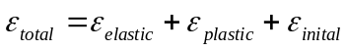 | (1)
In this study, only the elastic strain will be considered, assuming there is no plastic deformation and no initial strain.
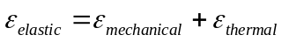 | (2)
The relationship between the strain, , and displacements,, is defined by
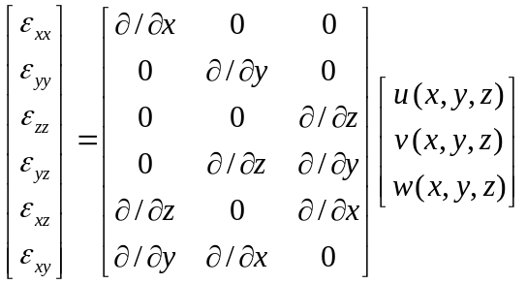 | (3)
or in short as
(4)
where the is the partial differential operator matrix.
Thermal strains are defined by
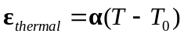 | (5)
where is the matrix of thermal expansion coefficient and and 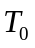 are the temperature and its reference temperature, respectively.
Assuming an isotropic behavior, the thermal expansion coefficient is equal in all directions. The total strain can then be written as
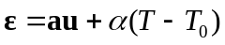 | (6)

The State of Stress
The deformation of porous medium solids containing water within its voids is defined by the principle of effective stress (Terzaghi 1943), which states that the total stress, , is consisted of the sum of the effective stress (intergranular stress that is exerted within the skeleton grains), 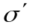, and the pore pressure, , as
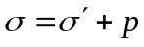 | (7)
For a dual-porosity medium, the fluid pressure within the system is comprised of the pressure within the porous phase, 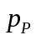, and the pressure within the fractured phase, 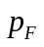(subscripts P and F referring to porous phase and the fractured phase respectively). Thus, the three-dimensional matrix equation for the state of stress in the porous phase becomes
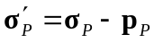 | (8)
and the fractured phase is
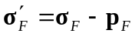 | (9)
where
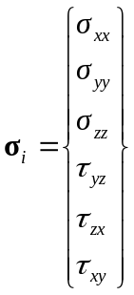 | (10)
and
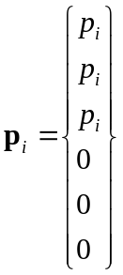 | (11)
which is the vector matrix of the fluid pressure operating in the normal directions only.
However, at equilibrium, the stresses in the fracture and the porous phases must equal to the total stress within the system, therefore
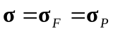 | (12)

Deformation
Hooke’s Law states that the stress, , and strain, , within a deforming material is related by a constant  which is the modulus of elasticity.
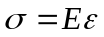 | (13)
This is the constitutive relations for linearly elastic material, and can be represented in matrix form as
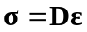 | (14)
where is the Elasticity Matrix, or more generally used in the form of the Compliance Matrix, 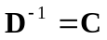, which for a three-dimensional isotropic case used in most problems, is given by
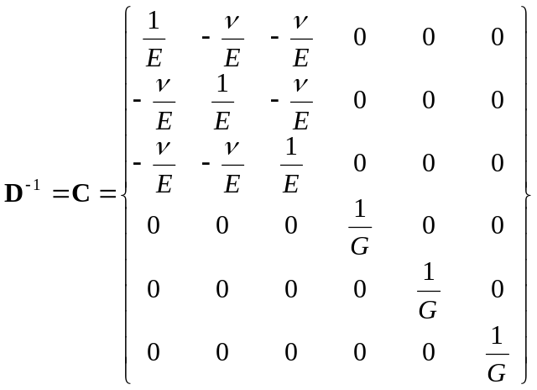 | (15)
where is the Poisson’s ratio, and the shear modulus, 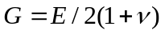, is true only for an isotropic medium.
However, for a discontinuous rock mass, the overall elastic properties accounts for the deformation characteristics of the intact rock and the fractures. For an orthotropic behavior of rock mass with three normal-sets of fractures, the compliance matrix can be written as (Amadei and Goodman 1981)
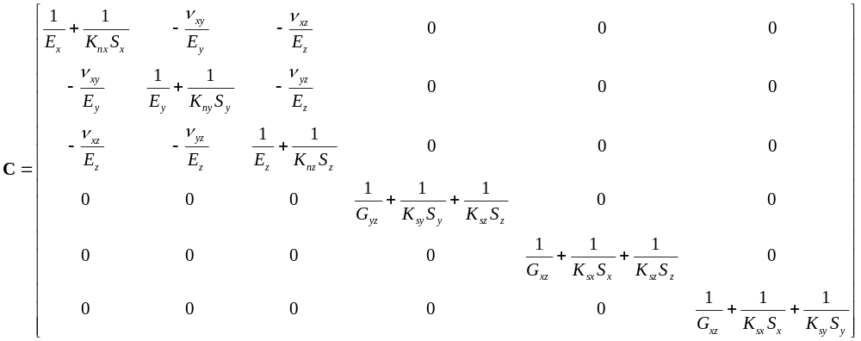 | (16)

where 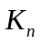and 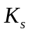are the normal and shear stiffness of the rock mass, is the fracture spacing, and the modulus and poisson’s ratio are that of the intact rock. The normal and shear stiffness are generally undetermined, however, they can be approximated from the modulus of the rock mass using the Rock Mass Rating obtained from experimental data (Bieniawski 1973; Bieniawski 1976) as shown in Figure 1.
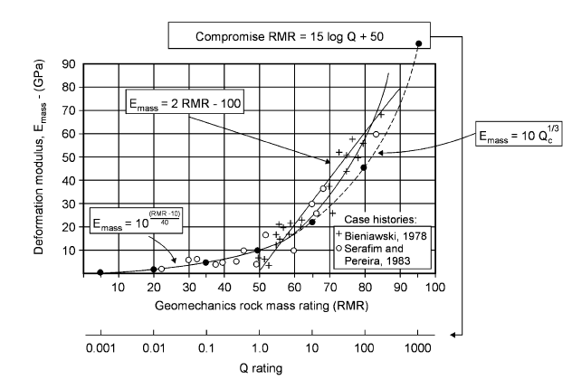
Figure 1 Deformation modulus and Rock Mass Rating (Barton 2002)
Accounting for the effective stress, and the differing fluid pressures within the fracture and porous phases, the relationship for stress and strain becomes
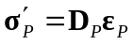 | (17)
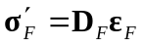 | (18)
The total strain, , which accounts for the fluid pressure and thermal expansion becomes
(19)
Thus, rearranging for stress gives
(20)
where 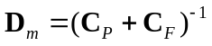 is the elastic matrix for the dual porosity medium.

Conservation of Mass
The governing equation for fluid flow which relates the flux, , and its potential, is defined by Darcy’s law which is expressed in matrix form as
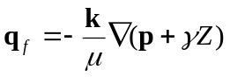 | (21)
where is the specific weight of the fluid,  the dynamic viscosity, 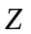 the elevation, the permeability matrix, and 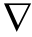 the gradient operator, defined by
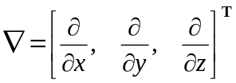 | (22)
The equilibrium equation for fluid transport in an isotropic medium according to Darcy’s law is
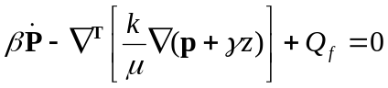 | (23)
The term on the LHS of equation (23) refers to the rate of change of pressure with time, , due to grain compressibility, . The second term is Darcy’s flux, which is function of the permeability, , dynamic viscosity,, specific weight of the fluid,, elevation, , and fluid pressure, . The third term, 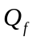, is the source term.
However, accounting for the thermal effects and the fluid mass transfer between the porous and fractured phases, the equilibrium equation for the porous phase may be rewritten as
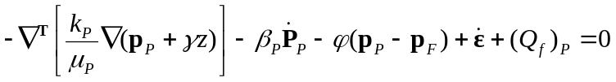 | (24)
where the added component in the first term on the LHS is a positive component referring to the flow of fluid mass driven by the changes of the volume due to strain, , and the second term is the fluid mass transfer between the porous and the fractured phase, where the coefficient which governs the quasi-steady response (Warren and Root 1963) is a function of the geometry of the porous block and the flow characteristics (permeability and dynamic viscosity) within, as
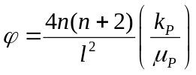 | (25)
The first term is the shape factor, whereis the number of normal set of fractures, and is the characteristic length which can be approximated from the dimensions , , and , of the porous block as
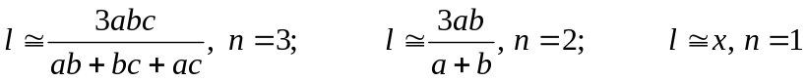 | (26)
Similarly, the equilibrium equation for the fractured phase may be expressed as
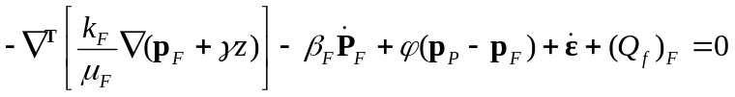 | (27)
which differs from that of the porous phase, equation (24), in the negative component of the mass transfer between the porous and fractured phase.

Thermal Behavior
The governing equation for fluid flow which relates the heat flux, 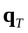, and its potential, which is the temperature, is defined by Fick’s law which is expressed in matrix form as
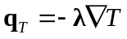 | (28)
where is the thermal conductivity.
The general thermal transport equilibrium equation for an isotropic medium is defined by
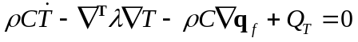 | (29)
for thermal conduction and convection. Where is the density, is the heat capacity, and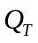 are is the heat source.
For the porous phase of a dual-porosity medium, the equilibrium equation is
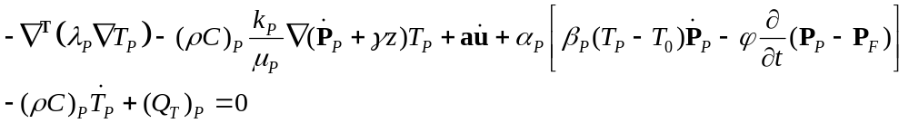 | (30)
whereis the thermal conductivity. The first term on the LHS is the rate of change of temperature due to the capacity to store heat, the second term is the thermal dilation due to change of pressure which also accounts for the fluid transfer between the porous and fractured phase. The third term is the change of temperature due to thermal strain. The last two terms are the thermal conduction and convection, respectively.
Similarly, the thermal behavior of the fractured phase may be expressed as
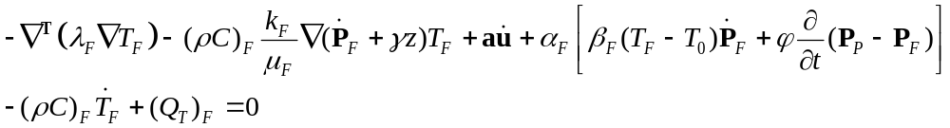 | (31)

Finite Element Formulation
Each of the governing equations developed in the previous section for the mechanical, hydraulic, and thermal behavior of the dual-porosity medium can be discretized using the Galerkin Finite Element Method in order to form finite element statements which can then be used to solve the problem at the global level.
The finite element procedure will not be described here, however readers are referred to various texts on finite element method such as The Finite Element Method: Its Basis and Fundamentals, by Zienkiewicz.
A shape function, , which interpolates the variation of the dependent variables (i.e. displacements, pressure, and temperature) with respect to the nodal coordinates, will be introduced as
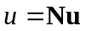 | (32a)
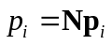 | (32b)
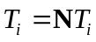 | (32c)
and
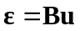 | (33)
where 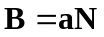is known as the Strain Matrix.

Mechanical Behavior
The general finite element statement of the mechanical behavior is defined by
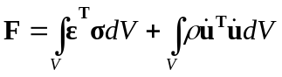 | (34)
where is the work done by external forces and the terms on the RHS represent the work due to strain energy and kinetic energy, respectively. For static analysis, the latter term can be dropped.
Substituting the value of derived from equation (20) into equation (34) and applying the shape functions gives a complete finite element statement for the mechanical behavior of a dual-porosity medium as
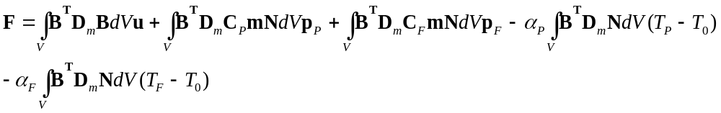 | (35)

Hydraulic Behavior
The general finite element statement of the hydraulic behavior is defined by
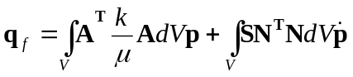 | (36)
where 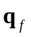 is the fluid flux, and the terms on the RHS represent the advective flow and the storage capacity,, respectively. Introducing the equilibrium equation (24) for the porous phase and equation (27) for the fractured phase, and substituting values of the time derivative of from equation (19), and applying the shape functions, the finite element statement for the hydraulic behavior of the porous and the fractured phases can be expressed as
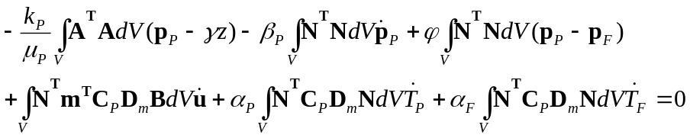 | (37)
and
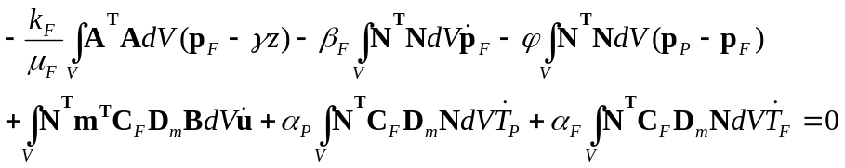 | (38)
respectively, where 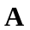 is the derivative of the shape function .

Thermal Behavior
The general finite element statement of the thermal behavior is defined by
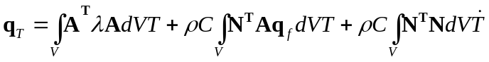 | (39)
where the terms on the RHS represent the thermal conduction, convection, and storage respectively. Introducing the equilibrium equation (30) for the porous phase and equation (31) for the fractured phase, and substituting values of the time derivative of from equation (19), and applying the shape functions, the finite element statement for the thermal behavior of the porous and the fractured phases can be expressed as
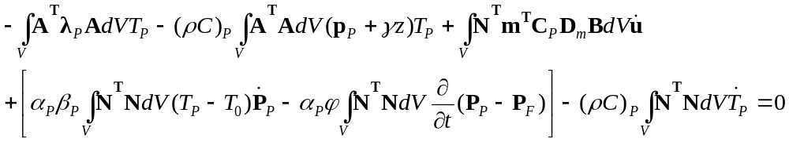 | (40)
and
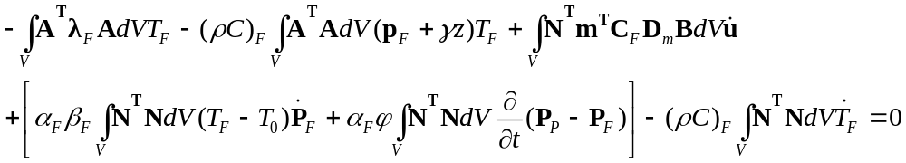 | (41)
respectively.
The system of equations can be combined in a matrix form by simplifying the integral terms for the mechanical, hydraulic, and thermal behavior as

 | (42)
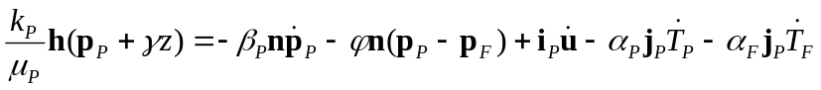 | (43)
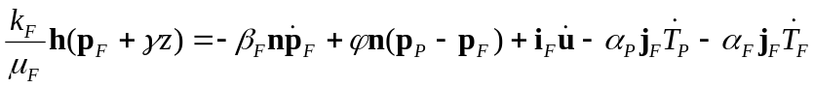 | (44)
 | (45)
 | (46)
The above equations can be combined and expressed In a convenient matrix form:
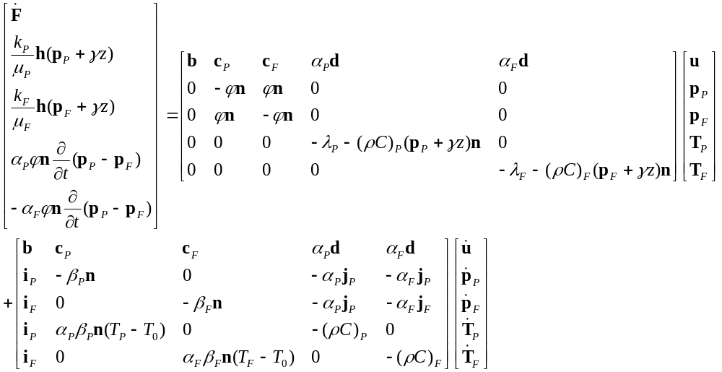 | (47)

FEMLAB Formulation
The finite element coupled equations derived in the previous section may be easily solved numerically with any finite element program. For this study a commercial finite element software FEMLAB is selected for evaluating the behavior of the dual-porosity medium.

FEMLAB Modules
In order to solve for the 5 dependent variables, which are displacements, , porous phase fluid pressure, , fractured phase fluid pressure, , porous phase temperature, 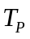, and fractured phase temperature, 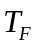; a total of 5 predefined modules have been selected. These are, Solid Mechanics (Stress-strain) module (initialed as sld), two Darcy’s Flow module, one for modeling the pressure in the porous phase (initialed as chdl) and the other for the fractured phase and (chdl2), and two Thermal conduction and convection modules, each for the porous (cc) and fractured phases (cc2).
The key to modeling the behavior of a dual-porosity medium in FEMLAB is to be able to incorporate the coupling terms derived earlier into the general governing equations initially defined by the program. Thus, there are four main adjustments which must be made to the predefined model, these are, defining the material properties of the dual-porosity medium, modifying the governing equation for the mechanical behavior to include the influences of fluid pressure, and strain due to thermal expansion, modifying the equilibrium equation for the fluid flow to account for the fluid mass transfer between the porous and the fractured medium and the volume change due to thermal expansion, modifying the equilibrium equation for the thermal transport to account for the temperature change due to fluid transfer between the two phases and the temperature change due to the mechanical influences on the thermal strain.
The general approach is to generate a simple block-shape geometry that has the elastic, flow, and heat properties which represents a dual-porosity rock mass. Then observe the behavior of the model when subjected to each and all of stress, fluid flux, or temperature conditions.

Defined Constants and Expressions
For convenience purposes, a set of constants and expressions which were to be used in modifying the system equations, assigning model parameters, and determining some material properties, were defined. These are listed in Table 3 and .

Geometry and Material Properties
A simple geometry consisting of one domain of a rectangular block, as shown in Error: Reference source not found, has be developed so far. The materials assigned to the material library are described in the Table 1.

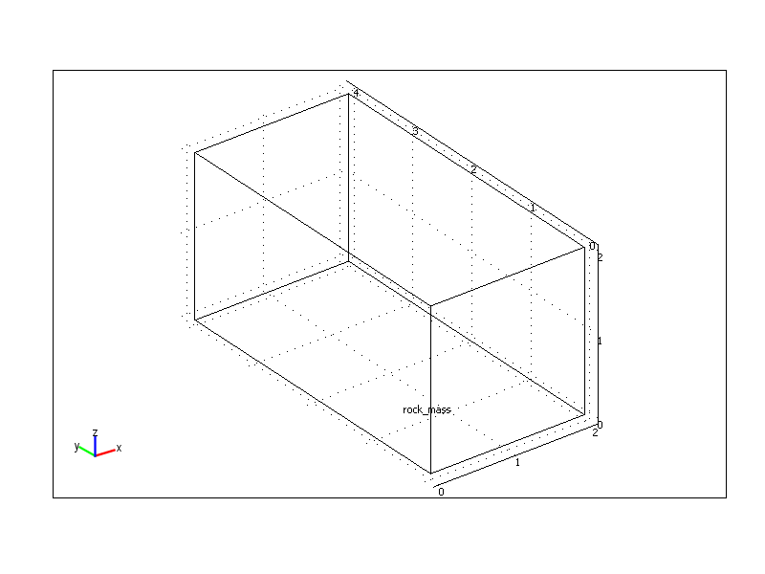
Figure 2: A rectangular 4 x 2 x 2 m block is assigned for the geometry of the domain. The dual-porosity medium occupies the entire domain of which the behavior is coupled by the porous phase and fractured phase.

Table 1: List of assigned materials
Material No. | Name | Function | Description
1 | Water | base material
2 | Glass (quartz) | base material
3 | Porous phase | subdomain material | properties are function of mat.1 and 2
4 | Fractured phase | subdomain material | properties are mainly of mat.1
5 | Dual-porosity medium | domain
Specific material properties of the porous phase, fractured phase, and the dual-porosity medium that are functions of the base material are defined in Table 2.
Table 2: List of specifically defined functions for some material properties
Material | Name | FEMLAB parameter | Expression
Porous Phase | Heat capacity, 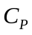 | mat3_C | 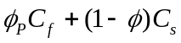
 | Elastic Modulus, 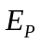 | mat3_E | 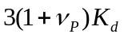
 | Thermal expansion coefficient, 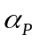 | mat3_alpha | 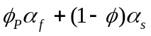
 | Thermal Conductivity, 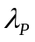 | mat3_k | 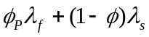
 | Density, 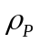 | mat3_rho | 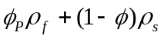
Fractured Phase | Heat capacity, 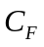 | mat4_C | 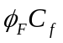
 | Elastic Modulus, 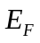 | mat4_E | 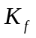
 | Thermal expansion coefficient, 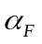 | mat4_alpha | 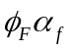
 | Thermal Conductivity, 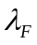 | mat4_k | 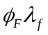
 | Density, 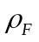 | mat4_rho | 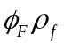
The elasticity matrix and the compliance matrix are defined for each material. The elasticity matrix of the dual porosity, 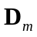, which is the inverse of the sum of the compliance matrix of the porous and fractured phases, was determined and assigned directly to the property of the Dual-Porosity Medium.

Equation Systems
Mechanical Behavior: The stresses in the global level can be modified directly by referring to the elasticity matrix of dual-porosity and adding the components of fluid pressure and thermal expansion as derived in equation (20).

FEMLAB Input Example – stress in the x direction
sxx=(mat5_Delastic3D_1_1_*ex_sld+mat5_Delastic3D_1_2_*ey_sld+mat5_Delastic3D_1_3_*ez_sld +2*mat5_Delastic3D_1_4_*exy_sld+2*mat5_Delastic3D_1_5_*eyz_sld+2*mat5_Delastic3D_1_6_*exz_sld) +(mat3_cE_1_1_*px+mat3_cE_1_2_*px+ mat3_cE_1_3_*px+ mat3_cE_1_4_*px+ mat3_cE_1_5_*px +mat3_cE_1_6_*px)+(mat4_cE_1_1_*p2x+mat4_cE_1_2_*p2x+ mat4_cE_1_3_*p2x+mat4_cE_1_4_*p2x +mat4_cE_1_5_*p2x+ mat4_cE_1_6_*p2x)-(mat3_aplha*(T_cc-T0_cc))-(mat4_aplha*(T_cc2-T0_cc2)

Hydraulic Behavior: Material type 3 and 4 are assigned to the chdl and chdl2 modules respectively. The pressures for each phase were modified to include the mechanical and thermal effects as discussed earlier. This was done within by including the coupled variables into the source flux of each subdomain (F_chdl and F_cdhl2), where

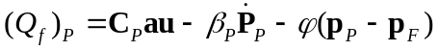 | (48)
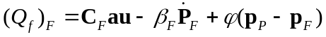 | (49)

FEMLAB Input Example – source flux for the porous phase
F_chdl=(mat3_sE_1_1_+mat3_sE_1_2_+mat3_sE_1_3_+mat3_sE_2_1_+mat3_sE_2_2_ +mat3_sE_2_3_+mat3_sE_3_1_+mat3_sE_3_2_+mat3_sE_3_3)*(pdiff(ux,t)+pdiff(vy,t) +pdiff(wz,t))+(mat3_aplha*(T_cc-T0_cc))+(mat4_aplha*(T_cc2-T0_cc2))-(beta_biotP*(pdiff(p2,t)))-Psi_factor*(p2-p3)

Thermal Behavior: Material type 3 and 4 are assigned to the cc and cc2 modules respectively. The coupled components were added to the thermal equation as a heat source for each subdomain (F_cc and F_cc2), where

(50)
(51)

FEMLAB Input Example – heat source for the porous phase
F_cc=(mat3_sE_1_1_+mat3_sE_1_2_+mat3_sE_1_3_+mat3_sE_2_1_+mat3_sE_2_2_ +mat3_sE_2_3_+mat3_sE_3_1_+mat3_sE_3_2_+mat3_sE_3_3_)*(pdiff(ux,t)+pdiff(vy,t) +pdiff(wz,t))+mat3_alpha*beta_biotP*(pdiff(p,t))-mat3_alpha*Psi_factor*pdiff((p-p2),t)-mat3_rho*(pdiff(T,t))-mat3_rho*mat3_C*mat3_kperm/mat3_eta*((pdiff(px,t))+(pdiff(py,t)) +(pdiff(pz,t)))*T

Verification
Several measures were taken to verify the solutions given by the model.
- Displacements: 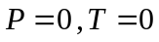
Assigning insulation boundary conditions for fluid pressures and temperatures, allows the mechanical behavior to be verified. The mechanical boundaries are fixed in the direction normal to the surface for all except the top face where a compressive stress of -10 N/m² in the z direction is applied. Reasonable displacements were given.
For the case with an elastic modulus and Poisson’s ratio of the porous phase at 100 GPa and 0.25 respectively, the normal and shear stiffness of the rock mass of 5 GPa and 0.1 GPa respectively, and the fracture spacing in the z direction of 1 m. The displacements at the loading surface is (5.909×10⁻³ m) very close that obtained from manual calculation (6×10⁻³ m).
Given a very large value of 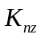 (5×10⁵⁰ Pa/m to suppress the influence of the fractured component on the modulus of the rock mass), the displacements at the loading surface is found to be (1.667×10⁻³ m) in the same order of magnitude with that obtained by manual calculation (1×10⁻³ m), although not exactly equal, since the manual calculation considers absolute 0 effect of the fractures.
- Fluid Flow: 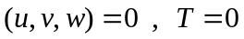
The velocity fields were verified for fluid flow conditions with no applied stress or temperature. The permeability and dynamic viscosity of the porous phase are 1×10⁻⁷ m² and 1×10⁻⁶ Pa⋅s respectively. The fractured phase permeability is 1×10⁻⁴ m².
The flow velocities of the porous phase and the porous phase is found to be 1.25×10³ m/s and 1.25×10⁶ m/s which is the exact solution obtained from calculation.

- Temperature: 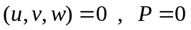
The verification of the heat transport was completed by creating a heat source at the inlet boundary, and assigning different thermal conduction in the porous phase and the fractured phase. The heat flux given by the model is exactly as calculated manually.
- Time dependent
The time dependent behavior was not able to be simulated due to a computer code deficiency in the program.

Parametric results
By far, the model is capable of providing correct solutions for static analysis. Although the time dependent solutions have not been verified and the model is not completed with the capability to update permeability values due to effects of stress and temperature, some results are shown to present the capability of the model to date.
Water at room temperature is injected in to the fracture in a hot porous matrix at 150° C. Normal stress in the Z direction acts on the top and bottom surface of the rectangular block at 10 Pa. Displacements are fixed in the y direction at the inlet and outlet boundaries and fixed in the x direction at the sides of the block. Heat flux at 1000 MW/m² is developed at the outlet.

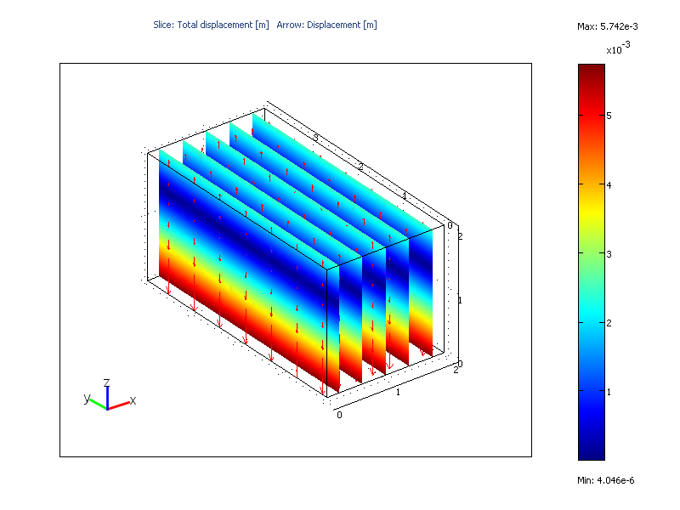
water at room temperature
Heat flux 1000 MW/m²
Temp ~ 150 °c
Figure 3: Results from injecting water at room temperature into the fracture which is surrounded by a hot porous matrix. The arrows and the colored-contours indicate the displacements due to applied stress in the z directions on the top and bottom of the rectangular slab. The injection results in an expected amount of heat flux at the outlet.

Conclusions
The finite element model for a thermal-hydraulic-mechanical coupled behavior is satisfactorily implemented by the computer code FEMLAB. The flexibility of the software allows detail designation of independent parameters and dynamic linkage of the dependent variables. With its pre-programmed modules, the constitutive equations for several coupled behaviors are immediately available, and only minor adjustments to the system equations are needed to complete the task at hand. Although, as encountered in any computer code, FEMLAB also has several minor code deficiencies some of which may obstruct the programs ability to provide solutions, these can probably be avoided by approaching the problem in a different manner since the software allocates a very wide range of methods to compute the solution.
The next task is to incorporate the relationship of the fracture permeability and the displacements in order to track changes of the increase or decrease in fracture width due to the effects from stresses and temperature.

References:
Amadei, B. and R. E. Goodman (1981). A3-D constitutive relation for fractured rock masses. International Symposium on the Mechanical Behavior of Structured Media, Ottawa.
Barenblatt, G. E., I. P. Zheltov, et al. (1960). "Basic concepts in the theory of seepage of homogeneous liquids in fissured rocks." Journal of Applied Mathematics and Mechanics 24: 1286-1303.
Barton, N. R. (2002). "Some new Q-value correlations to assist in site characterisation and tunnel design." International Journal of Rock Mechanics and Mining Sciences 39(2): 185-216.
Bieniawski, Z. T. (1973). "Engineering Classification of Jointed Rock Masses." Transactions - South African Institute of Civil Engineers 15(12): 335-344.
Bieniawski, Z. T. (1976). Rock mass classifications in rock engineering. Proceedings of the Symposium on Exploration for Rock Engineering, Johannesburg.
Biot, M. A. (1941). "General theory of three-dimensional consolidation." Journal of Applied Physics 12: 155-164.
Bึrgesson, L. (1996). ABAQUS. Coupled thermo-hydro-mechanical processes of fractured media. O. Stephansson, L. Jing and C. F. Tsang, Elsevier: Developments in Geotechnical Engineering. 79: 565-70.
Bowen, R. (1989). Geothermal Resources. New York, Elsevier Science Publishers.
Bower, K. M. and G. Zyvoloski (1997). "A numerical model for thermo-hydro-mechanical coupling in fractured rock." International Journal of Rock Mechanics and Mining Sciences 34(8): 1201-1211.
Collin, F., X. L. Li, et al. (2002). "Thermo-hydro-mechanical coupling in clay barriers." Engineering Geology 64(2-3): 179-193.
Elsworth, D. and M. Bai (1992). "Flow-deformation response of dual-porosity media." Journal of Geotechnical Engineering 118(1): 107-124.
Faulkner, D. R. and E. H. Rutter (2003). "The effect of temperature, the nature of the pore fluid, and subyield differential stress on the permeability of phyllosilicate-rich fault gouge." Journal of Geophysical Research-Solid Earth 108(B5).
Germanovich, L. N., R. P. Lowell, et al. (2001). "Temperature-dependent permeability and bifurcations in hydrothermal flow." Journal of Geophysical Research-Solid Earth 106(B1): 473-495.
Gray, W. G., K. O'Neill, et al. (1976). Simulation of heat transport in fractured, single-phase geothermal reservoirs. Summaries Second Workshop Geothermal Reservoir Engineering. Stanford, California, Stanford University: 222-228.
Guvanasen, V. and T. Chan (1995). A new three-dimensional finite-element analysis of hysteresis thermohydromechanical deformation of fractured rock mass with dilatance in fractures. The Second Conference on Mechanics of Jointed and Faulted Rocks, Vienna, Austria.
Hicks, T. W., R. J. Pine, et al. (1996). "A hydro-thermo-mechanical numerical model for HDR geothermal reservoir evaluation." International Journal of Rock Mechanics and Mining Sciences & Geomechanics Abstracts 33(5): 499-511.
Holloway, S. (1997). "An overview of the underground disposal of carbon dioxide." Energy Conversion and Management 38: 193-198.
Israelsson, J. I. (1996a). Short Description of FLAC version 3.2. Coupled Thermo-Hydro-Mechanical Processes of Fractured Media. O. Stephansson, L. Jing and C. F. Tsang, Elsevier: Developments in Geotechnical Engineering. 79: 513-522.
Israelsson, J. I. (1996b). Short description of UDEC and 3DEC. Coupled Thermo-Hydro-Mechanical Processes of Fractured Media. O. Stephansson, L. Jing and C. F. Tsang, Elsevier: Developments in Geotechnical Engineering. 79: 523-528.
Kohl, T., K. F. Evans, et al. (1995). "Coupled Hydraulic, Thermal and Mechanical Considerations for the Simulation of Hot Dry Rock Reservoirs." Geothermics 24(3): 345-359.
Koutsabeloulis, N. and S. A. Hope (1998). Coupled stress/fluid/thermal multiphase reservoir simulation studies incorporating rock mechanics. SPE/ISRM EUROCK-98 Symposium, Norway.
Neaupane, K. M., T. Yamabe, et al. (1999). "Simulation of a fully coupled thermo-hydro-mechanical system in freezing and thawing rock." International Journal of Rock Mechanics and Mining Sciences 36(5): 563-580.
Neuzil, C. E. (2003). "Hydromechanical coupling in geologic processes." Hydrogeology Journal 11(1): 41-83.
Nguyen, T. S. and A. P. S. Selvadurai (1995). "Coupled thermal-hydrological-mechanical processes in sparsely fractured rock." International Journal of Rock Mechanics and Mining Sciences & Geomechanics Abstracts 32: 465-480.
Noorishad, J., C. F. Tsang, et al. (1984). "Coupled Thermal-Hydraulic-Mechanical Phenomena in Saturated Fractured Porous Rocks: Numerical Approach." Journal of Geophysical Research 89(B12): 10,365-10,373.
Ohnishi, Y., H. Shibata, et al. (1987). Development of finite element code for the analysis of coupled thermo-hydro-mechanical behavior of a saturated-unsaturated medium. Coupled processes associated with nuclear waste repositories. C. F. Tsang. Orlando, Academic Press: 551-557.
Pao, W. K. S., R. W. Lewis, et al. (2001). "A fully coupled hydro-thermo-poro-mechanical model for black oil reservoir simulation." International Journal for Numerical and Analytical Methods in Geomechanics 25(12): 1229-1256.
Pine, R. J. and P. A. Cundall (1985). Application of the fluid rock interaction program (FRIP) to the modeling of hot dry rock geothermal energy systems. The International Symposium on Fundamentals of Rock Joints, Sweden, Bjึrkliden.
Pritchett, J. W., S. K. Garg, et al. (1976). Geohydrological Environmental Effects of Geothermal Power Production - Phase IIA. La Jolla, California, Systems, Science and Software.
Rutqvist, J. and C. F. Tsang (2003). "Analysis of thermal-hydrologic-mechanical behavior near an emplacement drift at Yucca Mountain." Journal of Contaminant Hydrology 62-3: 637-652.
Schrefler, B. A., G. A. Khoury, et al. (2002). "Thermo-hydro-mechanical modelling of high performance concrete at high temperatures." Engineering Computations 19(7-8): 787-819.
Swenson, D. V., R. DuTeau, et al. (1997). "A coupled model of fluid flow in jointed rock applied to simulation of a hot dry rock reservoir." International Journal of Rock Mechanics and Mining Sciences & Geomechanics Abstracts 34: 308.
Terzaghi, K. (1943). Theoretical soil mechanics. New York, John Wiley & Sons.
Thomas, H. R., Y. He, et al. (1998). "An examination of the validation of a model of the hydro/thermo/mechanical behaviour of engineered clay barriers." International Journal for Numerical and Analytical Methods in Geomechanics 22(1): 49-71.
Tsang, C. F., O. Stephanson, et al. (2000). "A discussion of thermo-hydro-mechanical (THM) processes associated with nuclear waste repositories." International Journal of Rock Mechanics and Mining Sciences 37(1-2): 397-402.
Wang, J. S. Y., C. F. Tsang, et al. (1981). "A study of regional temperature and thermohydrologic effects of an underground repository for nuclear wastes in hard rock." Journal of Geophysical Research 86(B5): 3759-3770.
Warren, J. E. and P. J. Root (1963). "The behavior of naturally fractured reservoirs." Society of Petroleum Engineers Journal 3: 245-255.
Wawersik, W. R. and W. Rudnicki (1998). Terrestrial sequestration of CO₂-an assessment of research needs. Invited panelist workshop, Department of Energy, Geoscience Research Program.
Wittke, W. (1973). "Percolation through fissured rock." International Association of Engineering Geology Bulletin 7: 3-28.
Yow, J. L. and J. R. Hunt (2002). "Coupled processes in rock mass performance with emphasis on nuclear waste isolation." International Journal of Rock Mechanics and Mining Sciences 39(2): 143-150.

Notations

Appendix
Table 3: List of defined constants
Name | Description
nset | number of normal set of fractures,
aptr | aperture width,
char_l | characteristic length of the porous phase,
Sx | fracture spacing in the x direction
Sy | fracture spacing in the y direction
Sz | fracture spacing in the z direction
appT | temperature applied to the system (for convenience of assigning the same temperatures on a set of boundaries)
P_in | assigned pressure of the inflow
vel_in | assigned velocity of the inflow
Knx | normal stiffness of the fractured rock mass (Pa/m)
Kny | normal stiffness of the fractured rock mass (Pa/m)
Knz | normal stiffness of the fractured rock mass (Pa/m)
Ksx | shear stiffness of the fractured rock mass (Pa/m)
Ksy | shear stiffness of the fractured rock mass (Pa/m)
Ksz | shear stiffness of the fractured rock mass (Pa/m)
Table 4: List of defined expressions
Name | Expression | Description
Kbulkf | 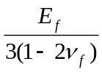 | bulk modulus of the fluid,
Kbulks | 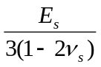 | bulk modulus of the solid,
beta_biotP | 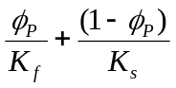 | compressibility of porous phase, 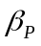
beta_biotF | 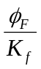 | compressibility of fractured phase, 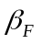
Psi_factor | 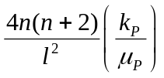 | fluid mass transfer coefficient,
Exi |  | elastic modulus of the intact rock component
Eyi |  | elastic modulus of the intact rock component
Ezi |  | elastic modulus of the intact rock component
Gyzi |  | shear modulus of the intact rock component
Gxzi |  | shear modulus of the intact rock component
Gxyi |  | shear modulus of the intact rock component
Exf |  | elastic modulus of the fractured component
Eyf |  | elastic modulus of the fractured component
Ezf |  | elastic modulus of the fractured component
Gyzi |  | shear modulus of the fractured component
Gxzi |  | shear modulus of the fractured component
Gxyi |  | shear modulus of the fractured component

