Composition and Lighting Essentials
This document is a resource that should prove helpful for both the aspiring and seasoned photographer. Having a solid knowledge base of fundamental composition and lighting techniques will elevate any photographer's work, regardless of the type of camera being used.

1/ Composition Essentials
Composition refers to the arrangement and visual relationship between your subject and other elements in your photo. Purposeful composition is foundational to strong photography. Being mindful of focal points, rule of thirds, leading lines, framing, figure to ground, and depth of field helps you compose visually compelling photos.

Focal Point
As a photographer, you need to decide where you want your viewers to focus their attention. This is achieved through having a clear focal point (or point of interest) in your photos. Thoughtful presentation of your focal point helps you communicate the stories and intended meaning behind your photos.
  - Putting this into practice:
- The focal point should always be obvious in your photos.
- Keep in mind what you want to tell the viewer through the photo.
- Get close to your subject; this is one of the most effective ways to eliminate distractions and focus the attention on where you want it to be. Using a wide angle lens means you’ll often want to be physically close to your subject when taking the photo. While providing a different perspective and unique benefits from a wide angle lens, a telephoto lens can also be effectively used to place your subject at the center of attention.
- Experiment with different angles, including high and low vantage points, to find new and interesting perspectives.
PHOTO ESSENTIALS | PAGE 1

Rule of Thirds
The rule of thirds is an essential composition technique in photography. Using the rule of thirds will leave your subject positioned to the left or right of the frame, allowing negative space on the opposite side to place text or graphic elements while maintaining visual interest and balance.
  - Putting this into practice:
- Imagine overlaying the lines of a tic-tac-toe board onto an image you’re composing.
- Position your subject at one of the four intersections of the grid. These intersections create a point of interest.
- You can balance the subject by having a supporting or a contrasting element in the opposing intersection.
- Aligning your subject to the left or right third of your photo will help provide the often-needed space for text and graphics for a designer.
PHOTO ESSENTIALS | PAGE 2

Leading Lines
Leading lines are linear elements that direct the viewer’s eye to the subject or focal point. Look for leading lines already present in your shooting environment when composing your photos.
  - Putting this into practice:
- Streets, sidewalks, fences, rows of street lights, streams, branches, etc., can act as leading lines.
- Experiment with high and low vantage points to find and use leading lines in your environment.
- Using a deep depth of field (both the foreground and background are sharp and focused) can help support leading lines.
  - TIP: Wide angle lenses, like 17–35mm, at a small aperture (f/22 or similar) will result in a deep depth of field (where most or all of the image is in focus).
PHOTO ESSENTIALS | PAGE 3

Framing
Strategically framing your focal point with elements found in your shooting environment can help focus your viewer’s attention. Framing also adds depth, interest, and context to the stories at the heart of your photos.
  - Putting this into practice:
- When composing a photo, look for framing devices in both the foreground and background.
- Windows, doors, people, and other elements in the environment can all be used as framing devices.
- Experiment with high and low vantage points to find and use framing devices in your environment.
- Framing shouldn’t distract from your focal point—it should elevate and help to make your subject more intriguing.
PHOTO ESSENTIALS | PAGE 4

Figure to Ground
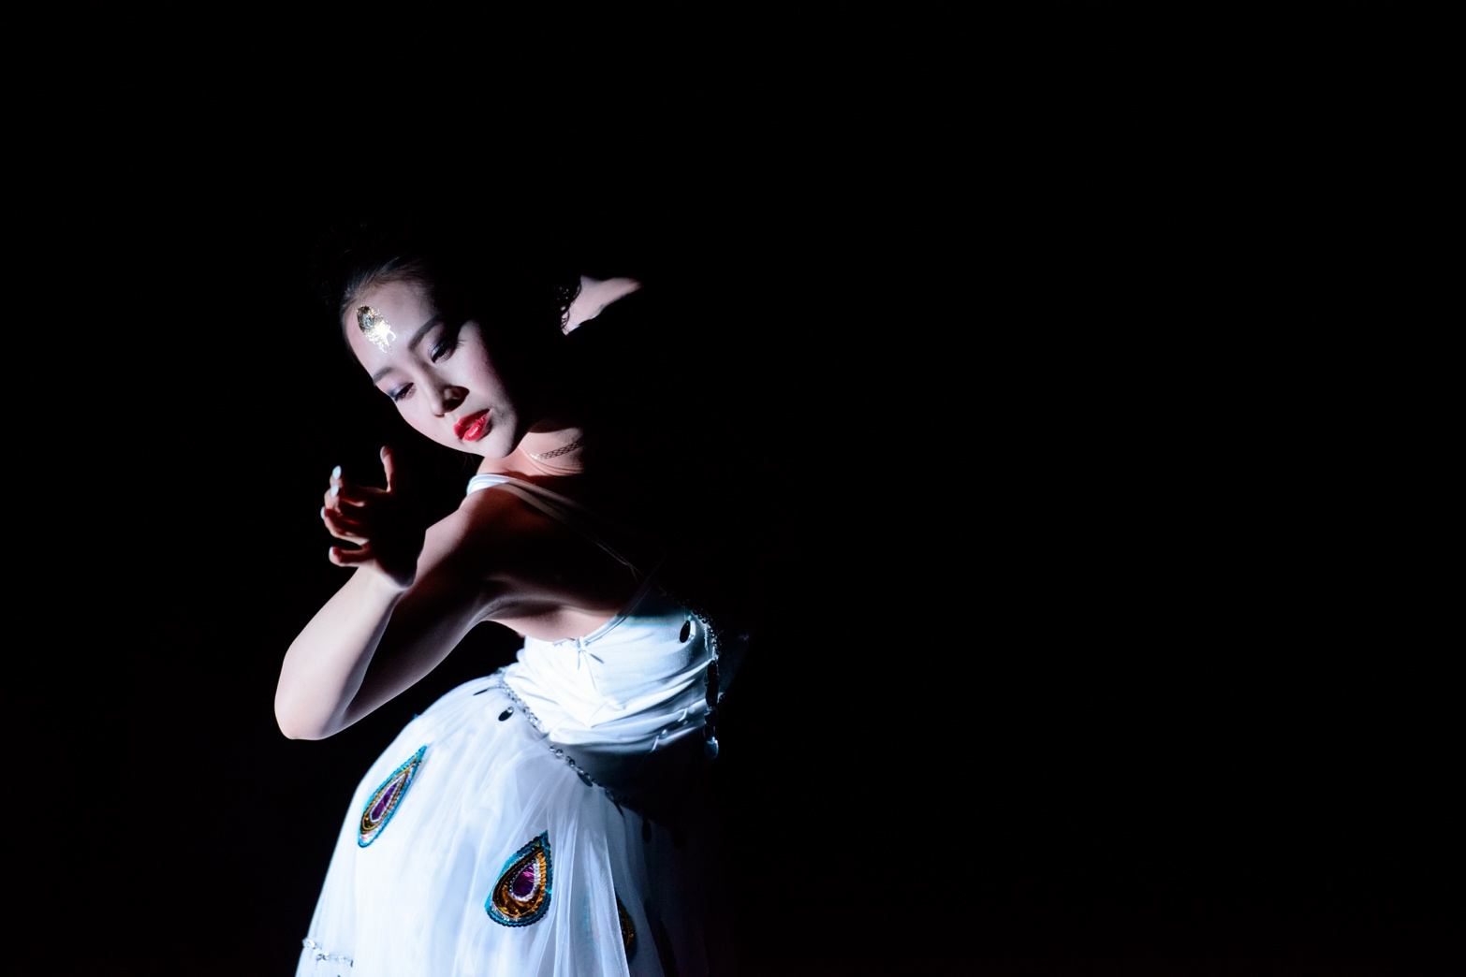
Figure to ground refers to the separation between your subject and the background (and foreground). Effectively using figure to ground can help your subject stand out from its surroundings and draw the viewer’s eye to your focal point. Experimenting with contrast and depth of field are two ways to achieve this effect.

Contrast
PHOTO ESSENTIALS | PAGE 5
Contrast describes the variance between the light and dark portions of a photo. Using contrast can make your photos more dynamic and engaging. Strong contrast can be achieved through color and lighting.
  - Putting this into practice:
- Having a brightly colored or saturated foreground against a dull background (or vice versa) can help isolate your subject from its surroundings.
- Bright highlights and dark shadows in a photo can also create a strong figure to ground effect.

SyMMetry
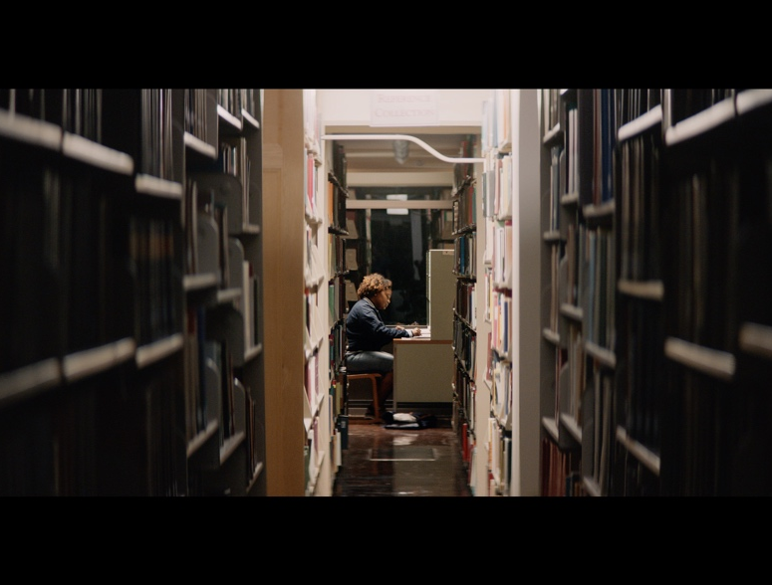

Symmetry takes balancing the composition of a photo one step further. The camera should be positioned in the exact center of the symmetrical scene and is often pointed perpendicular to the subject and background of the scene. When a scene lends itself to it, this approach can be very striking and powerful; however, because of its bold nature, symmetry should be used sparingly compared to other composition approaches.
  - TIP: Even the slightest misalignment from the exact center of a symmetrical scene or object can appear distracting.
PHOTO ESSENTIALS | PAGE 5

Depth of Field
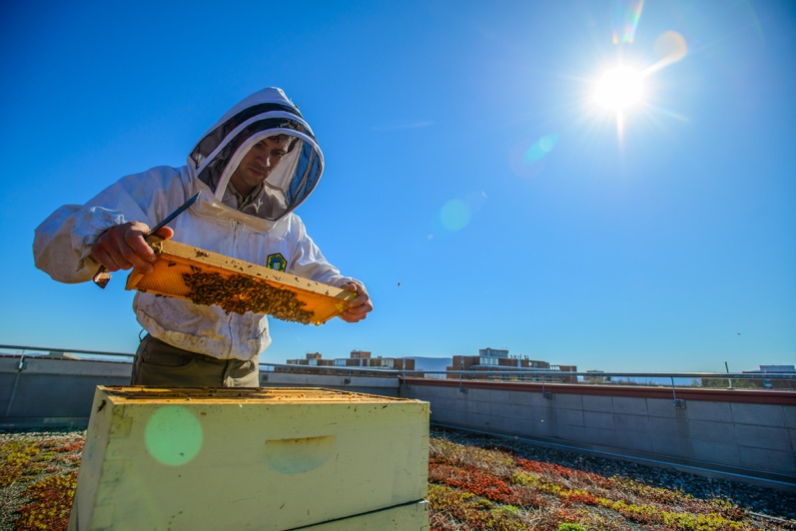
Depth of field refers to how clear or blurry your photo’s foreground and background appear compared to your focal point. A photo with a shallow depth of field (below, left photo) has a very narrow focal point while the rest of the image is blurry. Photos with a deep depth of field (below, right photo) are entirely or nearly entirely in focus and clear—neither the foreground nor background are blurry.
  - Putting this into practice:
You can alter the depth of field in your photos through a combination of adjusting your camera’s aperture and using specific lenses.
PHOTO ESSENTIALS | PAGE 6

Aperture
- Your camera’s aperture controls how much light is let into the camera—it functions similarly to how your pupil dilates and constricts.
- Your aperture is measured in numbers referred to as f-stops—the smaller the number, the wider your aperture.
- A low f-stop (like f/1.4 or f/2.8) uses a large aperture and results in a shallow depth of field.
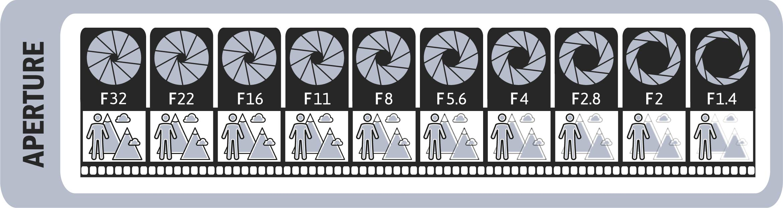
- A high f-stop (f/22 or similar) uses a small aperture and results in a deep depth of field. Mostly everything in the image will appear clear and in focus when using a deep depth of field.

Lens
- Wide angle lenses, like 17–35mm, at a small aperture (f/22 or similar) will result in a deep depth of field (most or all of the image is in focus).
- Telephoto lenses, like a 70–200mm zoom lens, at a larger aperture (f/1.4 or similar) will result in a shallower depth of field (a small portion of the image is in focus).
  - TIP: Combine a larger aperture (f/1.4) and a longer (telephoto) lens for the shallowest depth of field effect. A deeper depth of field is gained by using the widest lens with the smallest aperture (f/22).

PHOTO ESSENTIALS | PAGE 7

2/ Lighting Essentials
Lighting is possibly the most critical component in photography. Controlling and using light can transform and elevate your photography like no other factor.

Natural vs. Artificial Lighting
Different types of lighting can effectively evoke a variety of emotions and powerfully transform the aesthetic of a scene. Purposefully leveraging an abundance of natural light is ideal for capturing beautiful photography.
  - Putting this into practice:
- If you have a choice, seek bright, natural light and position your camera and subject to take advantage of this lighting.
- Optimal lighting positioning will often have the subject looking in the direction of the light source and the photographer's back toward the light source.
- Avoid backlighting your subject. Backlighting occurs when a bright light source is behind your subject. This often leaves the focal point of your photo in shadow and underexposed as your camera compensates for the bright backlight.
- Avoid using on-camera flash as it tends to make your subject look overexposed and in a flat light.

PHOTO ESSENTIALS | PAGE 8

Color of Light
The color of light ranges from blues (cool) to yellows (warm). The proper white balance setting on your camera will ensure colors look natural and accurate. Cooler, blue tones can communicate a clean, professional look, while warmer, orange tones can convey a relaxed look.
  - TIP: The best approach to color correcting photographs in the editing process is to adjust the color balance until the pure white portions of your scene are truly white (not yellow or blue). Once your whites are true whites, the rest of the colors in the photo will naturally be in the correct balance.
  - Common lights you'll encounter:
- Tungsten/incandescent—Most standard light bulbs produce tungsten/incandescent light, which tends to look warm in photos.
- Fluorescent—Fluorescent light typically lets off a green or maroon color. It's good to be aware that some fluorescents will flicker at different colors.
- Daylight—Daylight at midday is typically when colors are their truest and whites are their truest white.
- Shade—Photos taken in shade tend to look bluer.
- Sunrise or sunset—During sunrise and sunset, light can appear golden (also known as the golden hour).
  - TIP: Use the “daylight” white balance setting when shooting during sunset or sunrise to get more vibrant colors.
  - Putting this into practice:
- Set your camera’s white balance (WB) properly. Note: Auto WB is only accurate about 90 percent of the time. It can be a dependable default setting, but it would be valuable to learn how to manually set your WB.
- Try to avoid shooting in environments with old fluorescent or extremely yellow lighting.
- Whether indoors or outdoors, seek environments with bright, natural daylight.
- Avoid shooting in environments with multiple, conflicting light sources. For example, if you're shooting in a room with fluorescent lighting and bright window light, turn off the fluorescent lights and open the shades to let the natural daylight in.
- Avoid shooting subjects outside at high noon as the sun is very bright, casting harsh shadows and causing squinting and overexposure.

  - ADVANCED TIP: Your camera likely has several white balance presets to choose from. You
can quickly determine which setting looks best for a given environment by cycling through
the presets.
PHOTO ESSENTIALS | PAGE 9

Direction of Light
The relationship between your light source and your subject is essential to properly highlighting your focal point. Directional light can add depth, dimension, and interest to your photo by drawing the eye to the subject and creating dynamic contrast between light and shadow.

  - Putting this into practice:
- Front light (left photo)—Having your subject directly face a light source like a window can create flat, even lighting.
- Side light (right photo)—Having your subject perpendicular (to the side) to a light source will create a mix of highlights and shadows on the subject.
- Avoid light from above—Light from directly above your subject can create unflattering or harsh shadows. For example, shooting at high noon outdoors creates this un-flattering light. This should be avoided when possible.
  - TIP: Side lighting can be used to create a unique and dynamic look.

  - brand.psu.edu
Penn State is an equal opportunity, affirmative action employer, and is committed to providing employment opportunities to all qualified applicants without regard to race, color, religion, age, sex, sexual orientation, gender identity, national origin, disability, or protected veteran status.
THIS PUBLICATION IS AVAILABLE IN ALTERNATIVE MEDIA ON REQUEST.
Produced by the Penn State Department of University Marketing U.Ed. SCM 18-53
PHOTO ESSENTIALS | PAGE 10
PHOTOGRAPHY FIELD GUIDE | PAGE 2

